BMC Membership
Included in the membership:
1. 2 newsletters each year (1 copy per household)
Renew your membership today!

2. Bills Musky Club Outings - Free to members, Lunch
provided & Attendance prizes
3. Fish Registration - Awards for largest fish, many categories
4: Member of Musky Clubs Alliance of WI

Mail form and payment to:
BILL’S MUSKY CLUB, INC., PO BOX 476, SCHOFIELD, WI 54476

Membership Type | Price | Quantity | TOTAL
Adult | $10.00
Junior (18 Yrs Old & Under)  *must be sponsored by an adult member, parent or guardian | $5.00
Joint (Husband & Wife) | $15.00
Lifetime Single | $150.00
Lifetime Joint (Husband & Wife) | $175.00
 |  | TOTAL:
*Memberships are good for 1 year from the date of purchase

Member Information (Print Clearly)
Today’s Date
Name | Adult Joint Junior  Life Single Life Joint | Year of Birth

Street Address
City |  | State |  | Zip
Main Phone ( ) | Email Address

Name | Adult Joint Junior  Life Single Life Joint | Year of Birth

Name | Adult Joint Junior  Life Single Life Joint | Year of Birth

Name | Adult Joint Junior  Life Single Life Joint | Year of Birth
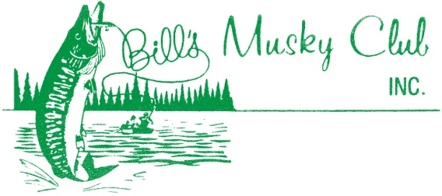

*Attach additional sheets if necessary*

Check us out at www.billsmuskyclub.com

