****BMC Annual 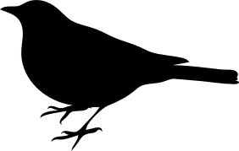Banquet

**Saturday, April 13th**

**Central WI Convention & Expo Center (Cedar Creek)  
10101 Market St, Rothschild, WI 54474**

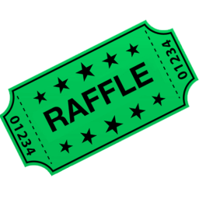Banquet Doors open at 4:00pm  
Dinner at 6:00pm   
Awards, Attendance Prizes & Raffle to Follow

$25 per person – advanced tickets  
$30 per person at the door

Raffle Tickets  
$5 each or   
25 for $100

Send below reservation form with payment by April 3rd to:   
**BILL’S MUSKY CLUB, INC., PO BOX 476, SCHOFIELD, WI 54476**

BMC Annual Banquet RSVP

|  |  |  |  |  |
| --- | --- | --- | --- | --- |
| **RESERVATION INFORMATION** | | | | |
| **Name (Print Clearly):** | | | | |
|  | **Price** | | **Quantity** | **Total** |
| **Banquet Ticket(s)** | $25.00 per person (includes tax) | |  | **$** |
| **Raffle Ticket(s)** | $5 Each or 25 for $100 | |  | **$** |
|  |  |  | **TOTAL** | **$** |

**For more information visit** [**www.billsmuskyclub.com**](http://www.billsmuskyclub.com)