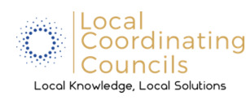
Coalition Name and County | Coalition for a Drug Free Newton County
Meeting Date and Time | November 20, 2025
Meeting Location | Newton County Government Center
Minutes Drafted Date | December 8, 2025
Attendees
Danielle Sands
Gene Bell
Lucy Illingworth
Diane Gonczy
Meeting Notes (Old/New Business, Decisions, Agendas)
Minutes
Minutes from the October meeting were discussed Danielle made motion to accept and Lucy seconded. Motion passed

Treasurer’s Report
Danielle reported: Current checking account balance: $1806.36 Diane made motion to accept and Lucy seconded. Motion Passed

Old Business:
T-Shirt Wrap up – Danielle reported extra t-shirts were ordered and received before Red Ribbon Week and delivered to schools who needed them.

2026 Officer nominations – Be thinking about officer positions for the 2026 year.

New Business:
Discussed the coalition purchasing own set of vision goggles to use for education outreach.
Danielle to check with sheriff’s dept. on set of goggles and order Motion by Diane seconded by Lucy. Motion Passed

As always – Drug Free Coalition does not meet in December.

