About Me : Wayne Smith
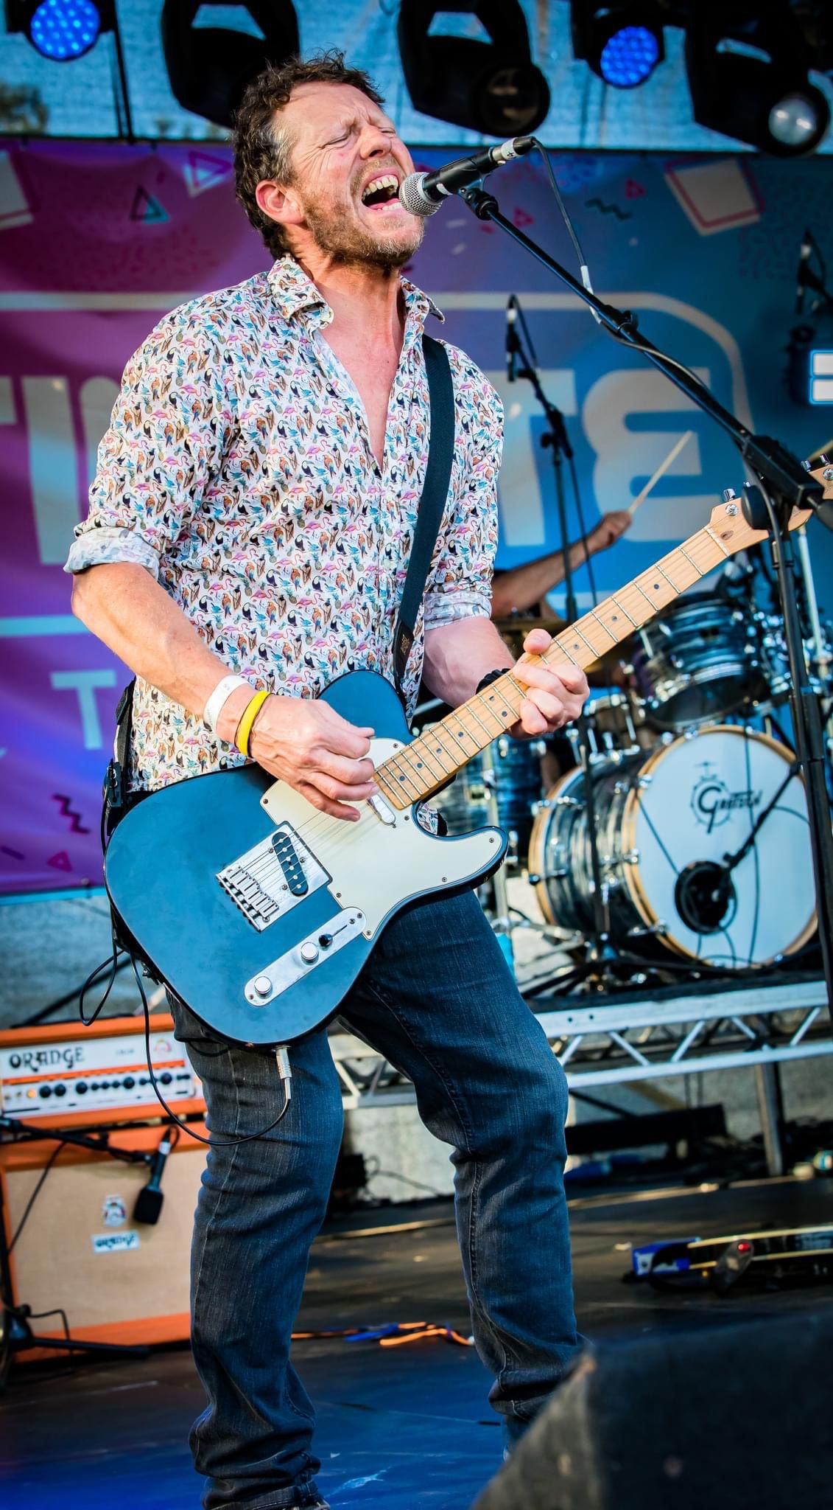

BTEC National Diploma in Performing Arts & DBS Checked
I have been fortunate enough to have made a living from my love of performing, and this has taken me to venues all over the UK & Europe. I have played guitar for over 30 years, and have many musical influences that have helped shape my style and technique over the years. I am now keen to share my confidence and musical abilities with younger minds and so, helping them build up confidence and resilience.

I play a variety of styles, instruments, and both electric and acoustic guitar.

I believe the most effective approach to teaching is to tailor lessons to align with students' tastes and interests, ensuring that their enthusiasm remains at the forefront of the learning experience.
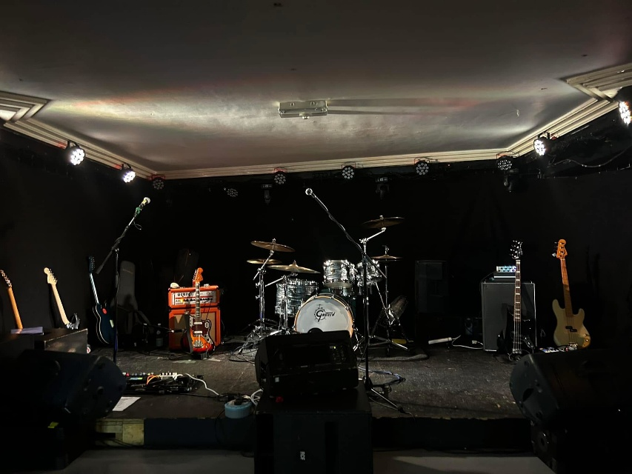

Playing the guitar for a living has led me to travel around some beautiful parts of Europe. Playing in the Four Seasons in Geneva, whilst living in Italy, and playing in
various different resorts. N

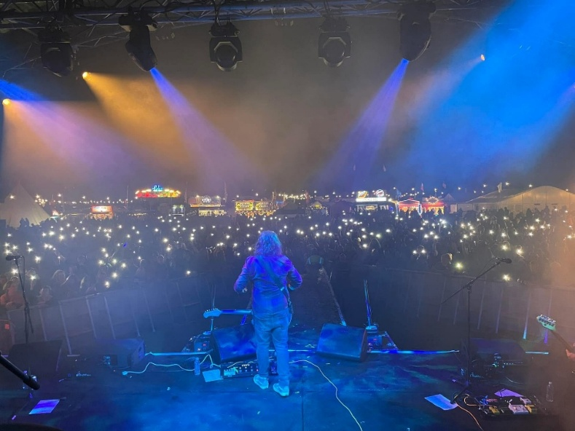

My contracts with 3+ Hotels in Italy have been ongoing for many years and continues to be part of my music diary.
Playing at music festivals in the summer in two bands : Foo Fakers Tribute Band & Nirvana performed by Ninvanot.
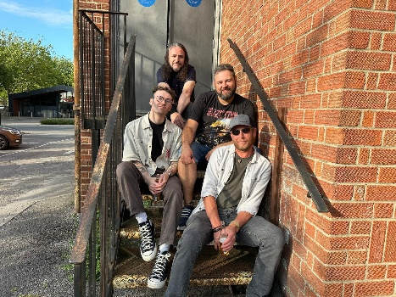
The Band
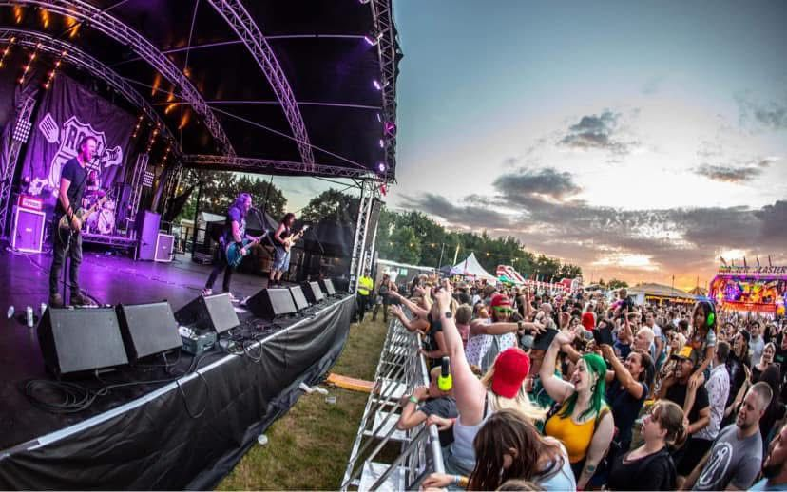

Performing at the following venues and festivals:
- Cheese & Grain, Frome
- The Vine Tree & The Tree House, Frome
- Rock n Ribs Festival, Wincanton
- The Egg Basket Bar & Venue Taunton
- Finns, Weymouth
- Riverside Festival, Somerset
- Pop & Rock Festival at Jimmys Farm, Ipswich
- Teddy Rocks Festival, Blanford
- Shine on Festival, Butlins, Minehead
- Studio 24, Wells
- Flashback Family Festival, Yeovil
- SomerFest featuring The Wurzels
- The Electric Banana, Weston Super Mare
- Shaftesbury Octoberfest
- The Attic, Southampton
- Somerset Tribute Festival, Yeovil
- Ultimate Festival at Upton Country Park

My musical career and has taken me all over Europe, and I want to share my skills and experience through Futurerock Music.

