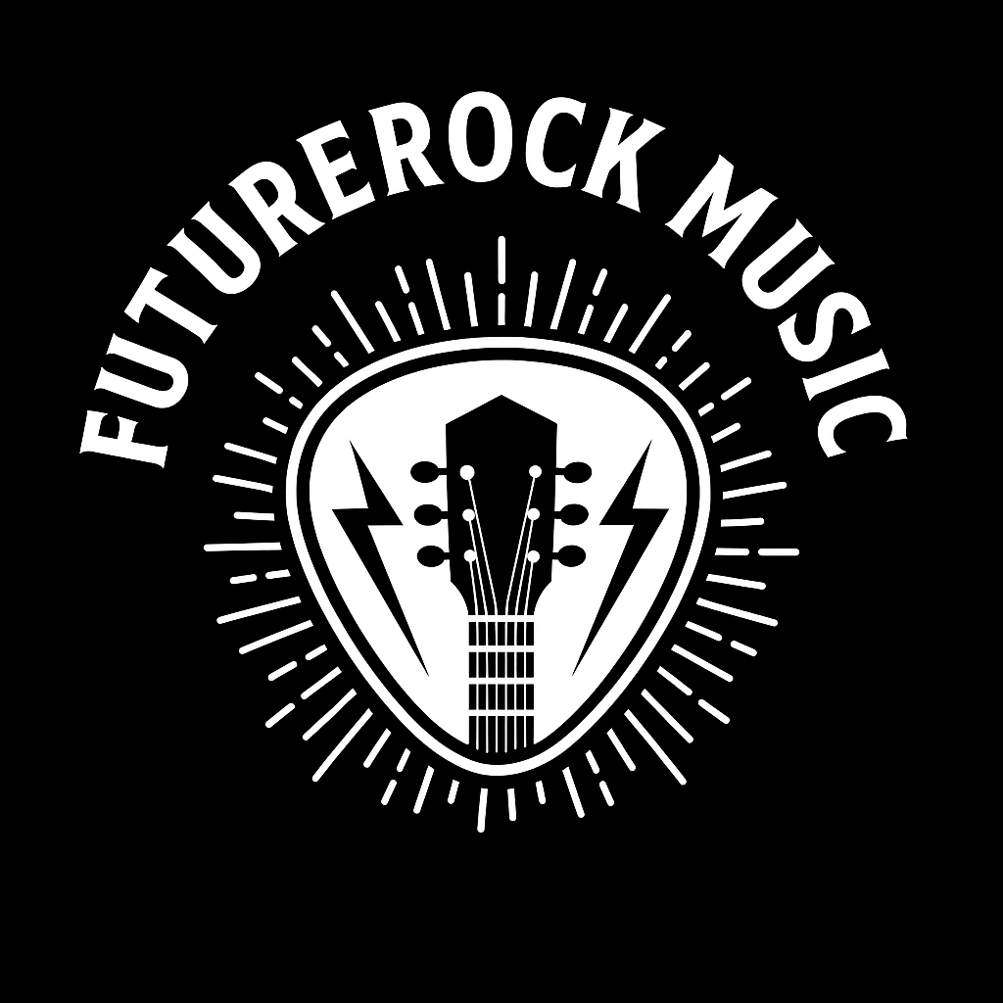
Fun and effective music-based lessons
Tailored to develop confidence, creativity, collaboration, and stage presence in young people.
Packages available :
Pricing structure
Lesson Style | Duration | Amount
Private lesson * | 45min | £15 (within 10miles of BA7)
Younth Program * | 4 – 6hrs | £140 - £180
School ½ Day * | 3hrs | £140
School full day * | 6 hrs | £160
Party Jam/ Interactive session * | 2hrs | £170
Full detailing explains what is included below.
*Private lesson :
First block of 6 lesson
Future lessons must be booked in blocks of 6 = £90
Joint lesson for siblings at £20per lesson ,must be booked in blocks of 6 = £120
Lessons outside of BA7 10 mile radios are changed at £20 per lesson
*Younth Program :
A fun and interactive session of music aged at 11 – 16 year olds. Providing a youth prevision to engage with local young people, developing skills and confidence.
Creating a tailored day depending on numbers.
Maximum numbers will apply depending on age rang and space you provide.
4 hrs – 9.30am – 13.30pm £140
6hrs - 9.30am – 15.30pm £180
*School ½ Day:
Tailored lesson to KS1 & KS2
9.30am – 12.30pm or 13.30pm – 16.30pm £140
Up to 5 lesson can be offered during this booking period
Block bookings available :
Creating a tailored day depending on numbers.
13.30 – 16.30pm can be built by school for individual needs. Hour from 15.30 – 16.30 could be offered as an after school music club offered by your school.
Maximum numbers will apply depending on age range and space you provide.

*School Full Day:
Tailored lesson to KS1 & KS2
9.30 – 15.30 £160
Or 10.30 – 16.30 £160
10.30 – 16.30pm can be built by school for individual needs. Hour from 15.30 – 16.30 could be offered as an after school music club offered by your school.
Up to 8 lesson can be offered during this booking period.
Block bookings available.
Creating a tailored day depending on numbers.
Maximum numbers will apply depending on age range and space you provide.

*Party Jam / Interactive session :
Party packages and interactive session are tailor-made
Example:

All equipment is provided and PAT tested
List of stuff here / pictures ?

Interactive Music Games
Pass the Beat - Circle Game
Objective: Rhythm, timing, teamwork
How we Play: Everyone sits in a circle/ Ice breaker / Opening activities
- Start a simple rhythm (e.g., clap-clap-pat) and “pass” it around the circle.
- The next person must repeat and pass it on without breaking the beat.
- Add complexity: speed up, change rhythm, or swap instruments.
Skills Building
Active listening, rhythm, group connection, laughter and energy building.

Mic Drop Challenges
Objective: Mic technique, confidence on stage
How we Play: Set fun 30-second challenges where each person takes the mic and:
- Says their name in a cool voice (funny)
- Freestyles a beat or rhyme or their name and a bit about themselves
- Tells a joke or does a sound effect
Skills Building
Stage confidence, vocal presence, public speaking through fun. Points for projection, posture, and using the mic like a pro.

Sound Sculptor
Objective: Creativity and teamwork
How to Play:
- One person is the “sculptor” and chooses a theme (e.g., jungle, space, city).
- Each person in the group makes a sound to build the soundscape.
- The sculptor “directs” by pointing, fading, or mixing people into the sound.
Skills Building
Creative thinking, sound control, collaborative creation

Rhythm Relay
Objective: Develop rhythm and musical memory
Activity:
- Split the group into teams.
- Give each a drum, shaker, or percussion instrument.
- Leader taps a rhythm (4–8 beats).
- Each team must replicate it perfectly as a group, relay-style.
- Increase difficulty with syncopation, pauses, and layering.
Skills Built: Rhythm accuracy, memory, listening, non-verbal coordination.

Music Activities
Group Song Creation
Objective: Teamwork, songwriting, creativity
Activity:
- Start with a theme (friendship, change, local pride anything ).
- In a group, write a chorus – using pens / phones
- Split into pairs or small groups to write short verses.
- Rehearse and perform together at the end.
Skills Built: Lyric writing, collaboration, stage confidence, musical storytelling

Mic Skills Masterclass
Objective: Master use of a microphone and stage space
Activity:
- Teach basic mic technique (distance, angle, avoiding pops).
- Practice with different volume levels and vocal styles (rap, spoken word, singing).
Do “solo spotlight” - LINKED TO Mic Drop Challenges
- Add in movement: walking, eye contact, and using body language.
Skills Built: Mic technique, posture, stage presence, vocal control.

Open Jam Time
All session end with a free jam where everyone can try an instrument, take the mic, or perform something they created.
Building a no-pressure, encouraging vibe.

