Why Children Need Music Delivered in a Live & Fun, Interactive Way

FutureRock Music – Where Young Talent Comes to Life

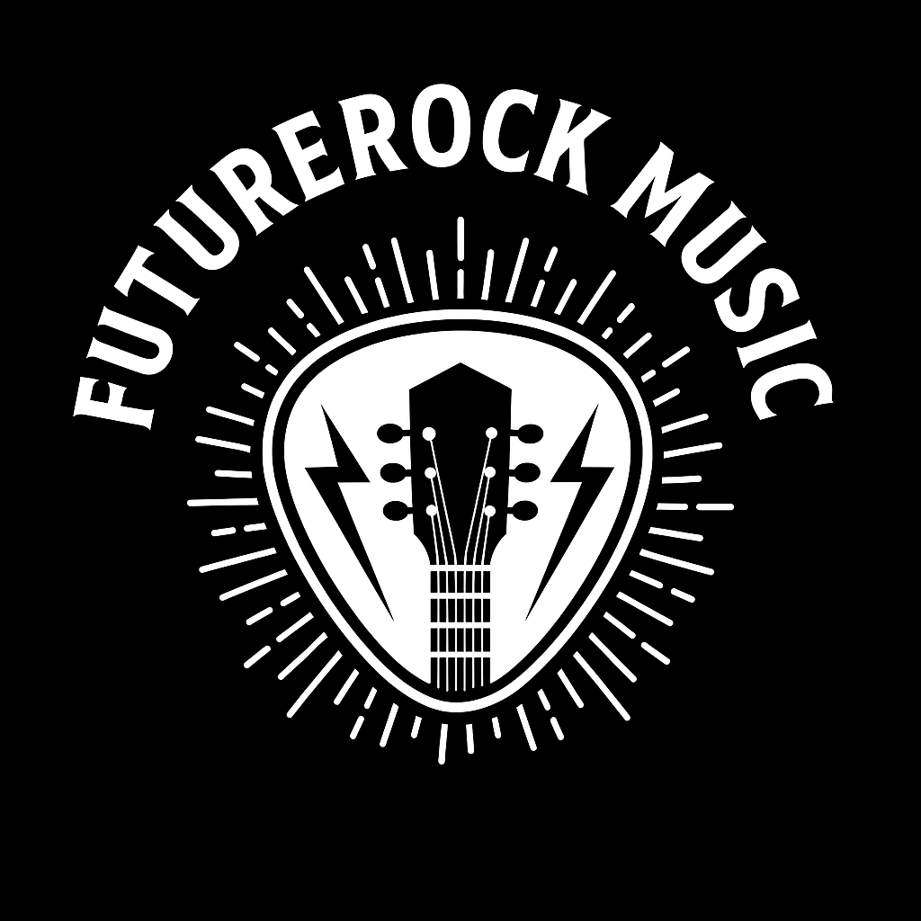
At FutureRock Music, I believe music isn’t just something to listen to. It’s something to feel, create, and live.
That’s why I deliver music in a way that’s live, exciting, and hands-on. Giving children the opportunity to truly connect with sound, rhythm, and experience playing live music.

Building Confidence Through Live Music

The National Curriculum for Music encourages children to sing, play, perform, and create. All of which naturally boost self-esteem, develop communication skills, and build confidence. But it’s how music is delivered that makes all the difference.
When music is fun, active, and interactive, children:
- Feel free to express themselves without fear of judgement
- Gain confidence through performing live in safe, encouraging settings
- Learn to collaborate and celebrate each other’s ideas
- Discover talents they didn’t know they had
- Build resilience by trying new things and learning from mistakes

Whether it’s jamming on instruments, singing on the mic, or creating beats together, children gain more than just musical skills. They develop lifelong confidence and a passion for learning.

Our Services – Music That Makes an Impact

I offer a range of energetic, engaging sessions designed to suit schools, parents, and community events.

 School Collaborations

In line with KS1 & KS2 curriculum goals, I deliver supportive music workshops and can offer performance projects that inspire learning and self-expression.

Private Music Lessons

Guitar or vocal coaching fun, relaxed, and tailored to each young learner’s style and pace.

 Party Jam Sessions

Turn birthday parties and school events into unforgettable musical experiences! Instruments, mics, and full-on fun.

Mic Skills & Confidence Workshops

Focused on helping children find their voice, these sessions boost speaking and performance confidence through rhythm, rhyme, and vocal expression.

 For Parents, Schools & Event Organisers

If you want to spark your child’s creativity, develop confidence through music, or bring energy and inspiration to your school or event — FutureRock Music is here for you.

 Email: futurerockmusic@outlook.com
 Phone/WhatsApp: 07815 664619
 Available for in-school sessions, private lessons, and public events across the region.

FutureRock Music – Where Young Talent Comes to Life
Let’s make music that matters. Let’s build confidence. Let’s rock!

