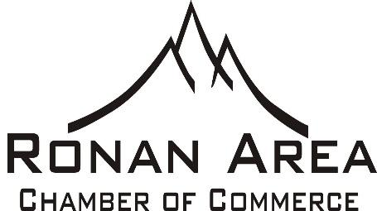
Ronan Business Community,
This message is being sent to all current & potential members of the Ronan Area Chamber of Commerce. It is that time of year again, Membership Renewal! We are excited to embark into 2022. We feel that we have a great board and staff that is full of enthusiasm, with exciting ideas for our business community and the town of Ronan!
Your membership dues make a huge difference in the success of the Chamber and its ongoing mission to promote local businesses and help grow the business community of Ronan. Membership dollars are used to run local events, promote the community both in local and state publications, work with tourism groups to promote Ronan, and staff a part-time Manager to promote & develop the Chamber. They also pay for our basic functionality of office supplies, utilities and rent. While we do ask for contributions throughout the year to further enhance events and the community, your membership dollars provide the foundation of the Chamber’s existence.
We have increased membership numbers as well as participation in local events over the years and look forward to continuing that this year and into the future.
As a Chamber our goals are to develop, implement and continue to grow exposure of the local businesses, attract new businesses and work to promote our town and business community. The Ronan Chamber of Commerce has 14 total committees that we have created, oversee and fund. These committees include Ag Appreciation, Shop Hop, Parade of Lights, Visitors Center, Crab Fest, Harvest Festival, Chamber Luncheon, Public Relations, Governance, Chainsaw Carving, Beautification, Clean-Up Day, Ranch Days and Ronan Revitalization.
We hope that you can see the value and impact that we at the Chamber of Commerce work hard to achieve and, as a result, will consider joining us. We’re better together! Please look over the membership levels to see if there is one that is right for you and your business.

Thank You,

Katie Jo Elliott,
Ronan Chamber of Commerce
(406) 314-1126

