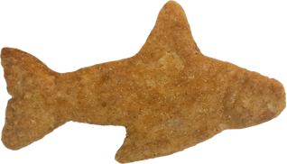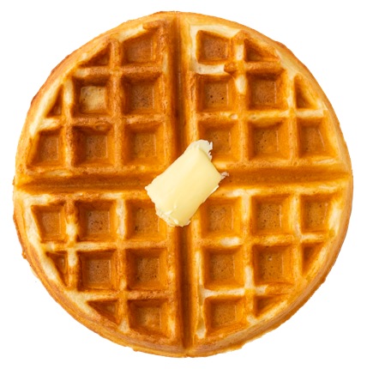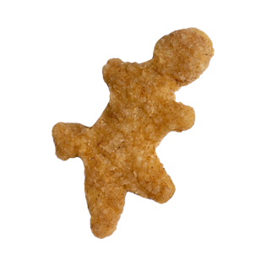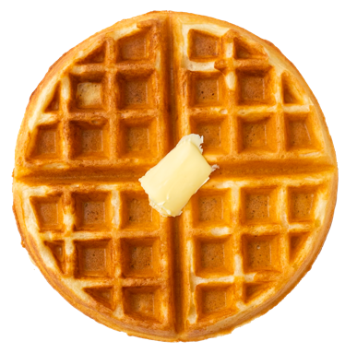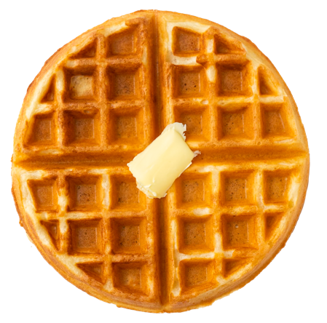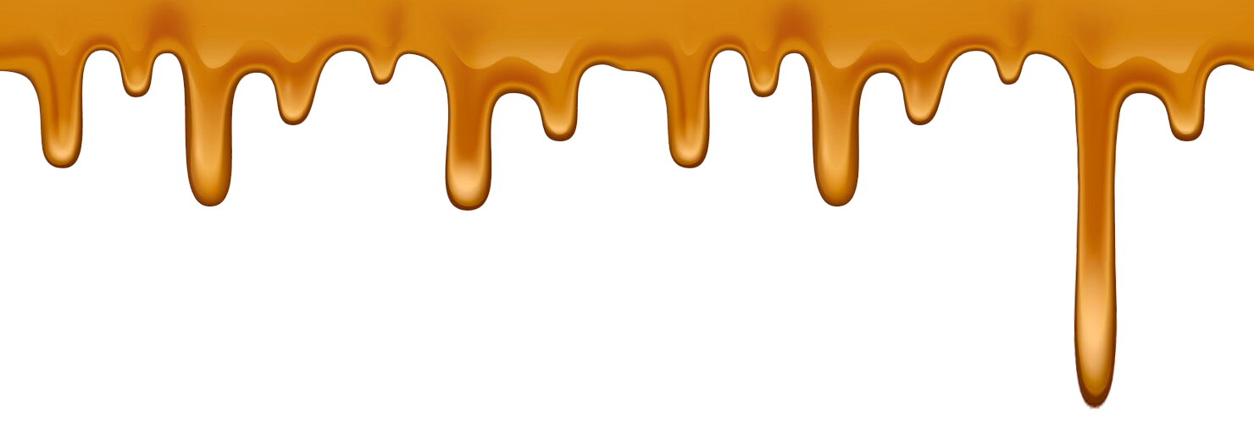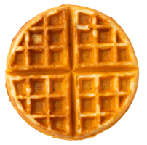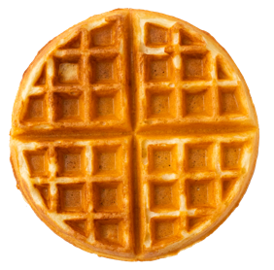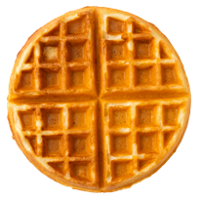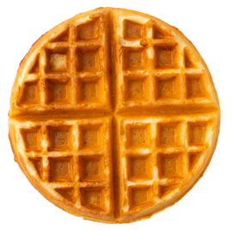

**Combine our delicious chicken nuggets with waffles and experience a famous enjoyable cafeteria meal!**

This poster uses assets from Freepik.com.

**Chicken**

**Waffles**

**‘n**