Week of December 12th!

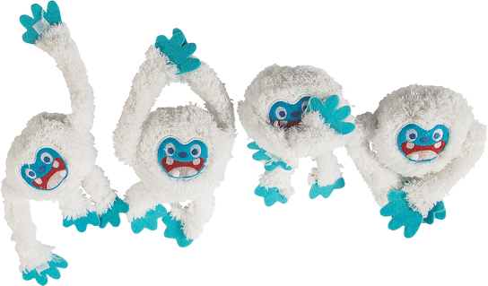Winter Wonderland

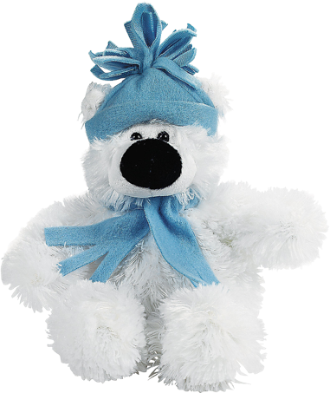

**Warm up your taste buds with winter-themed chicken nuggets and cozy up with an adorable holiday stuffed animal!**

**This poster uses assets from Freepik.com.**