This poster uses assets from Freepik.com.

Happy

Thanksgiving!

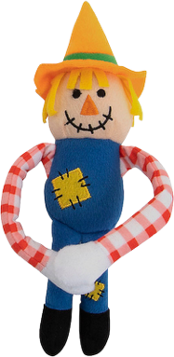**Monday, Nov 20th**

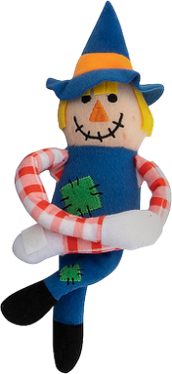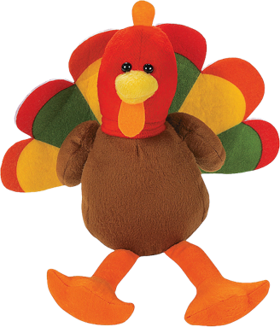

Enjoy tasty turkey-shaped chicken nuggets for your chance to win a plush turkey!