This poster uses assets from Macrovector and Freepik onFreepik.com.

**SEASON OPENER**

•TASTY STAR-SHAPED• •CHICKEN NUGGETS•

Start the season off with a home run by

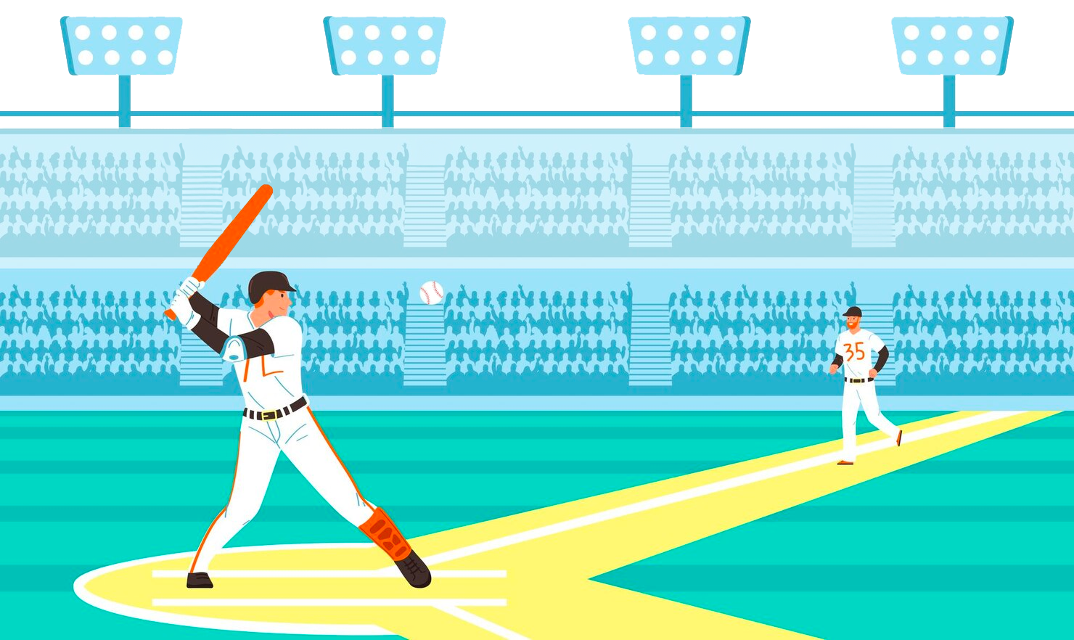munching on star-shaped chicken nuggets at lunch!