**HAPPY**

Cinco

De Mayo



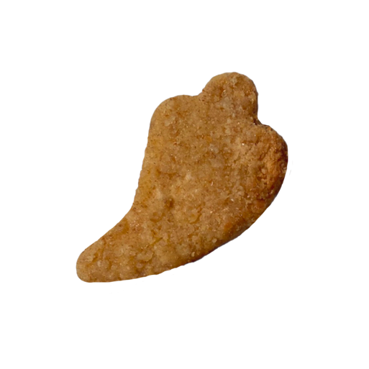**CELEBRATE**

**ON** May 5

**A celebration with**

fun chicken nugget shapes for a**

**tasty, and festive**

**Cinco de Mayo!**

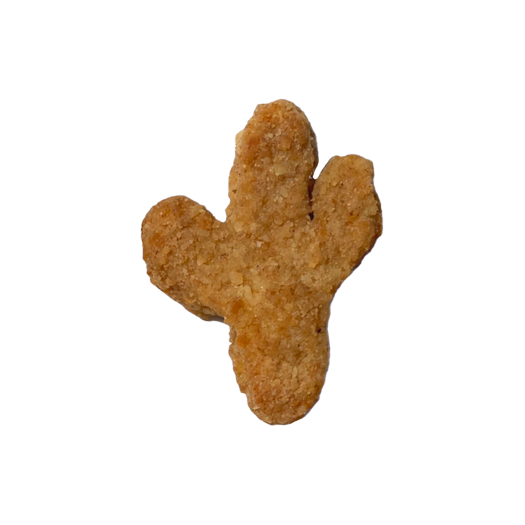

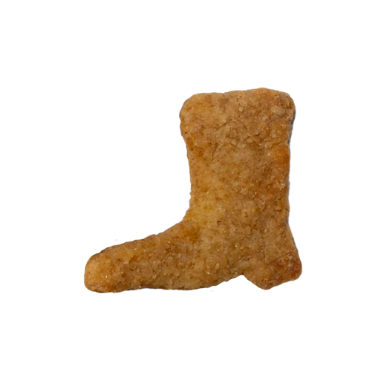

This poster uses assets from Freepik.com.