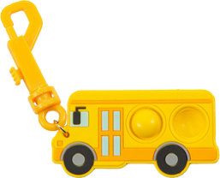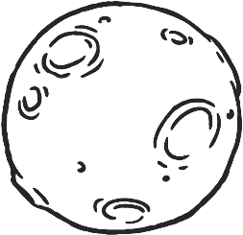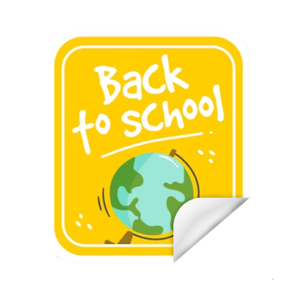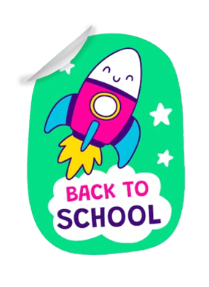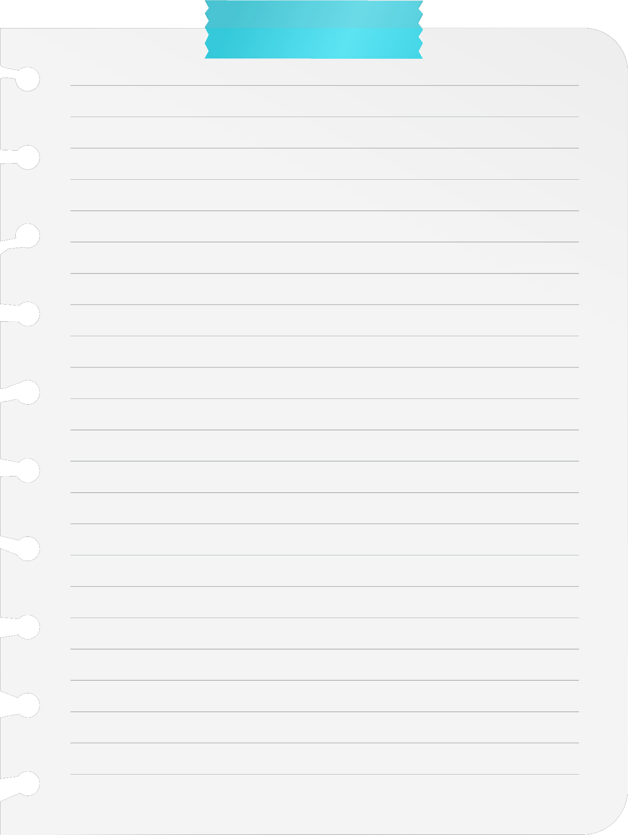

**Fun Promos!**

This poster uses assets from Freepik.com.

Back To

School

**ABC Chicken Nuggets!**

**Coming to your cafeteria**

**Aug-Sept. for back-to-school nuggets!**

**Fun-Moji Chicken Nuggets!**

