



HAPPY
This poster uses assets from Freepik.com.

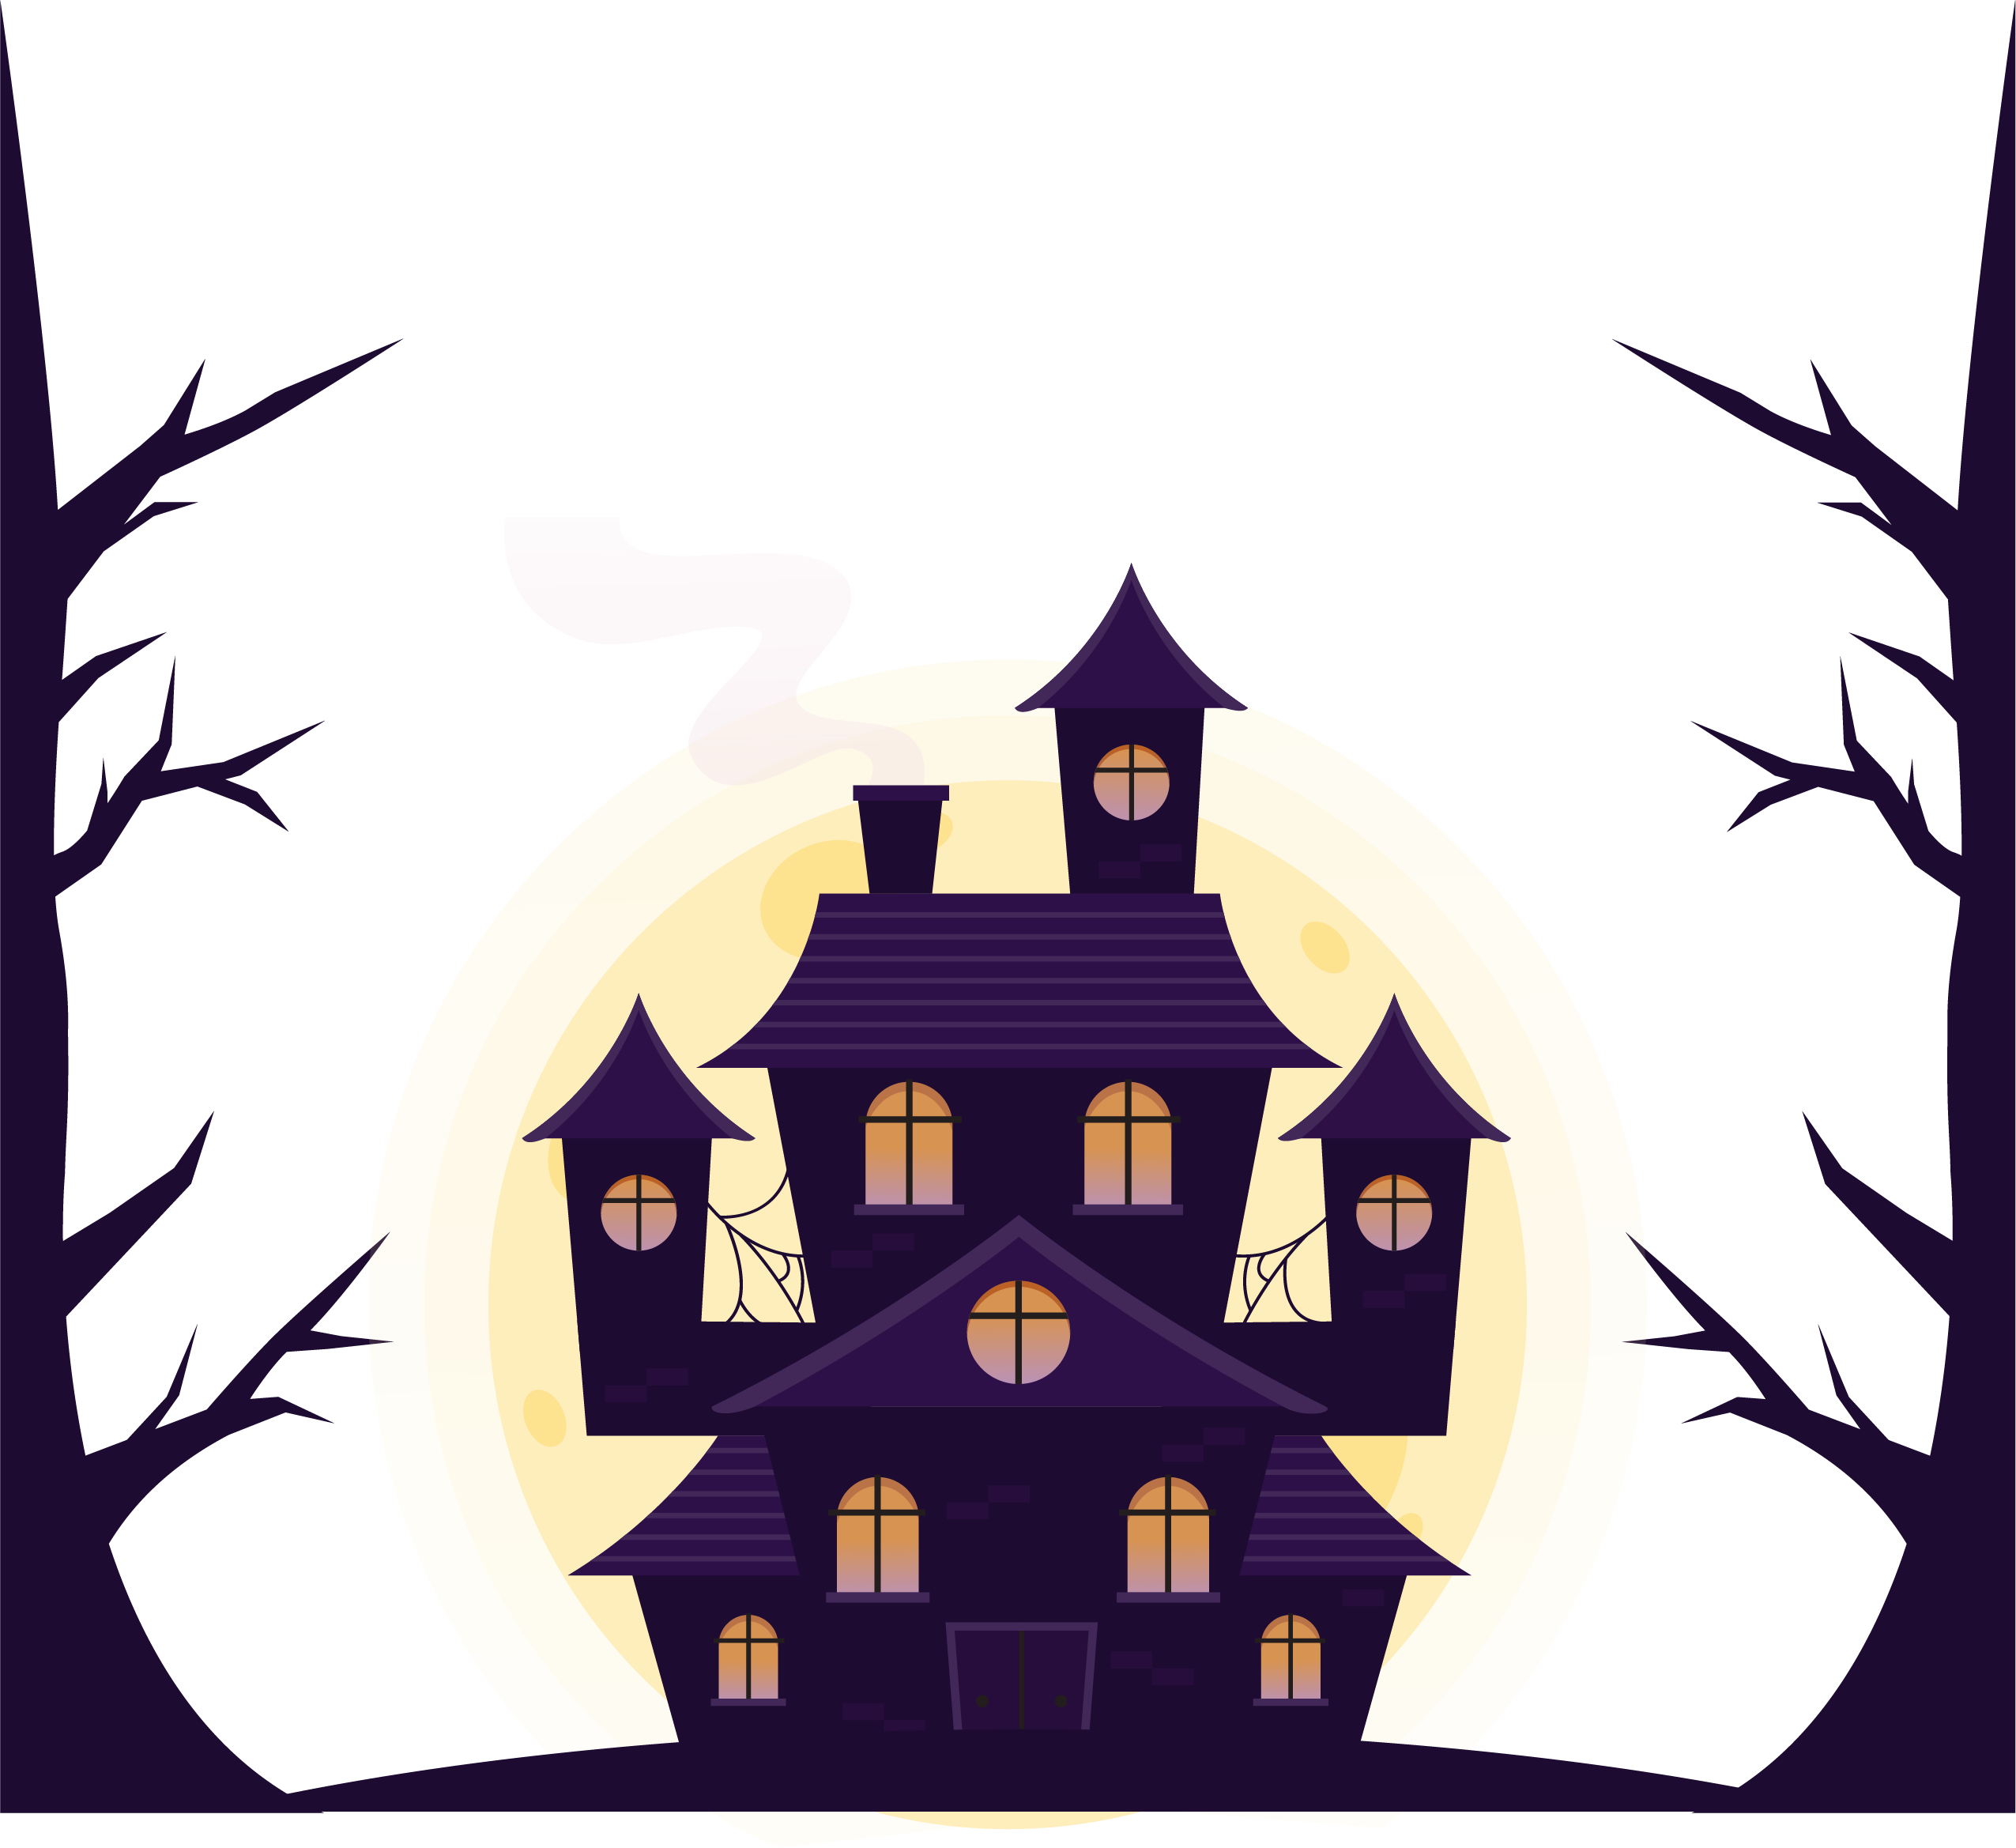
HALLOWEEN

Friday, October 31st

Let’s hang out and get a little batty while we enjoy spooky and delicious
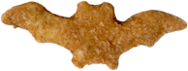
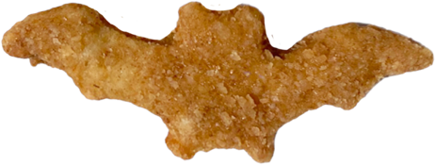


Bat-Shaped chicken nuggets.

