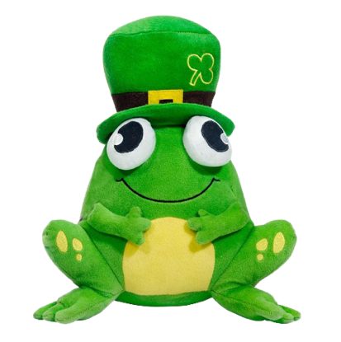****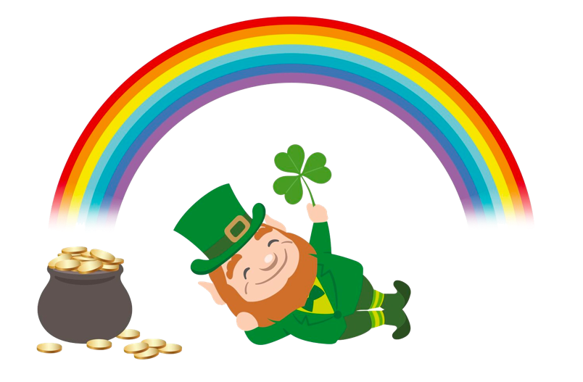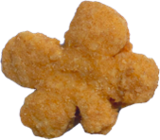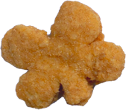

This poster uses assets from Freepik.com.

Enjoy shamrock chicken nuggets and, if you’re ***lucky***, you’ll win a shamrock

frog plushie!

Friday, March 15th!