CPAP Humidifier Cleaning and Replacement
Nearly all current CPAP machines now come stock with a heated humidification system that helps cut down on morning dry mouth as well as keeping your nasal turbinates from drying out and becoming irritated and inflamed. However, the humidification chamber needs to be cleaned out daily to prevent bacteria build-up as well as calcification. Here's how:
- Remove chamber from humidifier carefully so water doesn't enter your CPAP machine.
- Open chamber and wash with warm, soapy water.
- Rinse well with water and allow to dry on a clean cloth or paper towel out of direct sunlight.
- Fill with distilled, sterile or bottled water. It is also safe to use water from reverse osmosis systems systems. Do not use tap water as it may contain minerals and chemicals that can damage components of the machine. It is also not recommended to use filtered water (i.e. through a Brita filter) for the same reasons.
- Once a week the humidifier chamber should be soaked in a solution of 1 part white vinegar 3 parts water for approximately 15-20 minutes before rinsing thoroughly with distilled water.
- Some humidifier chambers are dishwasher safe, but make sure to check your CPAP machine's manual before cleaning in a dishwasher.
- Humidifier chambers should be replaced every 6 months or as needed.
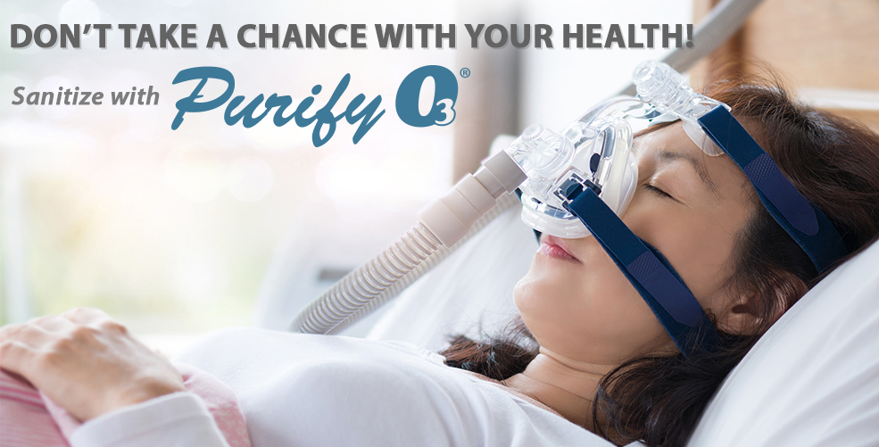

CPAP Mask Cleaning and Replacement
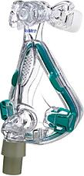
Most CPAP mask cushions are made of silicone, a gentle, non-irritating material. However, while silicone is a very comfortable material for masks, it doesn't have a very long lifespan, and without proper care can breakdown quicker than expected. Therefore, cleaning your CPAP mask is crucial in making it efficient as possible. Here's some tips on CPAP mask cleaning and replacement:
- Wash mask daily with warm water and mild, non-fragrant soap or purchase CPAP mask specific wipes and detergents.
- Rinse with water and allow to air dry on a clean cloth or paper towel out of direct sunlight.
- Before using mask at night, wash your face thoroughly and don't use facial moisturizers. Facial oils and moisturizers can breakdown the silicone faster.
- Once a week soak mask in solution of 1 part white vinegar 3 parts water before rinsing in distilled water.
- Headgear and chinstraps should be washed as needed by hand using warm soapy water, rinsed well, and air dried. Do not place headgear or chinstraps in washing machine or dryer.
- For replacement schedules of CPAP masks you should check both your manufacturer's recommendations and your insurance allowance. However, for most masks it is recommended that you replace the cushions 1-2 times per month, and the mask every 3-6 months.
- CPAP tubing should be cleaned weekly in a sink of warm, soapy water, rinsed well, and left to hang-dry out of direct sunlight.

CPAP Filters Cleaning and Replacement
Your filters are located near the back of the CPAP machine where the device draws air from the room that it compresses to your pressure settings. Nearly all CPAP machines have a disposable white paper filter and some have an additional non-disposable grey filter as well. Here are some cleaning tips for your CPAP filters:
- You should clean the grey non-disposable filter at least on a weekly basis. You may have to clean it more regularly if you have pets, smoke inside your house, or if your home is especially dusty.
- Rinse grey filters with water and allow to dry before placing back into your machine.
- The grey re-usable filters should be replaced when it begins to look worn or after 6 months.
- Replace disposable white paper filters monthly or more frequently if it appears dingy or dirty.
- Your CPAP machine itself does not need to be cleaned but you may want to dust it down with a slightly damp cloth as desired.

General CPAP Maintenance & CPAP Cleaning Tips
- Make your CPAP equipment cleaning part of your morning routine, allowing the equipment ample time to dry during the day.
- Keep machine and accessories out of direct sunlight to avoid damaging them.
- Never use bleach to clean accessories.
- Other machine accessories such as power cords and data cards may need to be replaced due to equipment malfunctions.
- Place machine on a level surface away from objects such as curtains that may interfere with the air intake.
- Always use distilled or sterile water when cleaning components.
- Keep track of when you should order replacement parts for your mask and accessories so that you always get the most out of your therapy.

CPAP Compliance
- Medicare requires a download of 30 consecutive days of usage within the first 90 days after setup. A download shows how often you are using the machine and notifies us if there are any issues with mask leakage or use. You are required to have a face to face visit with your doctor as soon as you become compliant (30 consecutive days of 4 hours or more per night). Please let your technician know when you are scheduled to see your physician. Your doctor then must provide us with chart notes of that visit in order for Medicare to continue coverage of your machine and supplies. The PAP machine is a rental for (13) months with Medicare. Most commercial/private insurances follow suit with Medicare guidelines. Contact your insurance company for more specific details.
- We will follow up with you at the 3rd week and 5th week after your setup. This is so we can verify that you are using the machine and that you aren’t having any issues or concerns. Please let your technician know how you would like to be contacted. We can call, text, or email.

Thank you for allowing us to help you with your PAP therapy needs!

