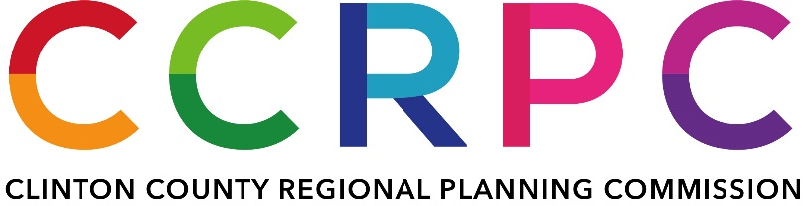

AGENDA

*Service Director’s Conference Room*

*Wilmington Municipal Building*

*69 N. South Street, Wilmington, OH 45177*

*September 14, 2023*

*4:00 p.m. Local Time*

1. **CALL TO ORDER**
2. **ROLL CALL**
3. **APPROVAL OF AGENDA**
4. **OLD BUSINESS**
5. **NEW BUSINESS**
   * **Creation of RPC nominating committee**
   * **Board meeting decorum**
     + **Pre-meeting starting with October RPC Meeting**
     + **Rules of decorum for public comment**
     + **Periods for public comment (opening and closing). Time limits for speakers.**
     + **Roberts Rules of Order**
   * **A/V equipment for meetings**
   * **Joint zoom license with the Land Bank**
   * **RPC Marketing**
6. **ADJOURNMENT**