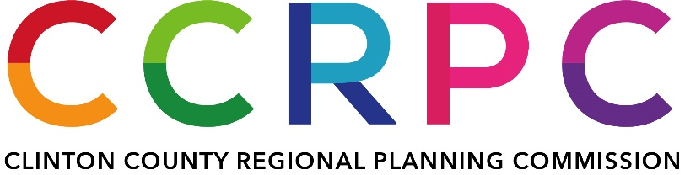

AGENDA

*Service Director’s Conference Room*

*Wilmington Municipal Building*

*69 N. South Street, Wilmington, OH 45177*

*November 13, 2023*

*4:00 p.m. Local Time*

1. **CALL TO ORDER**
2. **ROLL CALL**
3. **APPROVAL OF AGENDA**
4. **OLD BUSINESS**
5. **NEW BUSINESS**

* **Financial report**
* **Budget update**

1. **ADJOURNMENT**