**SHOWMANSHIP**

**Classes: #2 Hunt Seat Stock-Type**

**#6 Field Hunter**

**#40 Western Stock-Type/Saddle Pleasure**

**B**

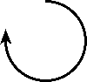

**J**

**A**

**Be ready at Cone A**

**Trot to Cone B**

**Back 4 Steps and Perform a 270° Turn**

**Walk to Judge for Inspection**

**After Inspection Perform a 90° Turn**

**Walk to Line-Up**

**SHOWMANSHIP**

**Classes: #2 Hunt Seat Stock-Type**

**#6 Field Hunter**

**#40 Western Stock-Type/Saddle Pleasure**

**B**

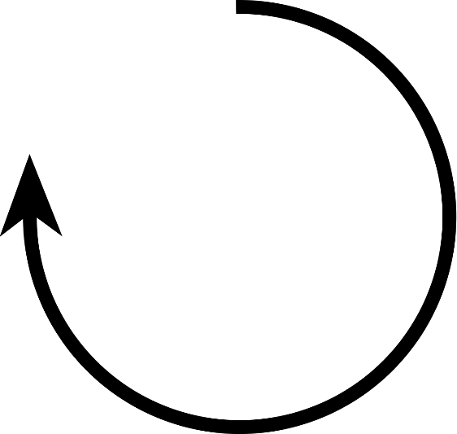

**J**

**A**

**Be ready at Cone A**

**Trot to Cone B**

**Back 4 Steps and Perform a 270° Turn**

**Walk to Judge for Inspection**

**After Inspection Perform a 90° Turn**

**Walk to Line-Up**

**SHOWMANSHIP**

**Classes: #3 Hunt Seat Youth**

**#4 Hunt Seat Adult**

**#5 Hunt Seat 12 & Under**

**J**

**B**

** A**

**Be ready at Cone A**

**Back 4 Steps and Perform a 180° Turn**

**Trot to Cone B and Perform a 90° Turn**

**Walk to Judge for Inspection**

**After Inspection, Walk to Line-Up**

**SHOWMANSHIP**

**Classes: #3 Hunt Seat Youth**

**#4 Hunt Seat Adult**

**#5 Hunt Seat 12 & Under**

**J**

**B**

** A**

**Be ready at Cone A**

**Back 4 Steps and Perform a 180° Turn**

**Trot to Cone B and Perform a 90° Turn**

**Walk to Judge for Inspection**

**After Inspection, Walk to Line-Up**

**Ranch Ground Handling**

**Class #41**











**Trot on Long Line**

**Halt and Perform a 180° Turn**

**Back Through Cones**

**Perform a 90° Turn on the Forehand**

**Side Pass over Ground Pole**

**Ranch Ground Handling**

**Class #41**











**Trot on Long Line**

**Halt and Perform a 180° Turn**

**Back Through Cones**

**Perform a 90° Turn on the Forehand**

**Side Pass over Ground Pole**