[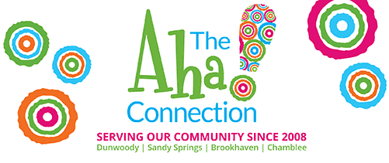](https://www.theahaconnection.com/)

Top of Form

Email NewsletterBottom of Form

Top of Form

* [**Aha! Originals**](https://www.theahaconnection.com/__trashed-2/)
* [**Businesses**](https://www.theahaconnection.com/__trashed-2/)
* [**Camps**](https://www.theahaconnection.com/__trashed-2/)
* [**Classifieds**](https://www.theahaconnection.com/__trashed-2/)
* [**Community**](https://www.theahaconnection.com/__trashed-2/)
* [**Education**](https://www.theahaconnection.com/__trashed-2/)
* [**Food**](https://www.theahaconnection.com/__trashed-2/)
* [**Pets**](https://www.theahaconnection.com/__trashed-2/)
* [**Real Estate**](https://www.theahaconnection.com/__trashed-2/)

**Pink Box Partners – Created by Women in Dunwoody – Little Box ~ Big Support**

[All about Pink Box](https://pinkboxpartners.com/about-pink-box)

A non-profit dedicated to supporting women facing breast cancer, uplifting their spirits and reassuring them they are never alone.

[Meet the Team](https://pinkboxpartners.com/our-team)

Donna Baumstark, Janna Benston, Ginger Bethune, Pam Bolton, Anne Covington, Holly Covington, Missie MacGinnitie, Katherine Ruzich, Hendie Salton, Ginger Schlanger, and Chrissy Scott.  Founded in 2025, Pink Box Partners Inc. was born from the hearts of eleven women who each shared a deeply personal connection to breast cancer. Whether they had battled it themselves, supported a loved one through treatment, or grieved the loss of someone they loved, these women came together with one shared mission: to show love, strength, and unwavering support to women fighting breast cancer. Gathering around a table in Dunwoody, Georgia, they poured their passion, pain, and purpose into something greater than themselves.

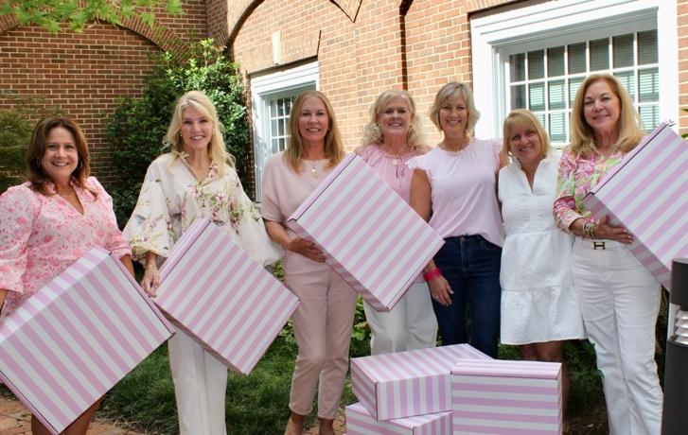

[Donate Now](https://pinkboxpartners.com/2025-kick-off-campaign)

Pink Box Partners is a 501(c)(3). EIN 39-2419874  
Our pink boxes are gifted to women facing breast cancer, providing comfort to those who are facing a difficult challenge. Included in these boxes are notes of encouragement, comfy wrap or blanket, all natural skin care products and other special items that will make a woman feel cared for. We curate each box with a specific goal of lifting spirits at such a critical time. We’ve joined forces with businesses and healthcare partners to ensure these Pink Boxes turn caring hearts into tangible comfort.

[Peek inside a Pink Box and/or request a Pink Box](https://pinkboxpartners.com/request-a-pink-box)

If you’re interested in sending someone a Pink Box, start by submitting a request [here](https://pinkboxpartners.com/request-a-pink-box). Please complete all fields, and click “submit request” when finished. We will contact you and get additional details about your requested Pink Box!

Follow Pink Box:

* [Website](https://pinkboxpartners.com/)
* [Facebook](https://www.facebook.com/profile.php?id=61581391891310)
* [Instagram](https://www.instagram.com/pinkboxpartnersinc/)
* [LinkedIn](https://www.linkedin.com/company/pink-box-partners-inc/posts/?feedView=all)

*October 6th, 2025 Category:*[*AHA News*](https://www.theahaconnection.com/category/aha-news/)*,*[*Community News*](https://www.theahaconnection.com/category/community-news/)

**If you like this, share it**

**Post navigation**

[< Previous](https://www.theahaconnection.com/p230398/)

[Next >](https://www.theahaconnection.com/marlows-tavern-late-night-combos/)

Top of Form

Bottom of Form

Top of Form

Bottom of Form