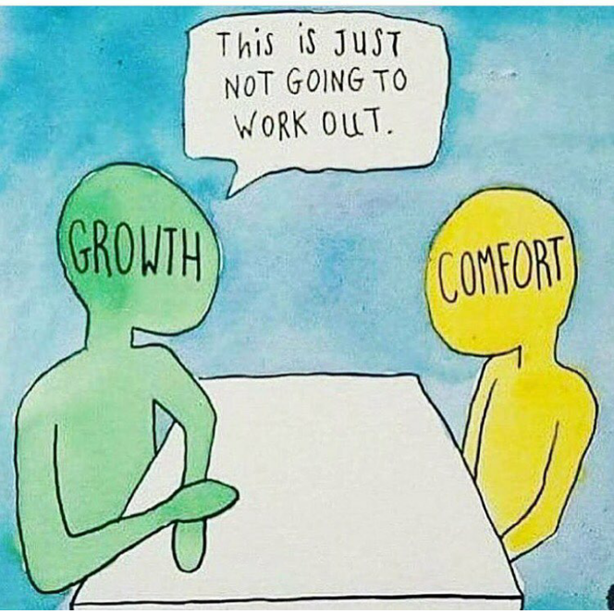
Comfort is the worst.
It’s crippling. It’s limiting. It’s a liar.
But Justin, isn’t comfort the ultimate end goal? No! As soon as you find comfort, you begin forfeiting any kind of further exponential growth! You have now leashed yourself to an arms-reach range of tangible success. So as soon as you agree to a specific amount of comfort, you sacrifice an equal amount of growth! Let me ask you something; what feels better? Challenging yourself to conquer a new goal and reflecting on how hard you worked to achieve it once you do or going through a passive life of getting by doing only what you think you can do? Even if “getting by” is better than most, you will always remember the moments of growth over times of complacency. So why limit yourself to never feeling that?
So what does growth take?
Focus.
Motivation.
Desire.
If you want something that you do not have, something that requires adaptation, then do what you have to do to achieve it. Period. There are those out there who will try to keep you in their box of normality because they feel they are entitled to limit you to the mediocracy of their own life and their own ambition. To become extraordinary, you must outwork the standard, you must progressively out-work your OWN standards. Do not fear the unknown. Do no fear the failures you will encounter in life. Embrace that you are given these opportunities; opportunities that time and efforts transforms into successes. Remember, the unknown can only remain unknown if you do not venture into it and failure can only remain failures if you stop attempting. So do not stop. Do not settle. Break standards.
If you are reading this, don’t doubt in your ability to be great. You are searching ways to be great so don’t question if you have what it takes. You do! Your actions will always follow your focus so remain diligent and grind; even if others doubt you. Work. Basing your self-worth on the opinions of others or because what life throws at you will quickly limit any truth growth. Life isn’t fair and people use that as crutch to be weak; to stay weak. They hold themselves to a low standard because they are not handed everything or because someone once told them they were not good enough. If life has given you a disadvantage, overcome it and use to inspire. Don’t use it to lean on, use it to motivate!
So how do we grow?
Growth requires you to keep your eyes up, your head forward, and one foot in front of you pushing towards your goals. It’s important to understand that the work always comes before the belief. That even if you think you are going to fail, you will have to put in the work before the opportunity of possibly succeeding comes. That in fact, you are more than likely to fail, and that’s okay! This is where we grow, learn, and adapt.
We often get reminded by people how we shouldn’t do something or can’t do something. How if we overly commit to anything that that specific person doesn’t understand we are deemed weird, crazy, or even obsessed. Obsession is a term that society seems to look down on, but obsession is needed to stand out. Obsessed is needed to be great. There are going to be potentially thousands of people competing for your same dream, so what are you doing to be better than them? Are you just working hard or are you being obsessed?

I recall reading from an Old English proverb once, “A smooth sea never made for a skilled sailor.”—Meaning if you want to be great, if you want to have true success, then prepare for strife along the way, failures to completely capsize your life, and a boat full of people doubting you. It’s these waves that we face that make us stronger and better prepared in life. If you have a goal, then take the hits that will be thrown your way to reach it. It just makes achieving it all that much more rewarding. Learn to love every part of the process. More times than not it’s looking back on the journey that’s the most memorable. Every single day is a new opportunity to show the world that you will not be defeated. Start by removing the words “I deserve” from you vocabulary and just put in the work and remember, you have to walk in the mud if you expect to leave your footprint in this world so quit running from the stress, quit running from the fear, quit running from the anxiety, and quit chasing comfort.

