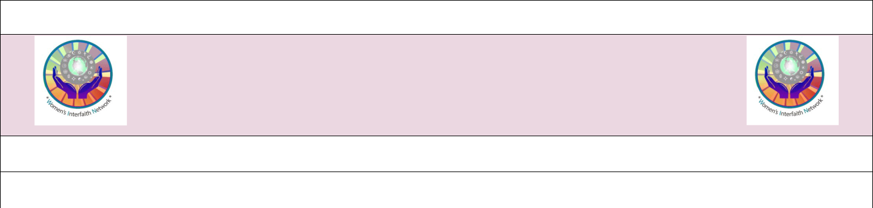
ANNUAL MEMBERSHIP APPLICATION

WOMEN’S INTERFAITH NETWORK

contact: susanskovronek@gmail.com

Membership is open to all women in the Sarasota-Manatee area.

Renewing Member ____ New Member____ | Birthday: Month /___Day /___
NAME: | EMAIL:
ADDRESS: | PHONE:

Your religion and/or congregation:

ACTIVITIES
Check below any activity in which you are interested; the facilitator will contact you.

COMMON TABLES

Sarasota Common Tables, check here: ___ Venice Common Tables, check here: ___ PLEASE NUMBER YOUR TOP TWO CHOICES FOR A COMMON TABLE MEETING TIME:

________ Monday Lunch ________ Tuesday Lunch _______ Wednesday Lunch

________ Thursday Lunch ________ Friday Lunch _______ Saturday Lunch

________ Sunday Afternoon

* We attempt to have each group represent women of different faith traditions and different congregations.

BETTY’S BOOK CLUB

We meet on the 4th Monday of each month at 10:30 a.m. at the North County Library, or on Zoom.
If you are interested in Betty’s Book Club, check here: ____

WOMEN OF FAITH BOOK CLUB

We meet monthly on the 3rd Thursday from 10:00 a.m. to noon at a member’s home, or on Zoom.
If you are interested in Women of Faith Book Club, check here: _____

MOVIE GROUP ___ MEMOIR WRITING ___ ETHNIC COOKING ___

Check the one (s) you are interested in.

If you wish to volunteer your skills and experiences, we’d love to learn about them here:

I grant WIN permission to post photos of me on its website: Yes __ No__

I grant WIN permission for my name, email and address be included in the Directory: Yes __No__ I agree that the information in the Directory can only be used for WIN purposes and if it is misused, I may be dismissed: Yes __

