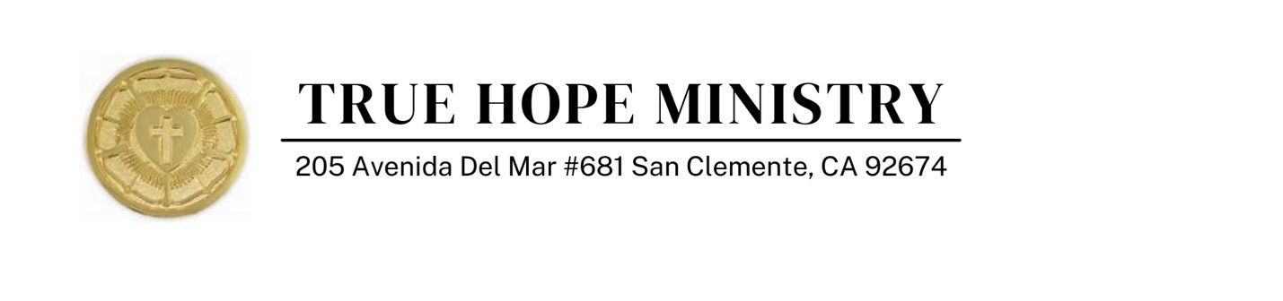

As an ordained Pastor and head of TRUE HOPE Ministry since 2011, I am writing to affirm xxxxxxx xxxxxxx xxxxxxx sincerely held religious objection to masks, covid tests and vaccines.

For the purpose of seeking a religious exemption, the organization receiving the request may only make a reasonable inquiry into the sincerity of the individual’s claim. This letter provides above and beyond what is required or expected in seeking a religious exemption. According to Title VII of the Civil Rights law, RELIGIOUS BELIEFS MUST BE ACCOMMODATED.

Please note that every believer is a member of the Body of Christ, regardless of one’s geographic region. The individual for whom I am providing this letter of attestation does not have to prove any attendance in any particular church, length of time of religious conviction, nor does one’s sincerely held religious belief have to be aligned with any formal religion according to state and federal laws. Again, the federal law protects each individual’s right to one’s religious and/or sincerely held ethical or moral beliefs.

We as believers in Jesus Christ as Lord and Savior believe in the tenets of the Holy Scriptures which state we are made in the image of God as image-bearers of God. We will be called into account for all we do – including what we do to our bodies! To be forced to do something which violates our beliefs is to sin against God.

The veiling of the face is a Muslim practice of submission to Allah. Xxxxxxx xxxxxxx xxxxxxx is not Muslim and is unable to violate his sincerely held religious beliefs by engaging in a Muslim religious practice. Requiring xxxxxxx xxxxxxx xxxxxxxx to veil his face with any sort of face covering, mask or shield -- which is a violation of his religious beliefs -- would be akin to requiring a Sikh to remove their turban, which would violate Sikh beliefs.

God breathed the breath of life into man, and man became a living soul. It is an affront to our Creator to be forced to veil the face and restrict our God-given breath. God created human beings with only two airways – the nose and mouth. We do not breathe through our ears. God breathed into the nostrils of man.

“God breathed into his nostrils the breath of life and man became a living soul.” (Gen 2:7) "The breath of life from God entered them.” (Rev 11:11)
We are clearly told by the Lord to stand before him with faces UNVEILED.

"And we all, who with unveiled faces contemplate the Lord's glory, are being transformed into his image with ever-increasing glory, which comes from the Lord, who is the Spirit." (2 Cor 3:18)

Covering the nose and mouth and concealing one’s identity is shown to us in the Bible as activities done by prostitutes and those who turn their faces from God in shame.

“When Judah saw her, he thought she was a prostitute, because she had covered her face.” (Gen 38:15)

Further, the use of masks as a protection against covid is under an “emergency use authorization” which places them in the category of a medical experiment. For many Christians, using the body for medical experimentation is an affront to our sincerely held belief that it would be a sin against God.

Regarding covid tests and vaccines, they are under an “emergency use authorization” by the FDA which places them in the category of a medical experiment. Aside from the fact that covid tests and majority of vaccines like flu and meningitis vaccines are completely unreliable, the tests are known to produce false positives and regular covid testing could damage the body because the substances in them are harmful. Tests and vaccines are intrusive and unnecessary in the eyes of a Christian. As believers, we know that the body is the temple of the Holy Spirit and as such, should not be used for medical experimentation. We are called to protect the body and not participate in pharmakeia.

“Do you not know that your bodies are temples of the Holy Spirit, who is in you, whom you have received from God?” (1 Cor 6:19)

Overall, it does not matter whether or not any vaccines or tests are under an emergency use authorization or that they gain complete FDA approval. What matters is that it is an affront to a Christian to inject their body with a man-made substance in an effort to “improve” the immune system or insert a dubious object into one’s body to detect an asymptomatic illness. God has already created the body with mechanisms to identify and ward off disease.

For any believer who may have had childhood vaccines or even a recent flu vaccine, that does not contradict the person’s desire to decline the covid vaccine. Some people may not have been aware that many of these vaccines have been cultured in aborted fetal tissue and carry the DNA of a male aborted baby. This is appalling to any believer.

The law states that a person’s activities – what activities they participate in, and what activities they refrain from, are a part of one’s religious expression. “Religious creed,” “religion,” “religious observance,” “religious belief,” and “creed” include all aspects of religious belief, observance, and practice that are part of an individual observing a religious creed. Taking a covid test or a vaccine or wearing any sort of face covering or shield is an affront to Charles William Ledford’s sincerely held religious beliefs. I concur with and affirm his sincerely held religious beliefs.

Therefore, I attest that xxxxxxx xxxxxxx xxxxxxx has the lawfully protected right to seek a religious exemption from activities that are offensive to his sincerely held religious beliefs. I would accept a phone call from your institution to discuss this further Biblically, morally, ethically, spiritually, and constitutionally. You may reach me at 949-355- 3927.

