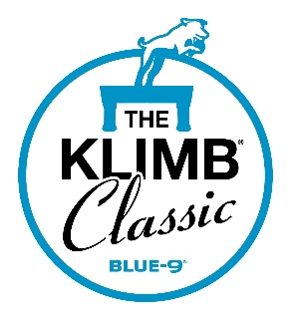

Official Premium for the Following:

Coursing Ability Tests
At
The 2026 Klimb Classic
Hosted by
Clinton Iowa Kennel Club
Licensed by the American Kennel Club
July 10 – 12, 2026
Jackson County Fairgrounds
1212 E Quarry St
Maquoketa, IA 52060

Fenced in Grass Surface with a Continuous Loop Lure and White Trash Bags for Luring
Entries Open May 26th, 2026
Pre-entries Close July 1st, 2026 at 5:00 PM

Open to all AKC Registered and Mixed Breeds (via AKC Canine Partners)

Event Numbers
Friday: 2026099209, 2026099214
Saturday: 2026099210, 2026099211
Sunday: 2026099212, 2026099213


These coursing tests are dedicated to the memory of our dear friend, Matt Gerdes.

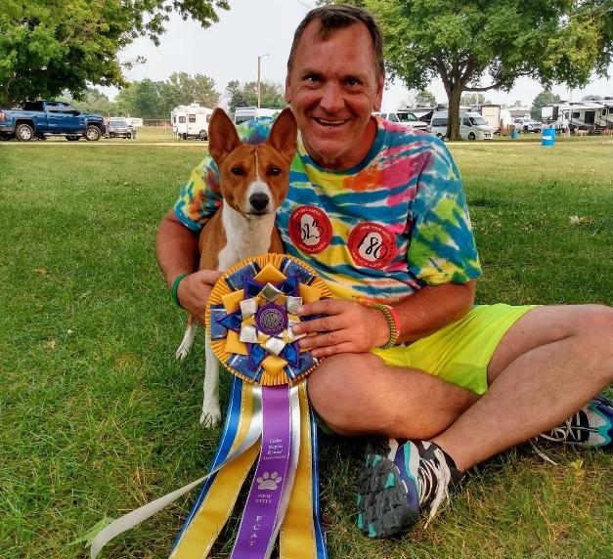

CIKC Club Officers

President: Zina Becker
Secretary: Sarah Horr
Vice President: Daryl Witt
Treasurer: Marie Appel

Inspection/Field Committee
Amanda Chase, Lana Luhring, Zina Becker, Daryl Witt, Marie Appel, Tricia Green, Jan Varner, Floss Bilger, Kayla Loussart, Darcy McBroom, Phil McBroom, Kim Martin, Kody Evers, Lynelle Mellecker, Sarah Horr, Becky Blevins

Committee members may be substituted as needed due to various circumstances.

Field Test Chair:
Zina Becker
2564 300th Ave
DeWitt, IA 52742
563-219-2025
rozilabs@hotmail.com
Field Secretary:
Amanda Chase
65 W Post Rd NW
Cedar Rapids, IA 52405
319-560-3710
chase.amanda.kim@gmail.com

Lure Operators: Danny Terry and Nic Chase
Judges: Marie Appel, Tricia Green, Danny Terry, Nic Chase

Entry Fees: The pre-entry fee is $25 per run. Entries after closing are $30 per run.

Day Of Entries: Day of entries will be taken from 7:30 AM to 11:00 AM each test day or until limits are met.

Fun Runs: The cost is $5 per fun run and will be donated to a charity of the club’s choosing. CASH ONLY FOR FUN RUNS!

How to Enter/Payments: Pre-entries are ONLINE ONLY. To enter, go to Secreterrier.com. If you do not already have a Secreterrier account you will need to set one up.

Field Hours: Check in will open at 7:30 each day. NO DOGS AT CHECK IN. You will check in for all the runs for all your dogs. Check in must be completed by 11:00 AM each day.

Inspections will begin at 8 am and will be held until the completion of the day. First dog on the line after inspections begin. Do not inspect until you are ready to run your dog. You must have at least 1 hour available to run your dog. If you leave to go to another event before running your dog, you will need to reinspect and get a new run #.
All dogs must be inspected by 3 PM on Friday and Saturday and by 2 PM on Sunday.
Fun runs will be available on Friday and Saturday, starting at 3 PM. Priority will be given to registered runs.

Roll Call: We will be using a rolling roll call. When you inspect you will be given a run #. If you miss your run # you will need to inspect again and get a new run #. This helps ensure that your dog didn’t run another event and possibly injure themselves.
There will be a whiteboard displaying the run # currently being served.

Awards Offered: A qualifier ribbon will be available to dogs that qualify. Title ribbons will also be available for dogs earning a new title, along with a gift.

CAT Basics:
COURSE DESIGN
The course shall be designed with safety for all breeds as a primary consideration. There shall be no turns more acute than 90 degrees. The total length of the course shall be no less than 600 yards and should be as close to 600 yards as possible. Dogs run singularly in Coursing Ability Tests. Depending on the size and breed of dog, the dog will run either the full course or a 300-yard course. The 300-yard distance shall be clearly marked. Safety is of utmost importance. The judge is responsible for walking the course prior to the start of the event in order to look for hazards.
DISTANCE AND MAXIMUM TIME
300-Yard Course – This distance is for dogs shorter than 12 inches at the withers and/or brachycephalic (“flat-faced”) dogs. A veteran dog may run 200 yards at the owner’s discretion. A dog must complete this course in less than 1 ½ minutes. 600-Yard Course – This distance is used for all dogs that do not run the 300-yard course. A veteran dog may run 400 yards at the owner’s discretion. A dog must complete this course in less than 2 minutes. If there is a question whether a dog should run the 300- or 600-yard course, the judge will decide.
COLLAR/PARAPHERNALIA
Dogs may wear any collar except a choker collar, a collar with prongs, or an electronic training collar. The collar should be snug to minimize the chances of getting hung on something during the run. The event committee may, at its discretion, require removal of tags (or securing with tape) to ensure the dog’s safety. Owners may use clips or rubber bands to hold the dog’s hair. The owner assumes responsibility for the safety of the dog with regard to the dog’s collar and paraphernalia. Harnesses or head halters may be used on the grounds but must not be worn while running the course.
TITLES
Coursing Ability (CA) – Awarded to a dog that passes the Coursing Ability Test three times under at least two different judges.
Coursing Ability Advanced (CAA) – Dog passes the Coursing Ability Test a total of 10 times. Coursing Ability Excellent (CAX) – Dog passes the Coursing Ability Test a total of 25 times. A numbered title will be awarded for every additional 25 passes.

Accommodations:

Camping available on site:

Jackson County Fairgrounds
563-652-4282

Highway 62 Campground (across the street)
403 IA-62 Maquoketa, IA
Highway62rvpark.com
563-212-2227

Hotels:

*Owners must assume full responsibility for their pets. Early registrations are recommended. Please pick up after your dog at hotels.

AmericInn by Wyndham Maquoketa
1910 Nairn Drive, Maquoketa, Iowa 52060
563-652-0222

Econolodge
1019 West Platt Street, Maquoketa, Iowa 52060
563-652-6888

Show Veterinarian:

Animal Emergency Center of the Quad Cities
2810 State St, Bettendorf, IA 52722
563-344-9599

