Application & Waiver: The St. Patrick’s Day Parade, March 14, 2026
Hibernian Princess Honor Court

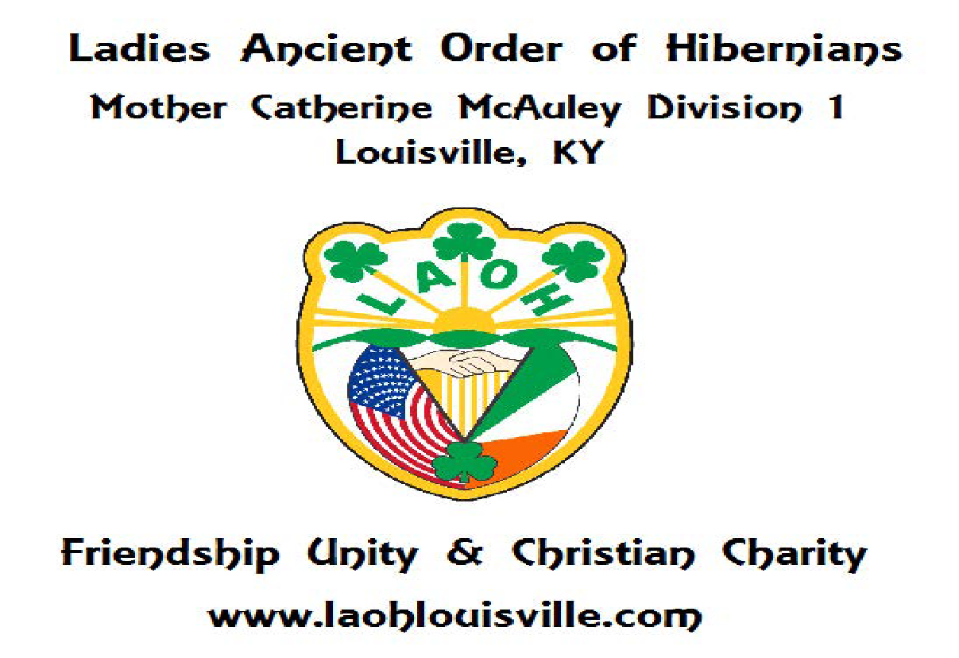
Deadline for Submission: March 8, 2026
Send application to jagwood4@gmail.com , megandunlevy@gmail.com (LAOH Division President) and clara.fulkerson@stgregoryparish.org
Selection: The Honor Court represents future generations of the LAOH. Being a Princess provides an opportunity to experience what it means to be a Hibernian, and the cultural heritage and traditions of Ireland. A total of at least six (6) princesses will be chosen from the following categories: age 6-9; 10-13; and 14-17. In the event that not all positions are filled, we will eliminate the age category limit of 2 per age range. Participants will be provided with a sash and a tiara to wear on Parade Day, which they can keep as a memento. The President of the Junior LAOH Division will be head of the Court and will be a role model of our Motto: Friendship, Unity, and Christian Charity.

Eligibility: To become a Hibernian Princess, the applicant shall be the daughter, granddaughter, niece, sister, or cousin of a member of the AOH or LAOH. Princesses will help represent the Louisville Hibernians on parade day. Participants must be age 6-17 and MUST have an assigned adult (parent, etc) walk with them in the parade. All parade participants must wear the parade pin to be identified as a participant

Responsibilities of a Princess: The Honor Court will greet parishioners and hand out mass programs at the St. Patrick’s Parade Day Mass as they enter parade day Mass at St. Brigid. This year, we will encourage the Hibernian Princess Court to appear on WDRB’s TV spot on March 7th (6AM) at O’Shea’s Irish Pub. Princesses fill other duties on parade day as needed but will have prior notice of said activity by the LAOH Division. The Honor Court will either ride on the LAOH parade float or march with the LAOH in the annual St. Patrick’s Day Parade or will march with their family member or other designee; all options are permitted.

------------------------------------------------------------------------------------------------------------------------------
Application, Consent and Waiver of Liability
Name:____________ Age: _______ Phone of Parent/Guardian: __________________________

I, __________________________________________________(name and relation to applicant)
give permission for _____________________________to participate as a Hibernian Princess on Parade Day (March 14,2026) and agree to the following terms of participation in the Hibernian Princess Court as follows:
1. As the parent/ grandparent/ designated guardian, I am responsible for transporting my Princess to and from said events (Mass & Parade), including transporting my Princess to the staging area before the parade begins (between 1pm & 2pm). I can choose to walk in the parade if so desired or someone I designate.
2. I understand and give permission to participate at Mass and for my Princess to ride on a float or other or walk in the parade with the LAOH members.
3. I give permission for my Princess to have her photograph taken with the LAOH. I understand that it may be used for the purpose of publicity in print or online. (Facebook page, The Record)
4. "In consideration of my child, _______________________________________, being permitted to participate in the St. Patrick’s Day Parade on March 14, 2026, I hereby release, waive, discharge, and hold harmless the LAOH or AOH and its agents, employees, or any other person against loss or expense, including attorney’s fees, by reason of the liability imposed by law upon the LAOH, for damages of property or person, bodily injury, including death at any time resulting therefrom, sustained by any person or persons, or on account of damage to property arising out of or in consequence of this agreement, whether such injuries to persons or damage to property are due or claim to be due to any passive negligence of the LAOH, its agents or employees or any other person while performing various volunteer activities. It is understood that the Princess will be supervised by a representative of the LAOH as much is it in their ability to do so, and that the LAOH will provide proper instruction, and supplies, to safely participate in the selected events Parade Day with LAOH (the Mother Catherine McAuley Division, Louisville, KY). I understand that I will agree to remain at the event (Parade, Mass, O’Shea’s, etc.) I will provide a phone number to the LAOH and will be available to answer attempts of communication

Parent/ Designated Guardian Signature ________________________________________________________________

date: _______________________________________________________

Printed Name of Parent / Guardian: ___________________________________________

Printed name of person walking with the Princess in the parade: (if not parent)____________________________________________________________

Parent Address:
E-mail:
Phone:
Emergency Contact:
Phone:
Allergies:

Dear Princess: State why you want to participate as a Princess in the Hibernian Court?

Respond Here:

