DISCLAIMER

The QEST4 system provides a completely non-invasive method for gaining valuable information about your body’s vital functions. The primary objective of the screening is to disclose patterns of stress and provide feedback that will assist in developing a program to restore each system and meridian to balance.

- I understand that the QEST4 survey does not provide medical diagnosis and that my Practitioner may recommend further medical testing. If I suspect I need further medical intervention, I understand I should consult MY physician. I give my permission to Ladybug Balanced Health, LLC to evaluate me on the QEST 4. I understand in doing so Fawn Silket is NOT becoming my primary care physician. I understand that Fawn Silket will give me information about myself and make recommendations based on the QEST4 screening. I understand that she will not pass judgements on prescribed medications and it is the responsibility of my primary care physician to make any adjustments on prescribed medications, Any decision to follow through with the recommended program is my own decision and I hold Fawn Silket of Ladybug Balanced Health, LLC harmless.
- I understand that I am here to learn about natural health and better lifestyle practices and I will be offered information about food supplements and herbs as a guide to general health.
- I understand that I should continue to see any medical doctors I am currently under the care of, and that any Prescribed medications should not be altered without first consulting the physician who recommended it.
- I fully understand that Fawn Silket of Ladybug Balanced Health, LLC is not a medical doctor, medical practitioner, licensed nutritionist, or licensed naturopath. I am not here for any medical diagnostic purposes or treatment procedures.
- Information about the traditional uses of supplements that may create a healthy balance in the body may be discussed. This is not intended to be interpreted as a substitute for a licensed physician’s treatment. Nothing said, done, typed, printed, or reproduced by us is intended to diagnose, prescribe, treat or take the place of a licensed physician.
- The intent is to provide educational information for the purpose of assisting you with lifestyle changes necessary to regain and maintain an environment needed to produce a healthy balanced body.
- I am not on this visit, or any subsequent visit, acting as an agent for the federal, state, county, local law enforcement or news media on a mission of entrapment or investigation.
- I understand that all information and conversations will be kept confidential, and that information concerning myself can be released to another health professional only with my written consent.
- I understand that the QEST4 screening will only identify energetic imbalances and does not diagnose any diseases in the body. The Balancing Item refers to energetic frequency needed to restore balance to the body. Balancing Items are defined differently from medical terms and are not a cure for any disease.
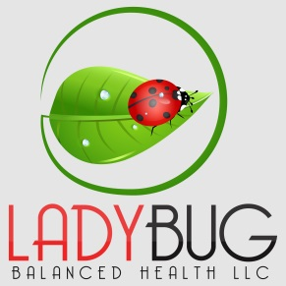
- I recognize that the QEST4 screening is an unorthodox approach to balancing my health. Being of sound mind, I have chosen this screening to assist in balancing my health of my own free will and in exercise of my constitutional right for the attainment of life, liberty, and the pursuit of happiness.

________________________________ ________________________
Client Signature Date
________________________________ ________________________
Guardian Signature (if under 18 years of age) Relationship

