Coolidge School Frozen Treat Friday
Dear Coolidge Families,
Each grade level at Coolidge School is responsible for one “Frozen Treat Friday Sale” during the school year.

Friday, ____________________________ is our day!

We offer frozen treats for students to purchase for $1.00 that meet USDA’s Smart Snacks in School standards.
We only offer specific brands and items, which are all available at Costco or Smart & Final:
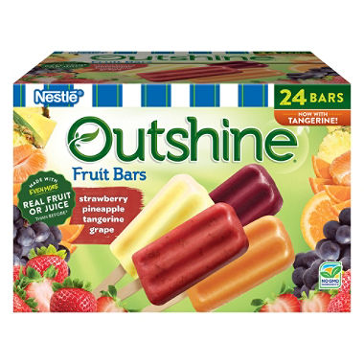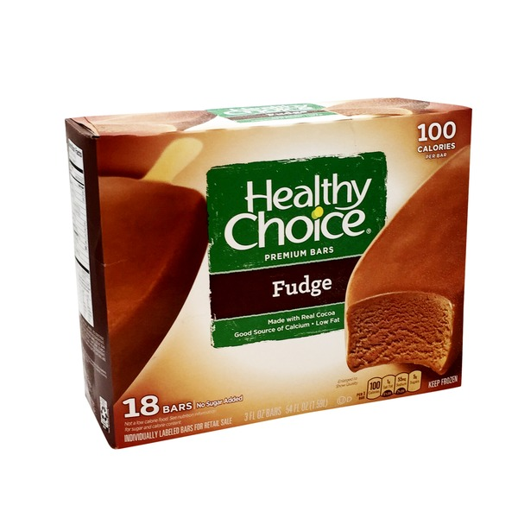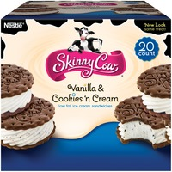
“Outshine” “Healthy Choice” “Skinny Cow”
Fruit Bars (Double Size) Fudge Bars Ice Cream Sandwiches
(strawberry, pineapple, tangerine, grape) (any flavor)
12 dozen total 8 dozen total 12 dozen total
Costco- $9.99/24pk Costco- $11.69/18pk Costco- $9.79/20pk; $5.99/6pk
Smart & Final- $10.99/24pk Smart & Final- $9.99/18pk (check after purchase-this item is often melted)

All frozen treats need to be dropped off in the school office anytime between now and before school that Friday. We NEED your help that Friday from 1:45 p.m. – 3:15 p.m. to help set up and sell frozen treats.
Please let us know if you can help sell and/or what you plan to drop off on Friday!
You can also contribute money and the Room Reps will purchase frozen treats on your behalf.

----------------------------------------------------------------------------------------------------------------------------------------

Student name_______________________________
Teacher_______________________________
Frozen Item and # bringing_______________________________
Can you help set up/sell_______________________________
Contact phone/email_______________________________

Thank you for your support!

