PROJECT: Valentine’s Day Table Runner

To celebrate holiday prints, set three simple blocks on point.

INSPIRED BY: *Spring Awakening* from designer Joanie Holton *(sewquiltcraft.com)* PROJECT TESTER: Doris Brunnette

AllPeopleQuilt.com

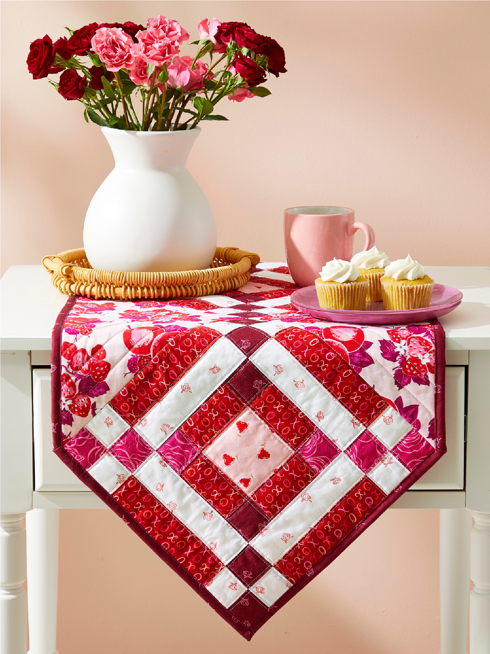

FABRICS are from the Love in Bloom collection by Louise Pretzel for Figo Fabrics *(figofabrics.com).*

FINISHED TABLE RUNNER:

171⁄2×511⁄2"

FINISHED BLOCK:

12" square

Yardages and cutting instructions are based on 42" of usable fabric width.

# MATERIALS

▫ 1⁄2 yard fuchsia print (blocks, binding)

▫ 1⁄3 yard *each* white print and red print

(blocks)

▫ 1⁄8 yard purple print (blocks)

▫ 10"-square pink print (blocks)

▫ 5⁄8 yard pink floral (setting triangles)

▫ 12⁄3 yards backing fabric ▫ 26x60" batting

# CUT FABRICS

Cut pieces in the following order.

From fuchsia print, cut:

▫ 4—21⁄2×42" binding strips

▫ 1—2×26" strip ▫ 6—2" squares

From white print, cut: ▫ 2—2×42" strips

▫ 2—2×26" strips

From red print, cut:

▫ 2—2×42" strips

▫ 12—2×31⁄2" rectangles

From purple print, cut: ▫ 1—2×26" strip ▫ 6—2" squares

From pink print, cut: ▫ 3—31⁄2" squares

From pink floral, cut:

▫ 1—181⁄4" square, cutting it diagonally twice in an X for 4 setting triangles

# ASSEMBLE BLOCKS

Measurements include 1⁄4" seam allowances. Sew with right sides together unless otherwise stated. Press seams in directions indicated by arrows on diagrams. If no direction is specified, press seam toward darker fabric.

1. Sew together fuchsia print 2×26" strip and a white print 2×26" strip to make Strip Set A (Diagram 1). Cut strip set into twelve 2"-wide A segments.

AllPeopleQuilt.com

1. Sew together two A segments to make a fuchsia Four-Patch unit (Diagram 2). The unit should be 31⁄2" square including seam allowances. Repeat to make six fuchsia Four-Patch units total.
2. Sew together a red print 2×42" strip and a white print 2×42" strip to make Strip Set B (Diagram 3). Repeat to make a second B strip set. Cut strip sets into twelve 61⁄2"-wide B segments.
3. Sew together remaining white print

2×26" strip and purple print 2×26" strip to make Strip Set C (Diagram 4). Cut strip set into twelve 2"-wide C segments. 5. Sew together two C segments to make a purple Four-Patch unit (Diagram 5). The unit should be 31⁄2" square including seam allowances. Repeat to make six purple Four-Patch units total.

1. Lay out two fuchsia print 2" squares, four red print 2×31⁄2" rectangles, two purple print 2" squares, and one pink print 31⁄2" square in three rows (Diagram 6). Sew together pieces in rows. Join rows to make a center unit. The unit should be 61⁄2" square including seam allowances. Repeat to make three center units total.
2. Referring to Diagram 7, lay out two fuchsia Four-Patch units, four B segments, two purple Four-Patch units, and one center unit in three rows. Sew together pieces in rows. Join rows to make block. The block should be 121⁄2" square including seam allowances. Repeat to make three blocks total.

# ASSEMBLE QUILT CENTER

1. Referring to Table Runner Assembly Diagram, lay out blocks and pink floral setting triangles in three diagonal rows. Sew together pieces in rows. Press seams away from blocks.
2. Join rows; press seams in one direction to complete quilt top.

# FINISH QUILT

1. Layer quilt top, batting, and backing; baste. Quilt as desired. 2. Bind with fuchsia print binding strips.

|  |
| --- |
| 61/ " |
| 2 |
|  |
|  |

|  |  |
| --- | --- |
| A |  |
|  |  |

|  |  |  |
| --- | --- | --- |
| Strip Set A Diagram 1 | Diagram 2 | Strip Set B Diagram 3 |

|  |  |
| --- | --- |
| C |  |
|  |  |

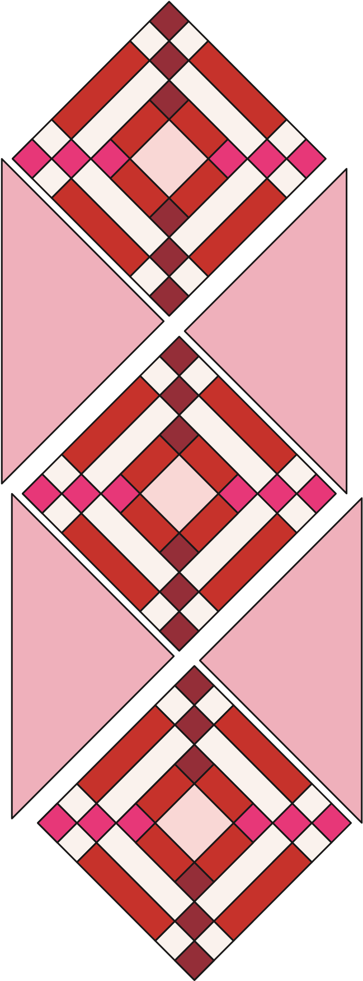Strip Set C

2

×

42

"

2

×

42

"

2

"

2

×

26

"

2

×

26

"

2

"

2

×

26

"

2

×

26

"

3

1

/

2

"

sq.

2

"

sq.

2

"

sq.

2

×

3

1

/

2

"

Diagram 4 Diagram 5

AllPeopleQuilt.com

Diagram 6

B

A

B

B

B

C

C

A

Diagram 7

Table Runner Assembly Diagram