**District 13 Website!**

Get info on the happenings in our District 13!

[www.area68district13.org](http://www.area68district13.org)

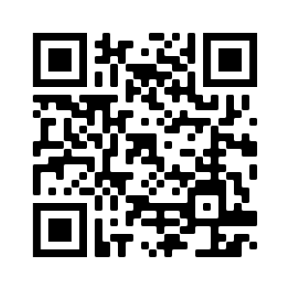

Schedules, Events, Newsletter Sign Up, and More!