Higley Spark Screens 2018 Trump Tariff Increased Pricing
For Those Who Want The Very Best
LIFT OFF DOME SCREENS
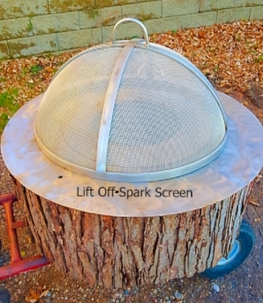 Lift Off Dome Screens.
Carbon Steel Model Painted Black
24” THRU 29” 265.00
30” THRU 35” 315.00
36” THRU 41” 370.00
42” THRU 47” 345.00
48” THRU 52 460.00
53” THRU 60” 700.00 add 25.00 Per Inch

Lift Off Dome Screen
HYBRED (Steel Frame With Stainless Steel Screen-Painted Black)
24” THRU 29” 300.00
30” THRU 35” 355.00
36” THRU 41” 430.00
42” THRU 47” 475.00
48” THRU 52 535.00
53” THRU 60” 815.00 add 55.00 Per Inch

100% Stainless Steel Lift Off Dome Screen (Continued P.2)

LIFT OFF DOME SCREEN
100% Solid Type 304 Stainless Steel “Frame and Screen
Finish: Mill finish stainless steel or painted black “no charge”
24” THRU 29” 445.00
30” THRU 35” 530.00
36” THRU 41” 560.00
42” THRU 47” 580.00
48” THRU 52 640.00
53” THRU 60” 975.00 add 60.00 Per Inch
Shipping: We ship to a brick and mortar business or pick up can be made at freight terminal.$155.00.
If you want or need home delivery there is a lift gate charge of $65.00

CENTER PIVOT-CLAM SHELL SCREENS
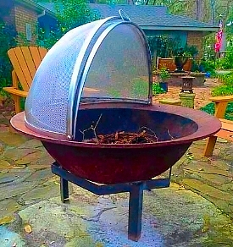CENTER PIVOT SPARK SCREEN
SOLID STEEL FRAME AND SCREEN “PAINTED BLACK”
24” THRU 29” 300.00
30” THRU 35” 360.00
36” THRU 41” 425.00
42” THRU 47” 460.00
48” THRU 52 595.00
53” THRU 60” 835.00 add 60.00 Per Inch
CENTER PIVOT SPARK SCREEN CONTIUED PAGE 3
HYBRID CENTER PIVOT SPARK SCREEN
STEEL FRAME WITH STAINLESS STEEL SCREEN”PAINTED BLACK”
The most important part of the spark screen “IS THE SCREEN”This model will save you some $$.
There is some maintenance as you will have to touch up with heat paint from time to time.
24” THRU 29” 335.00
30” THRU 35” 405.00
36” THRU 41” 510.00
42” THRU 47” 555.00
48” THRU 52 705.00
53” THRU 60” 985.00 add 60.00 Per Inch

Center Pivot Spark Screen
“OUR BEST “ 100% TYPE 304 STAINLESS STEEL SPARK SCREEN

24” THRU 29” 485.00
30” THRU 35” 580.00
36” THRU 41” 655.00
42” THRU 47” 680.00
48” THRU 52 840.00
53” THRU 60” 1200.00 add 60.00 Per Inch
Shipping: We ship to a brick and mortar business or pick up can be made at freight terminal.$155.00.
If you want or need home delivery there is a lift gate charge of $65.00
DOUBLE WING DOOR ACCESS FIRE PIT SCREEN
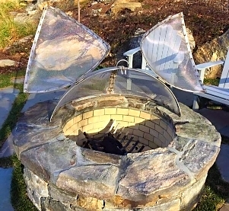
Steel Painted Black – Steel Frame -Steel Screen
24” THRU 29” 570.00
30” THRU 35” 705.00
36” THRU 41” 725.00
42” THRU 47” 755.00
48” THRU 52 775.00
53” THRU 60” 1015.00 add 50.00 Per Inch

Shipping: We ship to a brick and mortar business or pick up can be made at freight terminal.$155.00.
If you want or need home delivery there is a lift gate charge of $65.00
CONTINUED NEXT PAGE

Double Wing Door Continued
Hybred Model – Steel Frame With Stainless Steel Screen – Painted Black.
24” THRU 29” 600.00
30” THRU 35” 725.00
36” THRU 41” 760.00
42” THRU 47” 805.00
48” THRU 52 860.00
53” THRU 60” 1140.00 add 55.00 Per Inch

Double Wing Door
Solid Stainless Steel – Frame and Screen
24” THRU 29” 780.00
30” THRU 35” 945.00
36” THRU 41” 965.00
42” THRU 47” 999.00
48” THRU 52 1025.00
53” THRU 60” 11385.00 add 65.00 Per Inch
Shipping: We ship to a brick and mortar business or pick up can be made at freight terminal.$155.00. home delivery lift gate charge is $65.00
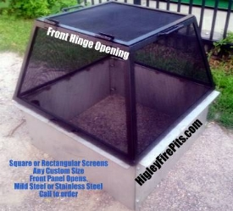
HINGED SQUARE – RECTANGLE SCREENS
Door located in long side. – Screen Heigth is 17” tall
Price based on screen perimeter size.

MILD CARBON STEEL PAINTED BLACK
UP TO 120” 650.00
121” UP TO 144” 780.00
145” UP TO 190” 890.00
191” + $10.00 PER INCH ADDED

HYBRED (STEEL FRAME + STAINLESS STEEL SCREEN) PAINTED BLACK
UP TO 120” 745.00
121” UP TO 144” 870.00
145” UP TO 190” 999.00
191” + $15.00 PER INCH ADDED

100% STAINLESS STEEL FRAME AND SCREEN
UP TO 120” 830.00
121” UP TO 144” 995.00
145” UP TO 190” 1155.00
191” + $10.00 PER INCH ADDED QUESTIONS CALL 763-438-0356

