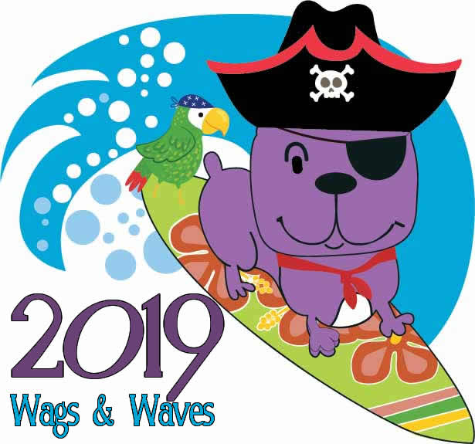
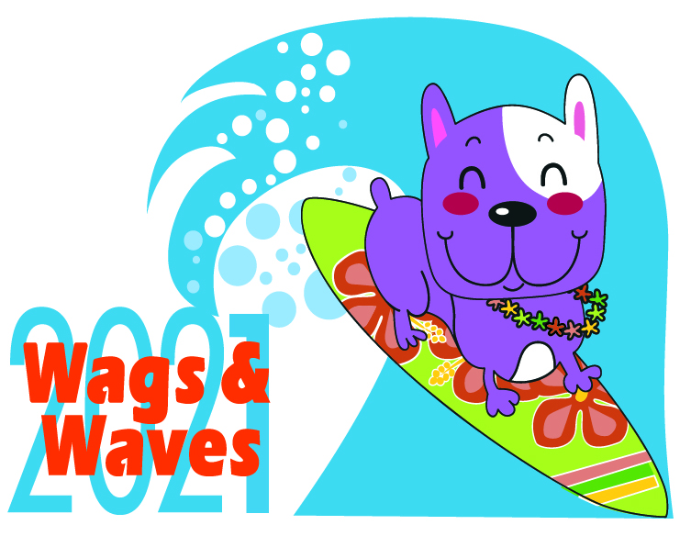

Wags and Waves Attendee agreement and waiver
I AGREE TO THE FOLLOWING TERMS:
- I do hereby represent and warrant that my dog(s) are spayed/neutered. (initial) ________
- I agree to practice responsible pet ownership.
- I understand that Wags and Waves is a litter-free event. I agree to immediately deposit any trash or dog waste in the proper receptacle.
- I do hereby represent and warrant that my dog(s) has complete, up-to-date vaccinations and current rabies shots.
- I agree not to leave my dog(s) unattended at any time.
- I agree not to leave my dog(s) enclosed in any vehicle.
- I release any right and grant full permission to Wags and Waves to use, without payment, any photographs, videotapes, motion pictures, sound recordings, or any other record or information derived from the Movie Night event or any other Wags and Waves related event.
- In participating in Wags and Waves, I recognize and acknowledge that injury, illness or damage could occur to my person, children, property, or pet(s) caused by any of the participating pets, participants, premises or property defects, or other causes. Nonetheless, in consideration of the acceptance of this entry and the allowance of myself, my dog(s) and/or my children’s participation in Wags and Waves, I, for myself and my children, and all others who might otherwise make claim on behalf of me or my children, do hereby voluntarily assume full and sole responsibility for any injury, illness, or damage, accidental or intentional, which may occur to myself, my children, property, or pets directly or indirectly as a result of or during my or my children’s participation in Wags and Waves. Further, I, do hereby forever waive, release, discharge, and hold harmless Cat Matchers, Dallas Companion Animal Project, DFW Rescue Me, Feral Friends, Legacy Boxer Rescue, Hawaiian Falls Water Parks and all sponsors, vendors, veterinarians/veterinary staff, and officials from any and all claims, demands, actions and cause of action whatsoever including, but not limited to, any injury, illness, or damages to myself, my children, property, or pets which might result directly or indirectly from or during my, my pets or my children’s participation.
I fully understand and agree that failure to fully comply with any and all obligations outlined in this Wags and Waves Attendee Agreement and Waiver, will result in my removal from the park and forfeiture of my entrance fee.
Signature _______________________________________________________________
Print Name ______________________________________________________________
Date __________________Time_______________ Zip code______________________

Participants under 18 in my direct care:
Name: _________________________________________________ Age: ____________
Name: _________________________________________________ Age: ____________

Total Number of Dogs entering park with us today: ____________________
Please contact me about future W&W events: (circle all that apply) sponsor/vendor, volunteer, general
Email _______________________________ Phone_____________________________

