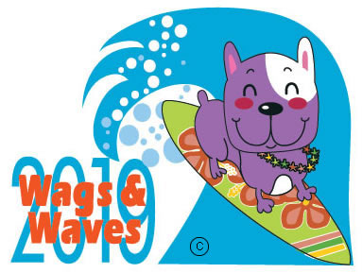
Wags & Waves
September 14, 2019
10 a.m. – 4 p.m.
Hawaiian Falls Waterpark - Garland

SPONSORSHIP OPPORTUNITIES

Poodle (Little Kahuna) - $300

Your donation includes these benefits:
- One event T-shirt
- Name listed on t-shirt and sponsor signage at event
- Complimentary 10’ x 10’ uncovered booth space at the event. May be used for many purposes, such as sampling, sales or recruitment!

Labrador Retriever (Big Kahuna) - $500

Your donation includes all of the above, plus:
- Logo listed on event t-shirt
- Listing on event website
- Mention in media releases
- Display of one sponsor banner

Mastiff (Great Kahuna) - $1,000

Your donation includes all of the above, plus:
- Audio thank-you announcements at the event
- Display of an additional banner

Top Dog - $2,000

Your donation includes all of the above, plus:
- Company name on a canine contest award
- Display of an additional banner at the event (total 3)
- Two reserved parking spaces
- Thank-you announcements from the stage

Presenting Sponsor - $5,000

Your donation includes all of the above, plus:
- Additional event t-shirts, up to 5 total
- One reserved cabana
- Display of an additional Presenter Banner at the front gate
- Five tickets to the event
- Participate as a judge for the canine contests

SPONSOR INFORMATION

Please Print

Contributor Name
Company/Organization
Address
City State Zip Code
Business Phone ___________________ Email: _______________________________________

I/We will be a sponsor of Wags & Waves at the $_________________ level.

Enclosed is our sponsorship check, payable to DFW Rescue Me.

Charge my MasterCard or Visa

The undersigned hereby authorizes DFW Rescue Me to charge his/her:

Card # ______________________________________________

Expiration Date ______________________________________

CVV / CID Code _____________________________________

Email Address (for your receipt)__________________________

In the amount of $_____________________________, dated ________________ for services agreed upon with the understanding that payment is guaranteed and charges will not be disputed.

_________________________________ _______________________________________
Print name as it appears on credit card Signature

________________________________
Date

Cardholder’s billing address:

Street: _________________________________ City: ____________________________

State: _______________________________________ Zip: ____________________________

Telephone: ( _____)__________________________

If you are sending your Wags and Waves sponsorship prior to August 25th, 2019, please note the name (personal or business) you wish to be posted on our website

Wags & Waves
DFW RescueMe
PO Box 51652
Denton, TX 76206

Please mail this form with payment to the above address.

Deadline for guaranteed inclusion in all materials is July 29th, 2019

We appreciate your support of companion animals in our community!

