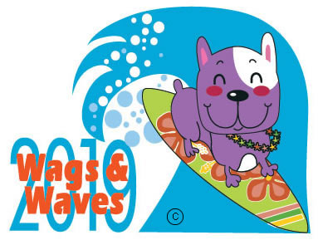
WAGS & WAVES
VENDOR/GOODIE BAG PROMOTION AGREEMENT FORM

COMPANY INFORMATION
Please Print
Name of Business ______________________________________________________________________
Representative ______________________________________ Title _____________________________
Address ______________________________________________________________________________
City ________________________________________ State _____________ Zip Code ___________
Business Phone __________________ Cell _________________________ FAX __________________
Email: _______________________________________________________________________________

VENDOR/GOODIE BAG INFORMATION

- Vendor Space $75
*Exclusive 10’x10’ space provided outside of pavilion. Booth, tables & coverage must be supplied by Vendor.
Special Needs, if any ________________________________________________________

Will you be selling product? [ ] Yes [ ] No
If yes, please list _____________________________________________________________________

Goodie bag promotion - $75 for coupon or business card – FREE if product is donated

I would like to provide up to 600 promotional items (coupon, product, or advertising item) to the W&W Doggie Bags that are distributed to attendees. Commitment needed by August 20th, 2017 for confirmation.

I am not able to attend the event but would like to make a tax-deductible donation in the amount of $_____________, which is enclosed.

PAYMENT INFORMATION
Vendor spaces are LIMITED. Please return this form with payment by Septembe 1st, 2019 to reserve your space.

***Setup of your booth MUST be completed by 9:30AM on the event day
By signing this form, I waive all claims against Dallas Companion Animal Project, Cat Matchers, Feral Friends, Legacy Boxer Rescue, DFW Rescue Me and Hawaiian Falls Water Park, all sponsors and all officials for any injury
or illness which may directly or indirectly result from my or my guest’s participation in Wags and Waves.

Printed Name ______________________ Signature _________________________________ Date: ___________

Please mail form and check/money order payable to DFW Rescue Me:

DFW Rescue Me
PO Box 51652
Denton, TX 76206 We appreciate your support of companion animals

CREDIT CARD AUTHORIZATION

The undersigned hereby authorizes DFW Rescue Me to charge his/her:

- MasterCard
- Visa

Card # ______________________________________________

Expiration Date ______________________________________

CVV / CID Code _____________________________________

Email Address (for your receipt)__________________________

In the amount of $_____________________________, dated ________________ for services agreed upon with the understanding that payment is guaranteed and charges will not be disputed.

_________________________________ _______________________________________
Print name as it appears on credit card Signature

________________________________
Date

Cardholder’s billing address:

Street: _________________________________ City: ____________________________

State: _______________________________________ Zip: ____________________________

Telephone: ( _____)__________________________

