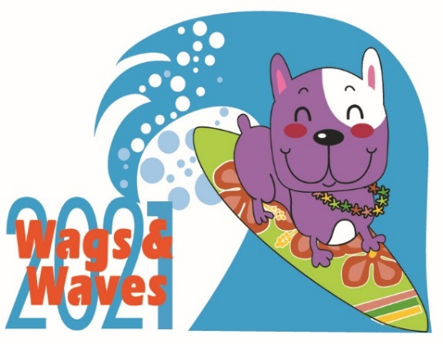

WAGS & WAVES
VENDOR AGREEMENT FORM

COMPANY INFORMATION
Please Print
Name of Business ______________________________________________________________________
Representative ______________________________________ Title _____________________________
Address ______________________________________________________________________________
City ________________________________________ State _____________ Zip Code ___________
Business Phone __________________ Cell _________________________ FAX __________________
Email: _______________________________________________________________________________

VENDOR INFORMATION

- Vendor Space $75
*Exclusive 10’x10’ space provided outside of pavilion. Booth, tables & coverage must be supplied by Vendor.
Special Needs, if any ________________________________________________________

Will you be selling product? [ ] Yes [ ] No
If yes, please list _____________________________________________________________________

PAYMENT INFORMATION
Vendor spaces are LIMITED. Please return this form with payment by August 20th, 2021 to reserve your space.

***Setup of your booth MUST be completed by 9:30AM on the event day
By signing this form, I waive all claims against Dallas Companion Animal Project, Cat Matchers, Feral Friends, Legacy Boxer Rescue, DFW Rescue Me and Hawaiian Falls Water Park, all sponsors and all officials for any injury
or illness which may directly or indirectly result from my or my guest’s participation in Wags and Waves.

Printed Name ______________________ Signature _________________________________ Date: ___________

Please mail form and check/money order payable to DFW Rescue Me:

DFW Rescue Me
PO Box 51652
Denton, TX 76206 We appreciate your support of companion animals.

.

CREDIT CARD AUTHORIZATION

The undersigned hereby authorizes DFW Rescue Me to charge his/her:

MasterCard

Visa

Card # ______________________________________________

Expiration Date ______________________________________

CVV / CID Code _____________________________________

Email Address (for your receipt)__________________________

In the amount of $_____________________________, dated ________________ for services agreed upon with the understanding that payment is guaranteed and charges will not be disputed.

_________________________________ _______________________________________

Print name as it appears on credit card Signature

________________________________

Date

Cardholder’s billing address:

Street: _________________________________ City: ____________________________

State: _______________________________________ Zip: ____________________________

Telephone: ( _____)__________________________

SPONSOR/VENDOR TERMS AND CONDITIONS

Booth placement: will be determined by the Wags & Waves Committee. We will do our best to accommodate your request. Booth Space is limited. Booths are assigned on a first-come, first-served basis.

Booth occupancy: Each booth shall remain attended at all times.
Booth attendants under 18 are allowed as long as there is an adult present at all times. Booth attendants under 18 are the sole responsibility of the booth occupant.

Booth removal: Event management reserves the right to stop or remove from the event any group or group representative performing any act or practice, or displaying any item which is, in the sole opinion of event management, objectionable or detracts from the purpose/objective of the event.

Liability: No participant will be allowed to set up without a signed and dated application and release of liability. Each group retains liability and assumes all risks of loss and/or damages onsite or in connection with transportation, display, storage and sale of merchandise at the event. The committee reserves the right to revoke or refuse to grant space at any time, without recourse by the participant. The Committee shall not be liable to anyone for this action.

Refunds: No fees shall be refunded—inclement weather will not be grounds for refunds

Music: “boom” boxes or recorded music is not allowed in booth areas

Exclusive Rights: No exclusive rights for the sales of any item will be granted to vendors.

Alcohol/Smoking:
No alcohol (including beer & wine) may be served.
Hawaiian Falls is a non-smoking facility.

W & W is a Litter-Free Event: Each group must immediately clean up and properly dispose of any waste left by their dogs and is responsible for the ongoing cleanliness and immediate cleanup of trash from their display area following the event.

Food/Drink: sales limited to those who have completed the Food vendor applications and have the appropriate Food Permit.

Parking-vendor parking is by the back gate. Please park in the specified area.

W & W will list your organization/company as a participant on the website and appropriate promotional material (depending on sponsorship level and time that application is received)

Setup/Breakdown- all participants MUST be 100% set up no later than 9:30am the day of the event. Set up may begin at 7:00. All vehicles must be immediately moved from the loading area once items have been unloaded/loaded. Property brought on event premises by any group must be removed from event premises during the load-out times designated by event management. Event management reserves the right to remove from event premises any remaining effects left after designated load-out times at cost to the owner, if applicable.

Park Entrance: All booth participants must have either an appropriate vendor badge for entrance or pay the entrance fee.
*Everyone must sign an event liability waiver prior to entering the park. This waiver can be downloaded from the event website and filled out prior to arrival or are also available at the park on the day of the event

I have reviewed and understand the vendor rules for participation in the Wags and Waves event.

Signature ______________________________________________ Date ________________

