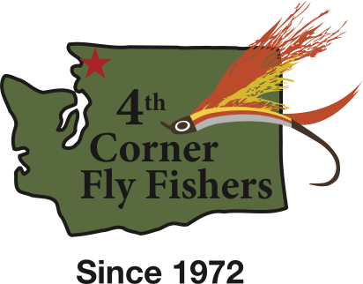

P.O. Box 1543
Bellingham, WA 98227
http://www.4thcornerfly.com
4CFF 2020 Conservation Auction

This year will be the Fourth Corner Fly Fishers’ 24th biennial Conservation Auction. It is also the Club’s 50th Anniversary. The Conservation Auction and Dinner will be held Saturday, October 15th at the Bellingham Golf and Country Club. There will be a silent and a live auction of gifts and services contributed by local businesses and individuals. The Auction proceeds support the Club’s annual conservation projects and youth educational outreach in the local schools.

The Club’s mission, in part, is to support the preservation of angling waters and to conduct educational programs that encourage individuals of all ages to become fly fishers. A listing of our current activities is included on the supplement page. The Fourth Corner Fly Fishers also provides financial support to numerous conservation groups including Nooksack Salmon Enhancement Assoc., Skagit Fisheries Enhancement Group, Wild Fish Conservancy, The Whatcom Land Trust, and the Coastal Conservation Association.

We ask for your support so that we can continue these efforts. We are proud of what we’ve accomplished in Whatcom and Skagit Counties over the last five decades. As we look forward to the challenges of the future, our mission to preserve local waters and to educate the next generation of fly fishers is vital. Your donation will be valuable to our cause.

Our membership approaches one hundred individuals and families. Many of us make a special effort to shop locally to support our local businesses. We sincerely appreciate the support of businesses like yours. As a thanks for your donation, we will add your logo and contact information to our monthly newsletter. Our club newsletter circulation extends beyond our membership to other flyfishing clubs in Washington and British Columbia.

Donations should be received no later than October 1st, 2022. Please feel free to contact me if you have any questions. I would be happy to help in any way that I can.

Sincerely,

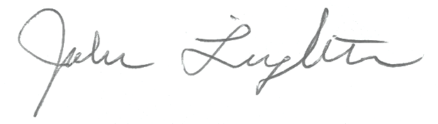

John Leighton- Conservation Auction Committee Chairman
(360) 724-6381
4cff.2022.conservation@gmail.com

P.O. Box 1543
Bellingham, WA 98227
http://www.4thcornerfly.com

The Following is a listing of the conservation and educational projects in which the Fourth Corner Fly Fishers has been recently involved.

CONSERVATION:

- Stream restoration 10 Mile Creek (Property on and adjacent to 10 Mile Creek Elementary School)
- Innis Creek (Acme Valley) stream restoration at headwaters of Samish River.
- Squalicum Lake- annual creel census, trail and boat launch area maintenance.
- Whatcom Creek - debris clean-up and trail maintenance between Woburn Ave. and Interstate 5 overpass.
- Lily Point (Pt. Roberts) and Point Whitehorn County Parks. Beach and trail maintenance and removal of invasive species. In conjunction with the Whatcom Land Trust.
- Nutrient enhancement projects - placing salmon carcasses in various streams in Whatcom and Skagit Counties
- Stream restoration Smith Creek
- WDFW access at Cedar Grove on the Skagit River. Trail construction and installation of benches and signage at site across from Concrete.

EDUCATION:

- Blaine Middle School - conservation, fly tying, and fly fishing classes (12 students).
- Options High School - same as above (30 students).
- Lummi Indian School - same as above (24 students).
- Ferndale High School - same as above (25 students).
- Lynden Christian School Camp - same as above (45 6th grade students).
- Western Washington University - same as above (14 college level students).
- Annual British Petroleum Christmas Fair - fly tying (250 attendees).
- St. Joseph Cancer Center - fly tying classes (6 attendees).
- 4H Super Saturday (Meridian High School) - fly tying, fly casting (35 students).
- North Cascade Institute (Seattle Power & Light – Skagit River Facilities) fly tying, fly casting.
- Yeager’s Sporting Goods – Introductory Fly Tying Classes, Opening Day Fly Tying Demonstrations.

