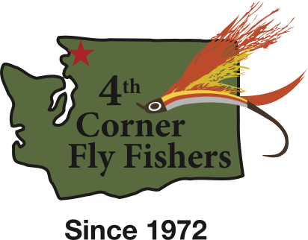

The following is a listing of the conservation and educational projects in which the Fourth Corner Fly Fishers has been recently involved.

CONSERVATION:

1. Stream restoration 10 Mile Creek (Property on and adjacent to 10 Mile Creek Elementary School)
2. Innis Creek (Acme Valley) stream restoration at headwaters of Samish River.
3. Squalicum Lake- annual creel census, trail and boat launch area maintenance.
4. Whatcom Creek - debris clean-up and trail maintenance between Woburn Ave. and Interstate 5 overpass.
5. Lily Point (Pt. Roberts) and Point Whitehorn County Parks. Beach and trail maintenance and removal of invasive species. In conjunction with the Whatcom Land Trust.
6. Nutrient enhancement projects - placing salmon carcasses in various streams in Whatcom and Skagit Counties
7. Stream restoration Smith Creek
8. WDFW access at Cedar Grove on the Skagit River.  Trail construction and installation of benches and signage at site across from Concrete.

EDUCATION:

1. Blaine Middle School - conservation, fly tying, and fly fishing classes (12 students).
2. Options High School - same as above (30 students).
3. Lummi Indian School - same as above (24 students).
4. Ferndale High School - same as above (25 students).
5. Lynden Christian School Camp - same as above (45 6th grade students).
6. Western Washington University - same as above (14 college level students).
7. Annual British Petroleum Christmas Fair - fly tying (250 attendees).
8. St. Joseph Cancer Center - fly tying classes (6 attendees).
9. 4H Super Saturday (Meridian High School) - fly tying, fly casting (35 students).
10. North Cascade Institute (Seattle Power & Light – Skagit River Facilities) fly tying, fly casting.
11. Yeager’s Sporting Goods – Introductory Fly Tying Classes, Opening Day Fly Tying Demonstrations.