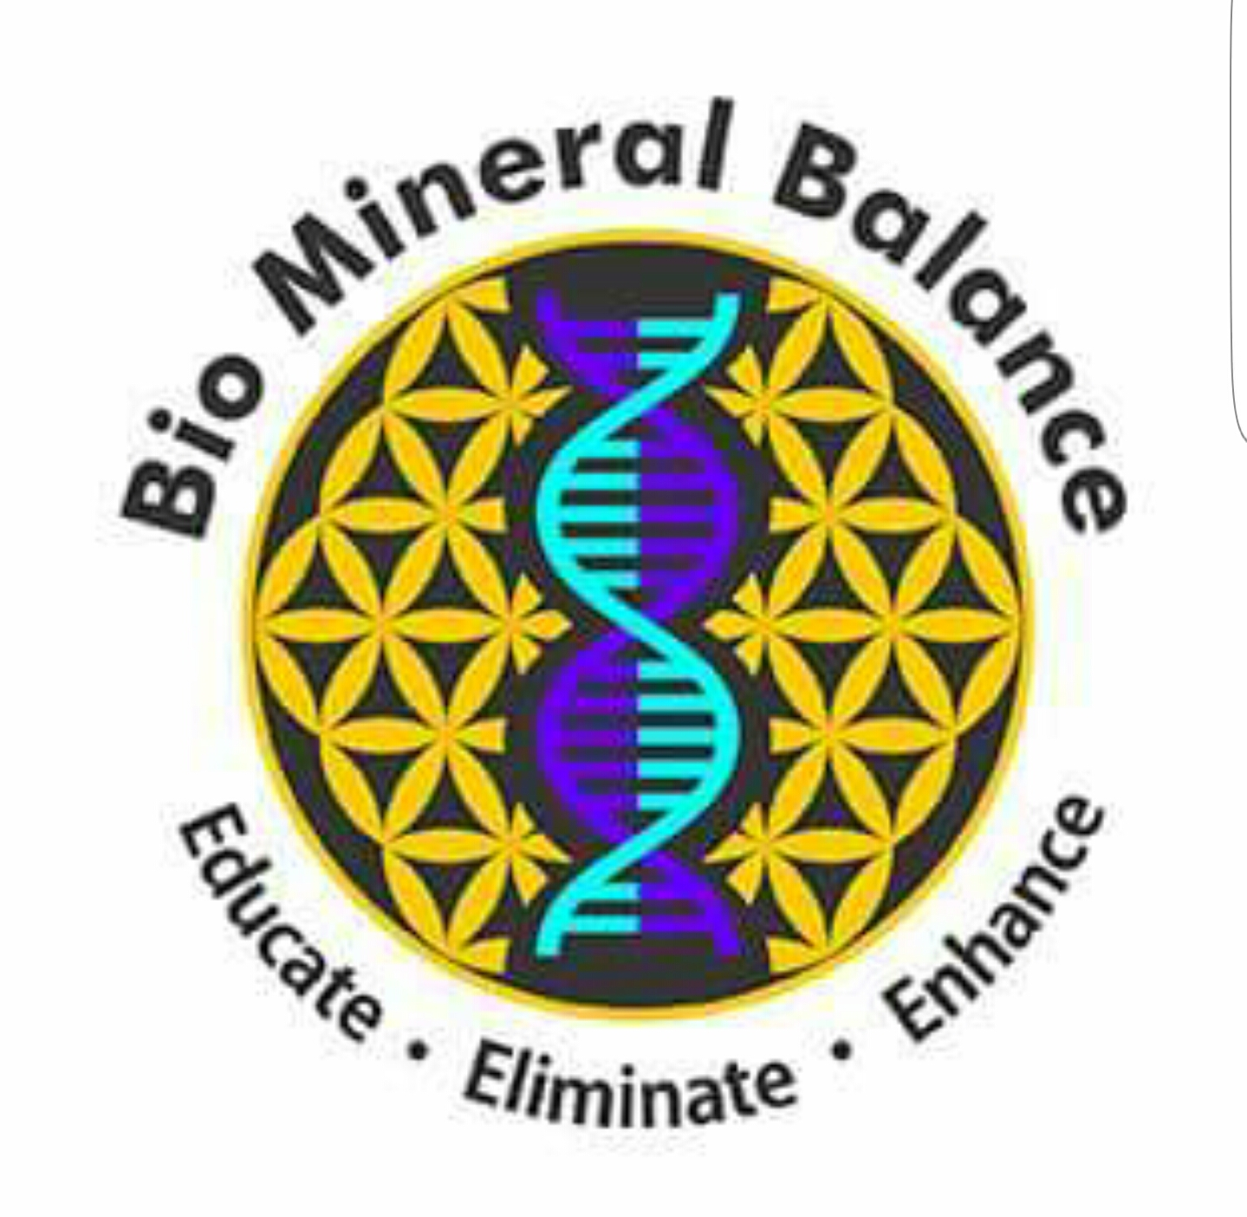

Fulvic & Humic Acid….

Restorer of life

Fulvic acid is one of nature’s most powerful life restorers**.**

Nutrient up take is more efficient, and with this, cell respiration and energy production encourages the bodies full function which balances, activates and energizes the biological properties with whatever organic material it comes into contact with.

Fulvic has the ability to restore life in repeated tests on animal cells, returning them to being healthy.

These findings can be compared with the weakness experienced in Humans such as haemorrhage, emotional stress, uncontrolled infections, unbalanced diet, prolonged loss of sleep and surgical shock.

These tests concluded that a steady decrease in electrical potential in the body will reduce to zero at death, and proves that the health of Plants, Animals and Humans is determined by electrical potential which if found in abundance in Fulvic Acid.

Acid derived from Humus i.e. Fulvic and Humic contains a large number of natural Phyto-chemicals, supercharged Antioxidants, nutrients, Free radical scavengers, super oxide dismutase’s, Enzymes, Hormones, 18 Amino Acids, 77+ minerals, Antibiotics, Fungicides, Antivirals, Prebiotics and Probiotics.

These amazing molecules; Fulvic and Humic acid have proved to be one of nature’s most powerful Organic Electrolytes, completely toxic free and serving to balance cell life.

Fulvic Acid dissolves minerals and trace elements to become bio-chemically reactive and mobile and therefore enhances availability of all nutrients, Minerals and Vitamins, making them more absorbable and prepares them to be utilized by the cell and penetrate the cell walls.

This allows interaction within the body creating: -

Energy

Electrochemical balance and harmony

Enzyme activity

Stimulation of the metabolism and the immune system

Rebuilds the immune system

Greater Oxygen absorption

Detoxification

DNA and RNA synthesis

Greater enhancement of physical and cognitive functions

Improved recovery times

Therefore Fulvic and Humic is also used to aid Longevity and also an excellent alternative to creatine and products for high and low Impact sports exercise.

Fulvic and Humic are also useful in the treatment of: -

Fertility issues

Fibromyalgia

Miscarriage

Skin disorders

Faster bone and tissue regeneration

Aids

Allergies

Chronic inflammation

Weight loss

Obesity

Fatigue

Depression

Degenerative diseases

Muscle weakness

M.S

Lupus

IBS

Anaemia

Hair loss

High blood pressure

Diabetes

Hormone and Thyroid issues

Arthritis

The list goes on……….

Fulvic is also completely safe for use during pregnancy as well as babies & children and is also beneficial for the treatment of Animals whether pets or live stock.

With correct diet and exercise such as rebounding (trampolining), body imbalance and illness can be a thing of the past.

Biomineralbalance.com

[biomineralbalance@gmail.com](mailto:biomineralbalance@gmail.com)

07474 511241