**The benefits of humus (humic acid and fulvic acid) in livestock**

Scientific literature and our own surveys show that supplementing humic acids has several positive effects on [gut health of livestock](http://bioag.eu/index.php/en/humic-fulvic-acid-live-stock-breeding#gut-health-livestock). The positive influence of these acids on digestive health can lead, among other things, *to improved digestion, increased milk production, improved feed efficiency and lower feed costs*.

**Dairy Cattle -** **Humic promotes the absorption of nutrients, vitamins and and minerals. Keep your farm animals healthy and strong!**

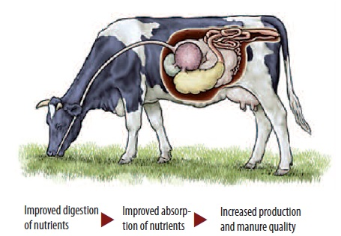

From scientific literature it appears that in dairy cattle, supplementing humus leads to increased milk production, a higher fat percentage, improved feed efficiency, reduced feed costs and fewer problems with insects. In calves, supplementing humus leads to improved growth and feed conversion and increases the weaning weight, while at the same time the occurrence of calf diarrhea is observed to be reduced. These positive results in the scientific literature have led BioAg Europe BV to examine the effects of Humic on dairy cattle on Dutch farms. This has led to the following conclusions:

**Benefits include:**

* Increased milk production
* Improved feed efficiency
* Improved quality of manure

Lower environmental impact

**Cattle** - **Humic promotes the absorption of nutrients, vitamins and and minerals. Keep your farm animals healthy and strong!**

In scientific literature, a large number of positive effects is attributed to humus (humic and fulvic acid), such as an improved intestinal health as a result of protective, anti-bacterial, anti-viral and anti-inflammatory properties, improved immune function, binding of mycotoxins and the reduction of stress. In calves, supplementing humus leads to an improved growth rate and feed conversion, and increases the weaning weight, while at the same time the occurrence of calf diarrhoea is observed to be reduced. A survey in the United States has compared supplementing humus with supplementing monensin (a growth promoter in the USA). Results showed that humus has a similar effect as monensin, including increased growth and lower ammonia emissions. In addition, Shi et al concluded that, in vitro, humus helped decrease ammonia emission (60.2% - 67.6%).

These positive results in the scientific literature have led BioAg Europe BV to examine the effects of Humic on rosé veal calves on Dutch farms. This has led to the following conclusions:

**Benefits include:**

* Improved feed conversion;
* More uniformity;
* Improved health.

**Pigs** - Nutrients from feed are absorbed by pigs’ gastrointestinal wall through villi and crypts. Villi are bulges of the intestinal wall, which in optimal shape are long. Crypts are the hollows between these bulges, which in optimal shape are shallow. Humic positively affects intestinal health in pigs:

* Promotes the development of the gut structure
* Improves the absorption of nutrients
* Improves overall health

**Benefits include**

* Increased growth (+ 3%)
* Slaughter weight reached faster (-4 days)
* Reduced feed intake (-2.3%)
* Fewer late finishers (-30%)
* Improved carcasses with more muscle and less fat (+ 2.5%)

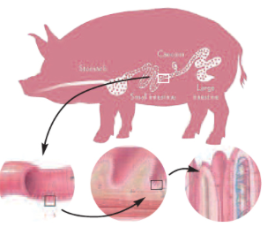

**Horses- keeps healthy and energetic**

A large number of positive effects is attributed to humus (humic and fulvic acid), such as an improved intestinal health as a result of protective, anti-bacterial, anti-viral and anti-inflammatory properties, improved immune function, binding of mycotoxins and the reduction of stress (Islam et al., 2005). In the past, research has been focused on farm animals, where improvements in growth, feed conversion and health have been demonstrated in chickens and pigs (Kocabagli et al., 2002, Bai et al., 2013).

This is mainly due to an improvement in the development of the structure and health of the intestine. The increased surface area of the intestine allows for a better absorption of nutrients, and the intestines are better protected from harmful influences.

This also has an effect on the blood parameters.

Humic supplementation allows red blood cells to carry more oxygen.

Among other benefits, this has a positive effect on the healing time of wounds, such as in tendon injuries of cutting horses (Islam et al., 2005). Positive effects are observed in the liver as well (Maslinski et al., 1993, Lotosh, 1991).

These positive results in the scientific literature have led BioAg Europe BV to examine the effects of Humic on horses.

**Research is still ongoing but has led to the following preliminary conclusions.**

Humic positively affects gut health:

* Promotes the development of the intestinal structure;
* Protects the intestines from harmful influences;
* Improves absorption of nutrients.

**Benefits:**

* Improved magnesium levels in the blood;
* Less acidic saliva;
* Improved energy values;
* Improved blood flow;
* Improved muscle tone / less muscle tension;
* Increased muscle buffering capacity;
* A more energetic and happier horse.

INTESTINAL HEALTH IS AN ESSENTIAL LINK

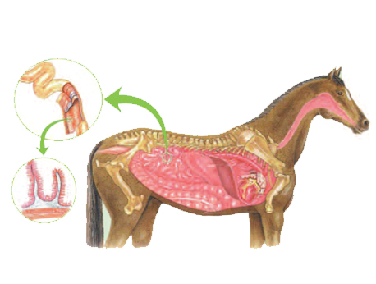

Intestinal health is an essential link in the health of the horse.

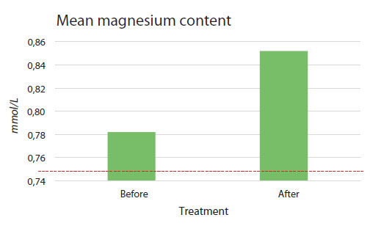

**Mean magnesium content in the blood of 20 horses before and after a 6-week treatment with Humic.**

## 

**The average energy profile of 20 horses before and after a 6-week treatment with Humic.**