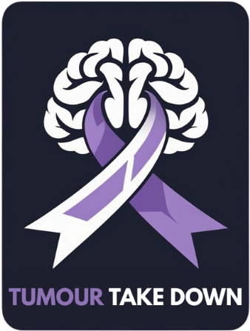

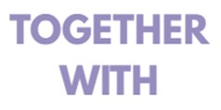

N E E D S Y O U R S U P P O R T

Every day in Canada, 27 families hear five live-changing words: You have a brain tumour. Among the most devasting is Glioblastoma-an aggressive, unforgiving diagnosis that steals precious time and leaves families searching for answers.

We are four women from St. George, Paris, and Brantford, determined to make a difference. Together with the St. George Ravens Hockey Club, we’re rallying our community for Tumour Take Down – our third annual fundraiser supporting Glioblastoma research and the Brain Tumour Foundation of Canada.

This cause is deeply personal. Two dear friends are currently living with Glioblastoma, and we’ve met many others whose strength and stories have moved us deeply. In 2024, we lost one of our own: Gary Wright-a beloved husband, father, and friend – a true warrior – whose courage and humour continue to inspire everything we do.

With the generous support of our community, we’ve raised $67,000 in our first two years. Now, we’re aiming higher - $50,000 more by May 1, 2026 – and we need your help to get there!

We invite you to review our attached sponsorship packages-the most impactful way to support our efforts, showcase your community spirit, and help us reach our goal. Each level of support honours those we’ve lost, uplifts those still fighting, and brings us one step closer to a cure.

100% of funds raised support the Brain Tumour Foundation of Canada – fueling research, patient & family support, education, and the ongoing search for a cure. Your support brings hope. Your voice raises awareness. Together, we can fund the breakthroughs that lead to a cure and bring light to those navigating their darkest days.

Join us Friday, May 1, 2026 at Gaukel Memorial Arena – 7:00 PM to Midnight for our largest event yet!
- Live music: The Village Joke opening for Grace 2-Celebrating the music of The Tragically Hip
- Big Ticket Raffle Table: TBD but past incredible prizes included a smoker, BBQ, custom guitar, and much more
- Community support: Food by ChefD Catering & Events – 100% of proceeds donated to the cause

Let’s end brain tumours. One step, one dollar, one life at a time.

With gratitude,
Tumour Take Down Team
Leslie 519-212-6667 / Fiona 519-717-3507 / Stacy 416-659-2693 / Trish 250-864-1564

tumourtakedown.ca
#EndBrainTumours | #Glioblastoma

