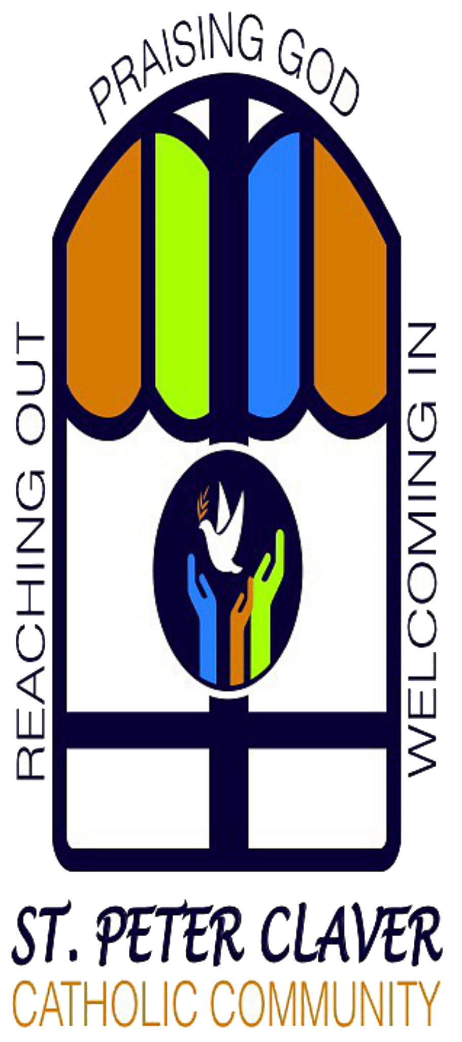

***St. Peter Claver Catholic Community at 8425 W. McNichols Road Detroit, Michigan 48221******. McNichols Road Detroit, Michigan 48221***

**The Journey of Faith Continues**

**God Has Long-term Plan to Work – Mary Mentors Us To Work The Plan**

**May 22 – Ac.15:1-29 & Jn.14:23-29 with Rev.21:10-23 – 6th Sunday of Easter**

**By Fr. John Phelps, C.Ss.R. – Pastor**

The Book of Revelations is an underground newspaper to the Aquarian Conspiracy. Jesus’ disciples are hidden in plain sight. They are called Christian for the first time in a Gentile community. But only those who are chosen will have the grace, the spiritual vaccine, to protect them from the virus named “live” by spiritual dyslectics.

Listen to the code for the “newspaper” written by the last of the twelve apostles. 3 plus 4 equals 7, the perfect number that can’t be evenly divided. 3 times 4 is 12. Two ways to be perfect, like the 7 days of creation and the 12 constellations.

In John’s Gospel the code continues. Every one of the miracles recorded in the Gospel of John is put on the Sabbath, the 7th day of the week. The 7th miracle was on the first day of the week – the Resurrection.

Take the law of circumcision that is written about in the Acts of the Apostles. Paul and Barnabas are sent by the Gentile Christians to Jerusalem to challenge the law. It is not needed for salvation. After a heated discussion, the decision set everyone free.

“It is the decision of the Holy Spirit and of us…” Pause a moment. There are two sources of truth – the Holy Spirit and the Twelve Apostles. Revealed truth comes to us through the chosen leaders who listen to the Holy Spirit.

God has a plan. It has been written by people like us since the beginning of the partnership between us creatures and our Creator. It calls for us to walk by faith and not by sight. It is full of hope against hope. It is based on loving each other as Jesus does.

We are in a time in history where the truth that God sent His Son to reveal is not popular. We are in a culture that is dominated by practical atheists as I listen. One way atheists express themselves is by deciding who lives and who dies.

To paraphrase Pope Francis, creation deselects some of God’s creation by the majority rule and the minority is ruled. In Revelations the resulting destruction of people happens. But in the end, there will be a New Heaven and New Earth. God’s Plan works.

**Healing the Racial Divide (TODAY)  
 (Loyola High School, Detroit)**

Come hear a diverse group of speakers and actively participate in live discussions about healing the racial divide through reconciliation, understanding, solidarity, unity and love. Isaiah "Ike" McKinnon, former Detroit police chief and deputy mayor, will be the keynote speaker. Other speakers will include Frank Jackson III, Joni Scott and Imam Arif Huskic.

The event will take place **Sunday, May 22, from 2-5 p.m.** at Loyola High School, 15325 Pinehurst, Detroit. The event is sponsored by the Trinity Vicariate and St. Peter Claver Catholic Community. Secure parking is available on site. Refreshments are offered.

**Five ordained transitional deacons for**

**Detroit, track for priesthood in 2023**

***Our*** ***Mission Statement***

Having reflected on the "four faces of our parish," **St. Peter Claver Catholic Community**, chosen by the Eucharistic Heart of Jesus, and under the guidance of Mary, resolves that: 1) we will provide more opportunities for deepening prayer life and faith life for youth, young adults, and adults; 2) we will initiate efforts to reach out and re-connect with those individuals and families who have disconnected from the Church; 3) we will collaborate with other faith communities and organizations within our parish to offer ecumenical events/activities (e.g., neighborhood clean-ups, prayer meetings, health fairs); and, 4) we will utilize resources within our parish community to advocate for education and to promote social justice issues.

MEETINGS / EVENTS May 22nd to May 29th

Sunday 10:00 am Mass at Marygrove and via Zoom

2:00 pm Convention TBD

Tuesday 9:00 am Collection Counting Training

Parish House, 13500 Grove St.

10:00 am St. Vincent de Paul at Mt. Lebanon

14400 Puritan St. Detroit 48227

7:00 pm Formation Team Zoom Video

7:00 pm Vicariate Meeting Zoom Video

Wednesday 11:00 am Lectio Divina Zoom Video

Thursday 9:30 am Staff Meeting Parish House

Sunday 10:00 am Mass at Marygrove and via Zoom

2:00 pm Convention TBD

Legend: PH=Parish House; MC=Marygrove College

Church refers to the Sacred Heart Chapel at Marygrove College

*For the “live” Parish Calendar, go to spcccdetroit.org*

**MINISTERS SCHEDULE May 29, 2022**

Celebrant: Rev. John Phelps, C.Ss.R.

Minister of Service: Pearl Crutcher

Lector: Kathryn Crutcher

**Save Those Pennies**

***Bring in your loose coins. Tanda Flounory will collect them for donation to the parish. Thank you to those who donate.***

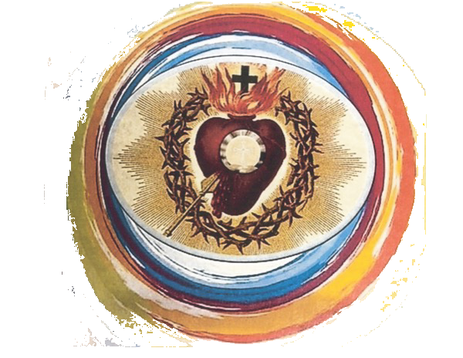

Department of Catholic Schools

Under the leadership of Archbishop Allen Vigneron, the Department of Catholic Schools provides vision, direction, and supervision to Catholic school communities in order to assist them in the achievement of their mission to proclaim Christ, promote student academic achievement, and form joyful missionary disciples.

**Pope Francis quotes**

"Find new ways to spread the word of God to every corner of the world."

"A little bit of mercy makes the world less cold and more just."

*St. Peter Claver Catholic Community*

*Parish Office:13305 Grove St., Detroit, MI 48235*

*(313) 342-5292*

*Church: Marygrove College - Sacred Heart Chapel*

*8425 W. McNichols Rd., Detroit, MI 48221*

*email: parishoffice@spcccdetroit.org*

*website: www.spcccdetroit.org*

*Mass: Every Sunday at 10:00 a.m. in the Church*

*(Check the bulletin for holy days and special services)*

*Reconciliation: Before Mass or By Appointment*

*Parish Office Hours: Parish Staff is currently working from home. Please contact Ed Shea if you require assistance.*

*\*\*\*\*\*\*\*\*\*\*\*\*\*\*\*\*\*\*\*\*\*\*\*\*\*\*\*\*\*\*\*\*\*\*\*\*\*\*\*\*\*\*\*\*\*\*\*\**

*Reverend John Phelps, C.Ss.R., Pastor*

*Edward Shea, Administrative Manager/Bulletin Editor*

*Cell: (248) 633-4476*

*Jennie Sinatra, Formation Director*

*Christopher Kendall, Engagement Coordinator/Music Minister*

*Tanda Flounory, Parish Pastoral Council Chair*

***Also, Please Remember in Prayer:***

Wayne Bradley, Olivia Boulden, Christopher Durant, Rochelle Evans, Andre Fox, Kiara Harris, Marley Jonah, Mary Caroline Jonah, Johnetta Mutes, Elke Rittenhouse, Elaine Ryles, Terrence Tidwell, Charles Tilghman, Jon Viado, Vickee Viado, Constance Washington-Daniel, Larry Washington, Wayne Washington, *and relatives of our parishioners*

***Eucharistic Heart of Jesus***

***Intercessory Prayer Team***

Beverly Alessio, Inez (Retinella) Alls, Florine Anderson, Alberta Asmar, Sylvia Baker, Warren Bridges, Donald Carter Michael Clarence Carter, Johnnie Davis, Peggy Endlein, David Gallesero, Tequilla Garrett, Ara Grier, Sandra Griffin, Karen Hickman, Myrtis Hildebrandt, Jacqueline Johnson, Bobbie Lewis, Addison Martin, Dorothy (Vicki) Martin, Dorrell Moore, Charles Nelson, Joan S. Noland, Nancy Oberhausen, Celestine Parker, Fred & Villa Ray, Romaine Redd, Flossie Ryles, Jeanne Schuldt, Irene Scott, Gussie Seay, Augusta Starks, Christine Versele, Helen Wajda, Anna Washington, Lillie Washington, Carmel Weems, Diana Wicker, Leonard & Ona Wilson

***Please Pray for Them as They Pray for Us!!***

**We are actively seeking singers to join the choir. You may reach out to Music Minister Christopher Kendall at:** [**cmkendall@spcccdetroit.org**](mailto:cmkendall@spcccdetroit.org) **if interested.**