Cuban food ★ Cuban coffee ★ Cuban energy

El Ambia Cubano

When we opened Ambia in May 2009 it was with the dream of offering not just great
authentic food and a sweet cafecito, but also a little of everything that makes Cuba
so enchanting ~ the music, the energy, the culture, the art, the warmth.
Thanks for being here (950 E Melbourne, Ave, Melbourne Fl 32901.

ADVISORY Consuming raw or undercooked meats, poultry, seafood, shellfish, or eggs may increase your risk of foodborne illness, especially if you have a medical condition.

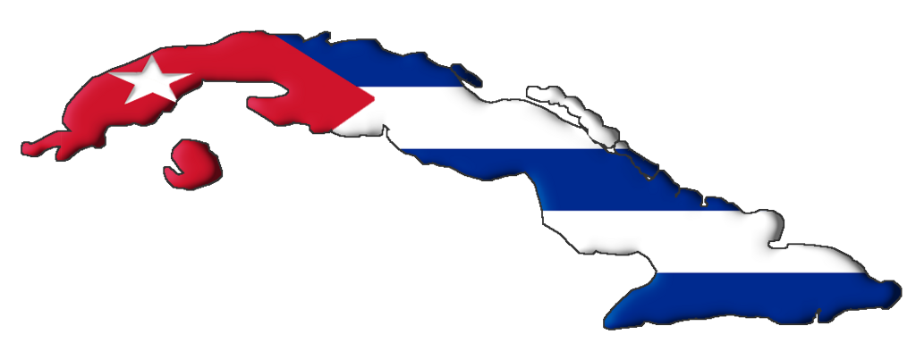

APPETIZER

YUCA RELLENA Casava stuffed with picadillo (ground beef) 3

YUCA FRITA Yuca sticks, fried and drizzled with mojo/onion house sauce 5.5
YUCA HERVIDA Boiled Yuca with Ambia’s delicious mojo onion house sauce 4.5

PAPA RELLENA Mashed potato ball stuffed with picadillo 3

HAM OR CHICKEN CROQUETAS Ground ham or chicken tubes, breaded 3.8

SHRIMPS CRIOLLOS Juicy jumbo shrimp sautéed in a garlic sauce with our secret Cuban touch 7.50

TAMAL Pork-stuffed cornmeal, wrapped in a cornhusk .2.85
( add shredded beef for 2.5) …..so delicious

MADUROS Sweet plantains 2.5

TOSTONES Green plantains with Ambia’s delicious garlic mojo 2.2

TOSTONES RELLENOS Tostones( 3) with pork, shredded beef, or ground beef 6.

EMPANADAS Doughy pockets filled with beef, chicken, or pork (2 per order) 4.8

ENSALADA Fresh spring mix salad with cucumbers, tomatoes, onions 4.75
(Add chicken Breast 6)

ARROZ BLANCO White rice 1.5

ARROZ AMARILLO Yellow rice 2

BEANS slow-cooked, Cuban-style black beans (black bean soup ) 2.3/5.49

CUBAN BREAD 1.5

ADVISORY Consuming raw or undercooked meats, poultry, seafood, shellfish, or eggs may increase your risk of foodborne illness, especially if you have a medical condition.

AMBIA-STYLE ENTREES

MASAS DE PUERCO FRITA 13.5
Succulent Tender pork chunks dunked, fried, marinated and drizzled with our mojo onion house sauce includes white rice, black beans and maduros
CUBAN STYLE ROASTED PORK 12.5
Our “melts in your mouth” roasted pork is slowly roasted to perfection with Cuban love. Includes white rice, black beans, and maduros.
CONTRA FIDEL (SURF & TURF) 21
Sautéed steak and fish fillet served with a fresh spring salad, yellow rice, and maduros.
PALOMILLA STEAK 13.99
Thin beefsteak sautéed with the freshest onions and served with black beans, white rice, and maduros
ROPA VIEJA 12.50
Tender shredded beef in a tomato-based sauce, garlic, onions and peppers, with white rice,
red or black beans, and maduros.
PICADILLO 12.5
Cuban style seasoned ground beef with olives, served with red beans, white rice & maduros
CHURRASCO 15.5
Our Churrasco is a juicy “certified Angus cut skirt steak” topped with our green tangy chimichurri sauce that will satisfy every taste-bud and served with yellow rice and a fresh garden salad (includes onions) Kick start your cravings while you read it.
POLLO ASADO 11.99
Our tender mojo-marinated leg 1/4 roasted chicken, served with white rice, black beans, and maduros.
CHICKEN BREAST 12.99
Sautéed chicken breast with white rice and asparagus.
VEGGIE PLATE 10.5
Ask any day for the veggie platter (known as the Communist Platter) Hard to get meet in Cuba.
Includes our black beans, rice, 2 maduros, One tostone, and green salad ( add cheese croquete 2)
HEMINGWAY RICE 16.5
Seafood paella with lobster, fish, and shrimp cooked together with yellow
rice in our secret broth. With sweet plantains and a salad.
FISH PLATE 14.99
Sautéed fish with cilantro mango onion sauce served with yellow rice maduros and salad.
SALMON & SRIMP 17.99
Sautéed Salmon, Juice Jumbo shrimps, served with yellow rice, fried yuca and asparagus.
WHOLE SNAPER 25
Lightly deep fried whole Snapper served with yellow rice, black beans, tostones and salad

CAMARON EXILIADO (EXILED SHRIMP) 15.99
Wonderful flavor combination, garlic, extra virgin oil, oregano and…. I will not give you my recipe. Served with white rice and maduros

ADVISORY Consuming raw or undercooked meats, poultry, seafood, shellfish, or eggs may increase your risk of foodborne illness, especially if you have a medical condition.

SANDWICHES

THE CUBAN 8.5 So much controversy, so much flavor. This is Alfredo’s Cuban Sandwich version.
Cuban Roasted pork, ham, Swiss, mustard/mayo, and pickles pressed to flat perfection.
MEDIANOCHE 8.5
Just like a Cuban, isn’t it? But on sweeter bread.
PAN CON LECHON 8
Shredded roasted pork wearing nothing but mojo and onions on Cuban bread.
PAN CON BISTEK 9.5 (please allow up to 10 minutes)
Mojo-marinated steak sandwich, mayonnaise w/tomato, lettuce, onion, & shoestring potatoes.
TE LO DIJE 7.9
Ham or chicken croquetas, Swiss, ham & mustard/mayo on Cuban bread. Because everyone enjoys a good “I told you so.”
PAN CON ROPA VIEJA 8.9
Bread with shredded beef, tomatoes , spring mix salad & shoestring potatoes.
CHICKEN BREAST SANDWICH 8.9
Sautéed Chicken with mustard/mayo, tomatoes and lettuce.
FISH SANDWICH 9.5
Fish Fillet breaded or Sautéed with mustard/mayo, tomatoes ,spring lettuce.

ADVISORY Consuming raw or undercooked meats, poultry, seafood, shellfish, or eggs may increase your risk of foodborne illness, especially if you have a medical condition.

DESSERTS ~ POSTRES

AMBIAS FLAN (Ambia’s Custard dessert with a layer of soft caramel on top) 4.5

PASTELES ( warm sweet Cuban pastries ) 2.5

BREAD PUDDING With Rum Sauce, whipped cream and cherry 4

TRES LECHES Moist spongy cake 4.5

RICE PUDDING 2.5

PINEAPPLE UPSIDE-DOWN CAKE 5

CASQUITOS DE GUAYABA Guava shells with cream cheese (Seasonal Item) 4

DULCE DE FRUTA BOMBA (PAPAYA) with cream cheese (Seasonal Item) 4

DRINKS

BATIDO (Cuban milkshake) mango, pineapple, strawberry, or chocolate. 4.
our shakes have no ice cream, They have actual fruit in milk or water
LEMONADE 3.5
LEMONADE & MINT (FROZEN ) 4.5
ICED TEA 2.50
HOT TEA / HERBAL TEA 2.25
SODA 1.95
Coke, Diet Coke, Sprite, Root Beer, Jupina, Materva, Iron beer.
MALTA 2.5
BOTTLED WATER 1.9
MILK 2.50
HOT CHOCOLATE 3

COFFEE

CAFECITO ( Cuban Coffee) 2.5
Tiny and enduring like the Island itself, strong and sweet like its people.
COLADA 3.75
3 cafecitos in one so you can share with your friends. They’ll love you for it!
CORTADITO (Don’t forget to order a flan too, it is just a deliciouuuuuuuuuuuuus combination.) Cafecito with a drop of evaporated milk, tastes like a dream and has less caffeine.
CAFÉ CON LECHE 4.5
Cafecito with steamed milk. So good! Impress your guest ordering it for her/him. Order it with
decaf and even your children will love it.
ICED COFFE 4.5

ALCHOLIC BREVERAGES

MOJITO 7 Refreshing and Delicious our famous Mojito
PI ÑA COLADA 7
CUBA LIBRE (LITTLE LIE) (rum/coke) 6
MARGARITA 7
BLOODY MARY 7
SANGRIA (RED or WHITE ) 5/glass 18/pitcher
WINE (Pinot Grigio, Chardonnay, Moscato, Merlot, Cabernet, Pinot Noir, Vino tinto.

BEER ~ domestic 3.5
Budweiser, Bud Light, Yuengling, Samuel Adams, Miller Lite,
BEER ~ imported 5
Alhambra, Corona, Corona Light, Negra Modelo, Modelo Especial, Heineken, Red Stripe, Presidente, Presidente Light

LUNCH FEATURES OF THE DAY ~ LOS ESPECIALES DE ALMUERZO 9

MONDAY TO FRIDAY 11am-2pm or until finish
MONDAY ~ PICADILLO
Seasoned ground beef, red beans, white rice & sweet plantains

TUESDAY ~ POLLO ASADO
Mojo-marinated roasted chicken, white rice, black beans, sweet plantains

WEDNESDAY ~ ARROZ CON POLLO
Chicken & yellow rice, black beans, sweet plantains

THURSDAY ~ ROPA VIEJA
Tender shredded beef in a tomato-based sauce, white rice,
red beans, sweet plantains

FRIDAY ~ BOLICHE
Cuban sautéed beef stuffed with chorizo and green olives, with white rice,
black beans, and sweet plantains

CHILDREN MENU (ONLY FOR CHILDREN).
Stop eating fast junk food and try Cuban Food

(Adults will be charged double) Not a joke
I is a actually a joke.

HAM AND CHEESE SANDWICH 5.5
Top quality ham and Swiss cheese in a Cuban bread pressed.

CUBAN CHESSE STICKS ( 2 croquetas ) 2

BLACK BEANS AND RICE. 4

Little Sneaky Plate: It is free for children 0.00
We will bring you a set of Silverware and when your parents are not looking or get distracted; you will take whatever you like from their plate, very Sneaky,

