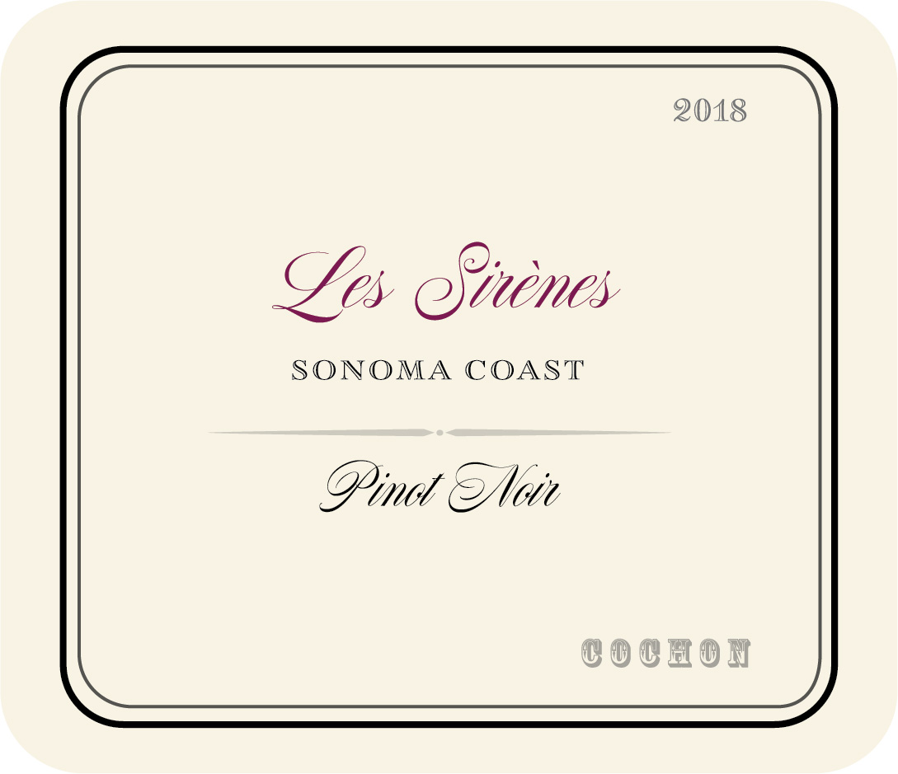

Vineyard: We had been scouting Pinot Noir vineyard sites in Sonoma County for about a year looking for the perfect marriage of soils, exposure, elevation, clone and vine maturity when we drove on to the beautiful property called Black Knight Vineyard. Grapegrowing from this unique site dates back to the 1880’s and the mature vines are planted in a complex mix of rocky soils with different microclimates and exposures. Our Pinot Noir is sourced from 4 separate vineyard blocks, each planted to different clones. We chose Clone 828, Clone 777, Clone 667 and Pommard each for their individual character and also how they would interact with each other. The deep, alluvial, cobbled-clay soils are a signature of the Petaluma Gap and the Sonoma benchlands made unique with rare deposits of quartzite and volcanic ash left behind from eruptions of Mt. St. Helena. These combinations of complex soils, mature vines, Clone and the cooling effects of the Petaluma Gap winds and coastal fog provide the perfect growing conditions for elegant Pinot Noir.

Winemaking: The fruit was picked at night and brought in to the winery in the early morning hours in mid-September 70% of the fruit was de-stemmed leaving 30% to ferment whole–cluster. Prior to fermentation the grapes were chilled to 50 degrees in a small open top tanks and held for 5 days to cold soak before a natural fermentation began from the grapes own native yeasts. During fermentation the grapes were punched down twice daily for a period of two weeks before being pressed and tranfered to French oak barrels 40% of which were new. The wine aged in barrel for 9 months before being racked and bottled unfined and unfiltered.

The Wine: Reveals vibrant ruby-purple color with a delicate nose of rose petal, crushed flowers, dried cranberry, pomegranate and red plum fruits plus hints of lavender, spice, underbrush, vanilla and toast. Medium-bodied with a concentrated core of bright, mineral laced red fruits with touches of savory spice all carried and lifted by a lively acidity. Smooth and polished displaying a velvety, supple texture and fine-grained tannins on the elegant finish. 200- cases produced.

Cochon Wines, 531 1st Street East Sonoma, CA 95476;
Ph: 925-915-1662; Fax: 925-855-1194; E-mail: adam@cochonwines.com; Website: www.cochonwines.com

