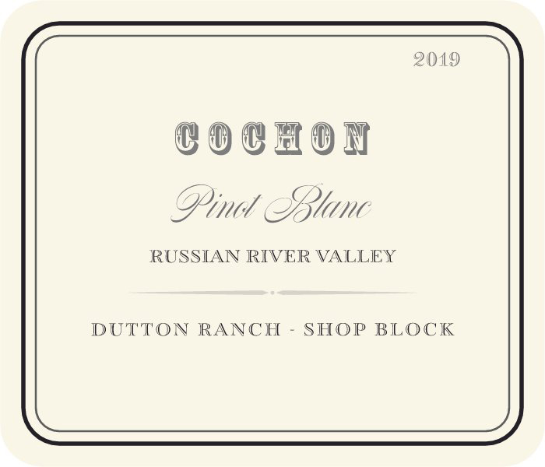

2019 Cochon Pinot Blanc, Dutton Ranch - Shop Block, Russian River Valley
175- Cases Produced (100% Pinot Blanc)

Vineyard: This vineyard is part of the original Graton Road Ranch in the Green Valley of Russian River Valley purchased by Warren Dutton in 1964. Originally planted to Riesling and French Colombard this spot is particularly suited for cool climate white varieties. The cool coastal air comes in to the valley and lingers with the morning fog creating a long growing season for complex flavor development and fresh natural acidity in the fruit. An Alsatian Clone of Pinot Blanc was selected to replace the French Colombard and planted in 2003. The Shop Block is a small parcel next to the Dutton’s shop for vineyard equipment and vehicles long prized for its complex Chardonnay. Planted in the Valleys classic and prized deep, but well drained Goldridge sandy loam soils the Pinot Blanc vines grow healthy and harmonious, dry farmed and seemingly a perfect match for this famous site.

Winemaking: The 2019 vintage began with a late spring and transitioned in to a warm summer producing ideal conditions at harvest for fully ripe, complex Pinot Blanc grapes. The pristine fruit from this block was hand picked and brought in to the winery in the early morning hours in mid- September. The grapes were gently whole cluster pressed to a stainless steel tank for primary fermentation. A slow, cold fermentation utilizing a special Alsatian yeast isolate took place over a thirty+day period after which the wine was transferred to another stainless steel tank for 4 months of additional aging to preserve the wines purity and freshness. We allow the wine to undergo partial malolactic fermentation in tank to create a more rounded mouthfeel and balance the wines natural acidity without taking away from its crispness and minerality.

The Wine: Subtle aromas of crushed white flowers, stone fruit, golden apple Asian pear followed by hints of lemon zest and a stony minerality. This elegant wine is medium-bodied and crisp with a slightly rounded mouthfeel. Displaying a deft balance of texture as well as a lifted acidity, bright fruit combined with steely, chalky coolness. Shows tremendous zest, purity and focused energy with a refreshing balance.

Cochon Wines, 531 1st Street East Sonoma, CA 95476;
Ph: 925-915-1662; Fax: 925-855-1194; E-mail: adam@cochonwines.com;
Website: www.cochonwines.com

