East Cedar Grove Missionary Baptist Association

“Telling the Story: We’ve Come This Far by Faith”
Written and Compiled by Rev. Joyce Daye Clayton

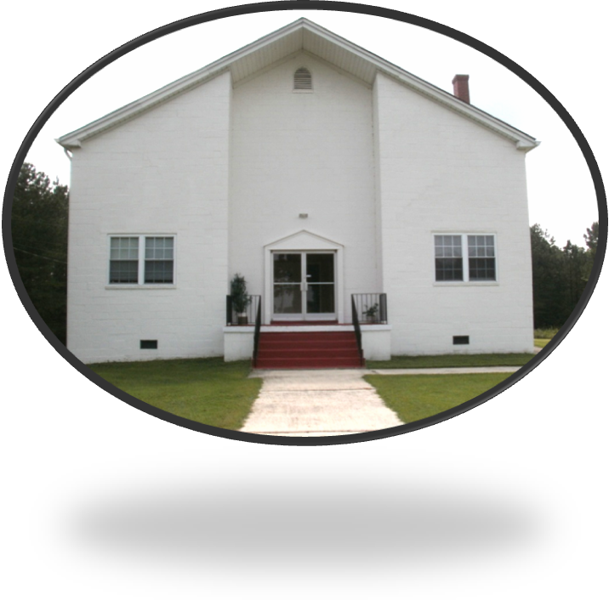
Celebrating 118 of Preaching, Teaching, and Reaching With Christ Jesus to Make a Difference
(Matt. 28:19-20)
9/13/2012

Moderator Reverend. Robert Daniels
Executive Board of Directors Chairman, Reverend William Richardson

Table of Contents

Table of Contents 2
Greetings and Acknowledgments 3
Remarks from the Moderator and Executive Board Chair 4
ECGMBA Brief History 5-6
Testimonials of ECGMBA Seniors on the Battlefield 7 – 18
Sister Glennie Carver 7
Rev. Mildred Chambers 8
Sister Emma Daniels 9
Sister Maggie Fogg 10-11
Brother Johnnie Pettiford 12-13
Sister Magdalene Ragland 14-15
Sister Zora Torain 16-17
Sister Mary Vanhook 18
East Cedar Grove Member Church 19
The East Cedar Grove Leadership Team 2012 20

ECGMBA History/Archives Committee
Chairperson, Rev. Joyce Daye Clayton, Rev. Willie Johnson, Sis. Magdalene Ragland, Sis. Novella Chick, Rev. Mildred Chambers, Sis. Glennie Carver, Sis. Emma Daniels, Deacon Johnny Pettiford, Bro. William E. Pitts, Dr. Bessie Layman, and Sis. Mary Vanhook

Dedication
This booklet is dedicated to those living and deceased co-laborers in mission of the East Cedar Grove Missionary Baptist Association.

Greetings and Acknowledgements from the History/Archives Committee

Dear Christian Brothers and Sisters:

On behalf of the History and Archives Committee, it is with greatest pleasure that this booklet is presented to the membership on this Founder’s Day Celebration, September 15, 2012, as East Cedar Grove Missionary Baptist Association, observes its 118th birthday. This booklet is a living history of testimonials from senior members of the Association. They tell a compelling and heartwarming story of how the Association affected them in their youth through adulthood, personally and professionally, as they faithfully served. Their shared experiences offer information, inspiration and instruction for current members and leaders, and for generations to come. Their story is told with excitement, candor and at times with humor.

Deep appreciation is expressed to all participating seniors who took the time to respond to the questionnaire about East Cedar Grove. Your commitment is sincerely admired. Your example of leadership, humility and serve to God increases our zeal to stay on mission, and that is “preaching, teaching and reaching to make a difference with Christ Jesus” Gratitude is also expressed to Moderator, The Reverend Robert Daniels and Executive Board of Directors Chairman, The Reverend Dr William Richmond for unyielding support and encouragement. Appreciation is also expressed to Sisters Melissa and Jasmine Battle and Deacon Raymond Paris for supportive services. And to all the members of the History and Archives Committee, thank you for your ideas, labor and team spirit as we worked together in Christian mission and fellowship. And most of all, thanks to Almighty God for blessing the Association as we have come this far by faith!

Co-laborer in Christ,
Reverend Joyce Daye Clayton
History/Archives Committee Chairperson
Asst. Pastor New Red Mountain Baptist Church, 9/13/2012
A Message from the Moderator and the Chairman of the Executive Board

Dear Christian Brother and Sisters:

Words alone cannot express the joy we feel as we celebrate East Cedar Gove Missionary Baptist Association’s one hundred and eighteen years of honoring Our Lord’s Great Commission as we labor in His vineyard. Many who have come before freely and jubilantly gave their time, resources and talents to assemble a group of Baptist Churches, stepping away from the mother association, Cedar Grove, trusting in the Lord and desiring to do His will. We owe founders such as; Rev. A. R. Cozart, Rev J.M. Taylor, Rev. A. R. Satterfield, Sister Jeannie Taylor, Sister Charlotte Webb, twenty six moderators and many others, appreciation for wanting Christian clergy and laity to be fully equipped and trained as they evangelized to bring souls to Christ Jesus. Today, we stand on their shoulders as each administration added lasting contributions to the legacy of East Cedar Grove. We are indeed grateful to each contributing member of this great Association. We, too, salute the contributors of this publication who took time to share their experiences with us.

Appreciation is expressed to the members of the Advisory Committee and History and Archives Committee, Chair, Rev. Joyce Daye Clayton, and the Founder’s Day Committee, Chair, Minister Elizabeth McCoy, for dedication to furthering the mission of East Cedar Grove.

Thanks be to God for upholding East Cedar Grove “with his righteous right hand.”

Yours in Christ,
Rev. Robert Daniels, Moderator
Rev. Dr. William Richardson, Chairman Executive Board of Directors

East Cedar Grove Missionary Baptist Association History at a Glance

East Cedar Grove Missionary Baptist Association came out of the Cedar Grove Association near the end of the 20th Century. On August 10, the year 1895 a resolution was passed in the Cedar Grove Association as follows: Whereas, we as members and churches composing the Cedar Grove Association have grown to such magnitude that it has become burdensome upon any one community or church to support us in our present condition. We have become convinced that we would secure much better results by dividing our forces, because of the personal inconveniences necessitated by our pastors and messengers in having to struggle over mountains and across valleys, through gorges and chasms; Therefore be it resolved: 1) That we be and are hereby divided into two separate associations, with the Lynchburg and Durham Railroad as the line; 2) That the churches west of said line retain the name Cedar Gove Association; 3) That the property known as the Cedar Gove Academy be retained by the Cedar Grove Association, as long as kept for school purposes, and if sold the Eastern Association shall have equal part of the proceeds in accordance to the valuation of the property at the present time; 4) That nothing herein contained shall prevent churches on either side of said line from becoming member so the Association on the opposite side of said line. These resolutions were respectfully submitted by the Rev. J.R. Cozart. After thirty minutes of debate and discussion they were accepted. Thus the East Cedar Grove Association sprang into being August 10, 1895.

“Rev. J. R. Cozart was easily the acknowledged leader of the new faction, and his influence did much to shape the child, so that it soon became stronger in every way than the parent. Reverends J. M. Taylor, W. H. Lyons and Mayes greatly assisted in the new organization. Rev. R. H. Harris, though a member of the old body, was conservative and greatly aided the new body by his prayers and counsel. The East Cedar Grove Association from its organization was a friend to missions and education, and never did they turn deaf ears to a worthy cause. It kept in line with the State and Foreign Mission Conventions, and in fact with every effort of the Baptists of the State which meant progress. They were not encumbered with local projects, as many of the Associations of the State, and hence were in a better condition and position to do for objects on the outside. Missions especially suffered often at the hands of associations where local interests were in the ascendency. The Wake, the East Cedar Grove and a few others were the exceptions.” (Source: African-American Baptist Annual Reports, 1896-1990 s,www.reformedreader.org/history/whitted/negrobaptists06.htm)

The mission and goals of the Association is captured in the Holy Scriptures, Matthew 28:19-20, “¹⁹ Go ye therefore, and teach all nations, baptizing them in the name of the Father, and of the Son, and of the Holy Ghost: ²⁰ Teaching them to observe all things whatsoever I have commanded you: and, lo, I am with you always, even unto the end of the world. Amen.” Its theme is “Preaching, Teaching and Reaching with Christ Jesus to Make a Difference.” In essence, “The sole object of the Association shall be for fraternal intercourse, mutual counsel to stimulate the union of churches, to promote among ourselves the interest of education and the spreading of God’s word.” The Association’s objectives are: To develop and encourage Christian fellowship, To provide spiritual assistance to the member churches, congregations and auxiliaries, To enhance the quality of life in the community, To support the General Baptist State Convention of NC. Inc. and its objectives, to provide support to the Ordaining Council, and to support the Lott Carey Baptist Foreign Mission Convention and the National Conventions.

The Association is composed of churches that practice “the doctrines, faith, discipline, ordinances and efficacy of the regular Baptist denomination;” meet the financial requirements as specified by the Association; and participate in the activities of the Association. The Association’s mission is carried out through several auxiliaries/ministries that include the following: The Ministers and Deacons and Deaconesses Union, The Woman’ s Auxiliary; The Congress of Christian Education; The Laymen’s League; The Usher’s Department; The Music Department and The Spouses of Ministers. The Association meets annually with delegates from each member church. The Holy Bible and Roberts Rules of Order, Revised governs the deliberations of the Association. The business of the Association is conducted through the leadership of the Moderator and the administrative work of the Executive Board of Directors. .

The Association Moderators serving the Association since 1895include the following: The Rev. A. R. Satterfield (1895-1898), The Rev. J. M. Taylor (1895 Acting), The Rev. J. T. Peace , The Rev. Jerome Cozart, The Reverend J. W. Daye, The Rev. G. H. Tilley, The Rev. Dr. John L. Tilley, The Rev. S. T. Thomas, The Rev. H. D. Eaton, The Rev. Dr. A. S. Croom, The Rev. G. W. Thomas, The Rev. Dr. W. H. Fuller, The Rev. U. R. Booker, The Rev. A. L. Thompson, The Rev. Dr. Frederick Terry, The Rev. Leman M. Gooch, The Rev. S. P. Biggers, The Rev. Dr. W. T. Bigelow, The Rev. H. L. Timberlake, The Rev. Dr. William Richardson, The Rev. W. R. McNeal, The Rev. Dr. Harold Trice, The Rev. Dr. James Richmond, The Rev. Dr. James Smith, The Rev. Mildred Chambers, The Rev. Dr. Langston Logan, and the current Moderator, The Rev. Robert Daniels (2012)

Compiled and Revised by Rev. Joyce Daye Clayton
History/Archives Committee Chairperson 9/13/2012

Sister Glennie Carver

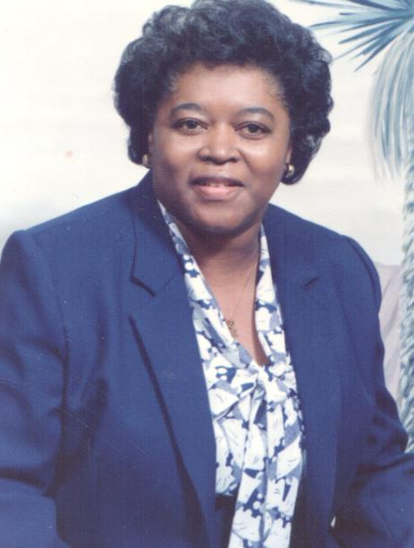
Past President Woman Auxiliary
Lattisville Grove Baptist Church

- What Does East Cedar Grove Missionary Baptist Association mean to you?
When I think of the word association, I think of a lot of people getting together to have a meeting, singing, praising God and the business of taking care of matters of the Association. It means to me the joy of seeing friends, hearing ministers I haven’t heard, worship committees and getting involved. The purpose of East Cedar Grove Association is to bring us together, to help us to understand our purpose in the Church and in the world and to give God our best!

- What accounts for East Cedar Grove’s longevity of 118 years?
East Cedar Grove’s longevity is due to Jesus Christ keeping the Association alive. The strength of our earlier leaders play is a large part of East Cedar Grove long life span. The men and women prayed. Their dedication and support they put in the work and programs of the Association have kept East Cedar Grove alive.

- What are your fondest childhood memories of East Cedar Grove?
My fondest memory is a snowball. My father would bring us to the Association. I lived for that snowball! A man, we called him Mr. Goody, made the best snowballs. My mother took us to the tent meeting for service. The Church was so full you could not get a seat. When I grew up the tent meeting, the food, selling stopped. We went into the church for service. I found out then what the Association really meant. I love the Association!
Reverend Mildred Chambers

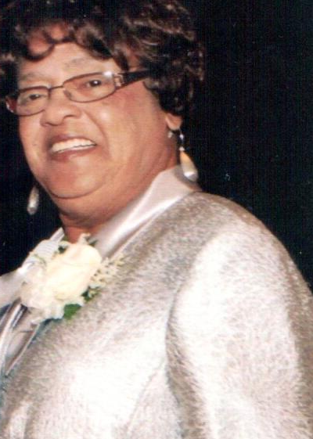

Past ECGMBA Moderator 2001-2005
Assoc. Minister, Cedar Grove Baptist Church,

- What Does East Cedar Grove Missionary Baptist Association mean to you?
The purpose of East Cedar Gove Missionary Baptist Association is to promote spiritual growth and unity among members. This is done through teaching and training. The Association brings a time of fellowship and sharing for the Bible teaches us in Psalm 133, “Behold how good and how pleasant it is for brethren to swell together in unity.”

- What accounts for the longevity of East Cedar Grove for 118 years?
The Association has been kept alive because of senior member concern and love for the Association. Communication is a very important factor. I recall many senior pastors, deacons and missionaries would talk to younger members encouraging them to stay involved with work of the Association.

- What are your fondest childhood memories of East Cedar Grove?
The fondest memory of the Association is the time that I worked so hard on the farm, knowing that in July I could go to the association. I consider that time my vacation, a time to be friends walking the grounds, stopping at booths to buy hot dogs and snow cones. Later, when time begin to change, I would go inside to listen to preaching and singing by different preachers and choirs.

Reverend Sister Emma Gooch Daniels

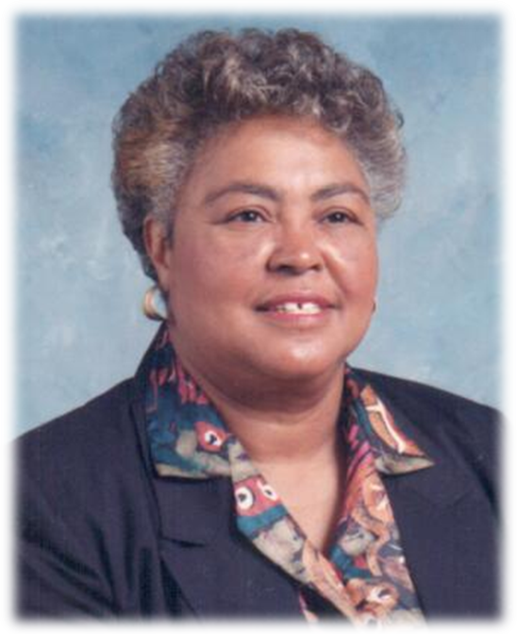
Former President Woman’s Auxiliary
Woman’ s Auxiliary Exective Board Secretary
Synama Grove Baptist Church, Creedmoor, NC

- What accounts for the longevity of East Cedar Grove at 118 years old?
One of the most important factors that have kept East Cedar Grove alive for 118 years is strong leadership. They believe in leadership and real unity.
- What are your fondest childhood memories of The Association?
My fondest childhood memory of the Association was going to the Association and getting my picture made for 25 cents, eating snow cones, eating hot dogs, meeting my friends from school and Church friends. The Association had services inside of the building and outside under a tent. My parents, Rev. Gooch and Sister, always assisted that I must come inside for some of the services. There was a lot going on outside including things from vendors. Sometimes I would to inside and sit on the back seat, so I could slip quietly back out! Sometimes my friends and I would go under the tent for services. My mother always took this great basket of food and served it from the car when time came for the Association to break for lunch. She fed her family from the car. Others ate from their cars and delegates and others ate from outside under a tree that churches brought.
Deacon Maggie Fogg

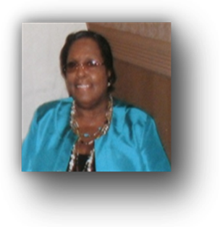
Past Secretary of the Ministers, Deacons and Deaconesses Union, History/Archives Committee Member
Tally Ho Baptist Church, Stem, North Carolina

- What does the East Cedar Grove Missionary Baptist Association mean to you?
The East Cedar Grove Missionary Baptist Association is: a place to belong, a place to fellowship, a place to make lasting and valuable friendships, a place that fosters participation, a place to worship and a place that makes me feel that I am not alone in my endeavors. The Association seems to provide an umbrella of protection.

The Association is also an organized place that consists of many disciplines with a variety of expertise, experience, talent and professionalism. Therefore, I feel that if I or my Church needs a particular service, whether it be spiritual or otherwise, I can find help within the Association. That’s what the Association means to me.

- What accounts for the Association’s longevity of 118 years?
Factors that have kept East Cedar Grove alive for one hundred eighteen years are: 1) The Christian commitment of its leaders and dedicated members; 2) hard work and determination; 3) unyielding spirits in the midst of confusion and turmoil; 4) the many prayers made to our Lord and Savior Jesus Christ for the Association’s success and 5) Christian leaders who held on to their faith, and continued to believe that Jesus’ promises are true- believing that the race is not given to the swift, but to those who can endure to the end.”

- What are your fondest childhood memories of East Cedar Grove
Missionary Baptist Association?

When I was a child I could not wait to go to the Association. I knew the routine. First we listened to one or two messages. Then they would have a business meeting to discuss issues that I had no knowledge of. After the business meeting, it was like being at the State Fair! There were lots of food and barrels of lemonade; pictures to take; things to buy and lots and lots of people everywhere. All I know as a child is I had fun!

“Go ye therefore, and teach all nations, baptizing them in the name of the Father, and of the Son, and of the Holy Ghost: Teaching them to observe all things whatsoever I have commanded you: and, lo, I am with you always, even unto the end of the world. Amen.”(Matt. 28:19-20, KJV)
Deacon Johnnie Pettiford

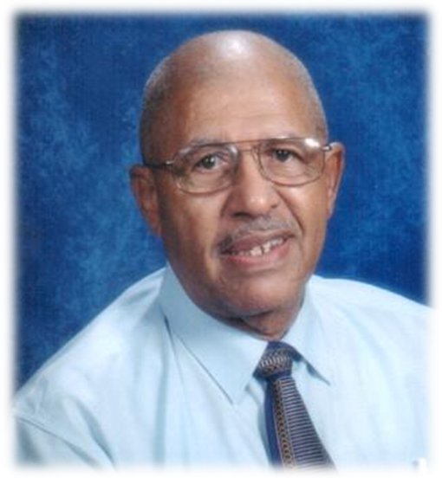

ECGMBA Executive Board Secretary, President, The Congress of Christian Education, First Ledge Rock Baptist Church, Durham, NC

- What does the Association mean to you?
As a child I was introduced to the Association by my parents. My parents were guided by their parents in believing that the Association stood for unity, togetherness, a foundation for religious growth and promoting fellowship among the various churches in the Association. This was still is my belief.

- What accounts for the longevity of East Cedar Gove being 118 years old?
The Association has always served as a meeting place for brothers and sisters of various churches where Christian unity could be promoted. The Religious teaching during my early years of development continues today because I feel that the Association stands for what all religious leaders should still promote- brotherly love among His disciples because all baptized believers are ambassadors for Christ.

- What are your fondest childhood memories of East Cedar Grove?
My fondest memories are: a) the small buildings that housed the elderly; b) since I lived just around the corner from the Association site, I enjoyed meeting and talking with the residents living on the property; c) excitement generated by neighbors in planning ahead for the Association’s meeting; d) meeting under the tents- and then crawling out beneath the flaps to go and buy the many refreshments offered at the gathering; e) having my picture taken (this was a great item); f) eating 10 cents hot dogs and 5 cents snow cones; g) the happiness and enjoyment shared by those attending from near and far.; and h) not working on the farm for two days- everyone planned for this meeting because it was the only live activity around.
Sister Magdalene Ragland

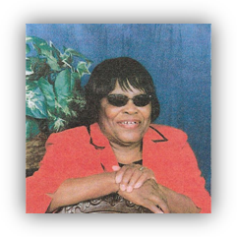
Past President Woman’s Auxiliary 20005-2009
Cedar Grove Baptist Church, Roxboro, North Carolina

- What does East Cedar Grove Missionary Baptist Assocition mean to you?
If one were to take a long look back at the history of the Association in the Baptist tradition, one will find two common treads of why aassociations form- for fellwoship and counsel. I believe these remain the purposes of the East Cedar Gorv Association even today. In simple terms, “associations are autonomours organizations made up of autonomous Baptist chruches of similar faith and practive (Id., we are missonary Baptists), who meet regularly through equal messangers to accomplish the objectives of the organization.” From the practical side, associations help their member churches solve mutual problems when their beliefs and practices are challenged. In term of fellowship, in theearly days and even now when congregations are small, there is a sharing of preachers (non-stationed chruches) and revivalists, services of baptism and cummunion.

From a theological standpoint, associations helped Baptists understand more fully and completely what it means to be part of an invisible, universal church.” We are, to our local communities, the visible chruch, the body of christ and there is a relational and analytic framework descirbed in Scripture that defines how we are to be In connection with one another. From a Biblical standpoint, Acts 15 appears to be the strongest support for the idea of coming together to resolve disputes and to set the course for the teaching and training of leaders. In addition, Ephesians 4:4-6; Matthew 23:8; Romans 12:5 all support the concept of Christian unity and cooperation among beleiveers.

- What accounts of East Cedar Groves’ longevity of 118 years?
In simplest terms, Go’s mercy and grace have allowed the Association to continue. Factors that have kept East Cedar Grove alive for 118 years are: 1) the member churches continue to be a light in their respective communities and send godly men and women to the meetings who understand the mission mandate and denominational doctrine. These representatives from the local congregations desire to build upon the legacy and foundation of those early pioneers. East Cedar Grove has remained a friend to missions and education, preparing leaders from the early ages to serve in ordained and lay ministry positions that positively impact today’s issuers and tomorrow’s challenges.

- What are your fondest childhood memories of the Association?
My fondest childhood memory is when the Association used to have those old-fashioned meetings with the almost festival-like atmosphere. Much of the fellowship took place on the grounds and there appeared to be more fellowship than business. People just enjoyed being in one another’s company and each family brought a basket to share of home cooked food, and eh entire family attended, not just the adults. It was truly an intergenerational event. It was something you looked forward to, going to the “sosation” meeting. As a youngster, I knew I would see friends and have a good time. Even the singing and preaching kept my interest. Growing up with the Association meetings being a positive experience made me look forward to the passing of the mantel to my generation. I offer thought; one day it will be my turn to bring my family to experience the “Sosation” annual meeting.
Deacon Zora Torain

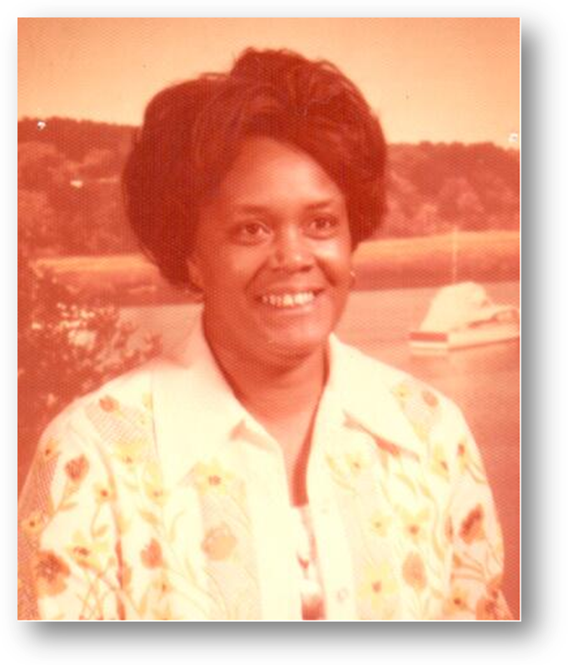
Past President The General Sunday School Convention
(Congress of Christian Eucation)
Member New Red Mountain Baptist Church, Rougemont, NC

- What does the Association mean to you?
I must say that I have been a member of East Cedar Grove since my teens and have been involved in participation for many years. I have served as an officer and am very pleased to announce that I have grown to be a worker for the Lord and happy to learn much through the administration and teaching levels to represent my Church, New Red Mountain Missionary Baptist Church.
- What accounts for the Association’s longevity of 118 years?
From my perspective the longevity of East Cedar Grove Missionary Baptist Association is due to the strength of those who seek to keep it alive for the purpose it is established. With all the cooperation and the bonding of the few who continue to plow the fields, it shows to this body the grace and mercy of God. It shows the strength of the ones who see the purpose of working together edifying what God has put in his Word and plan for us. It gives all of us the direction to follow if we seek salvation for our own souls. Many of us continue to have that desire to love one another and extend this Association to the end for it is good for wisdom, knowledge, education and purpose.
- What are your fondest childhood memories of the Association?
My fondest memories of the Association are being in the midst of all ministers, preachers and leaders working situations out, workshops, greetings, meetings and sermons – all fitting for the cause and keeping abreast, especially on how we are and can grow through participation.

I leave to all of us this thought- to look at salvation, love, grow in the Word of God, participation, and to continue to encourage those churches that sometimes are unable to meet, greet and be a part of this great Association that we have agreed to be a part of to make the best better!

Sister Mary Vanhook

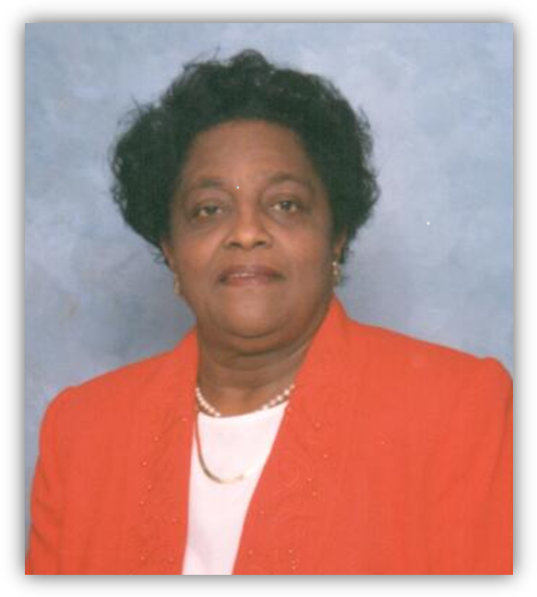
Sister Mary Vanhook
Past Secretary, The General Sunday School Convention
Mt. Zoar Baptist Church

- What does the Association mean to you
The Association helped me to develop leadership skills as a president, deaconess and Director of the State and local Oratorical Contest, and the Sect of the Congress of Christian Education.

- What accounts for the longevity of East Cedar Grove at 118 years old?
East Cedar Grove is alive because of the great leaders, with God on their side, who had good followers who walked together in love and strive for the advancement of all churches.

- What are your fondest childhood memories of The Association?
In July, we looked to being present for the (3) days enjoying the delegates from the Youth Department, Missionary, Trustees and Deacons. It was good to fellowship under a tent. The leaders looked forward you helping churches in need of help too.
ECGMBA Leadership Team 2012

Officers
Moderator, The Reverend Robert Daniels
Vice President, The Reverend Willie Johnson
2nd Vice President, The Reverend J. Eric Morgan, III
Recording Secretary, Deacon Johnny Pettiford, Recording Secretary
Corresponding Secretary, Sister Lois Gooch,
Chairman Executive Board, The Reverend Dr. William Richardson
Financial Secretary, Sister Linda Thomas
Treasurer, Deacon Hubert Gooch, Jr.
Chairperson Trustee Board, Sister Novella Chick

Auxiliary Presidents
The Reverend Johnnie Bethea, Ministers, Deacon and Deaconess Union
The Woman’s Auxiliary, Minister Rosa Hester
The Congress of Christian Education, Deacon Johnnie Pettiford
Brother Ralph Mack, Usher Department
Brother William Pointer, Layman League

The Board of Trustees
Chairperson, Sister Novella Chick
Brother Horace Bridges
Brother Thomas Buffaloe
Brother William Crews
Sister Linda Henderson
Sister Shirley Peace
Brother Wilbert Johnson

The Ordaining Council
Chairperson, Rev. Dr. Harold Trice
Rev. Louis Cash
Rev. Rufus Johnson
Rev. Dr. James Richmond
Rev. Dr. James Smith
Rev. Dr. William Richardson
Rev. Dr. Linda Bullock Vanhook

The Advisory Committee
Chairperson, Rev. Joyce Daye Clayton
Sister Glennie Carver, The Reverend Mildred Chambers, Sister Novella Chick, Sister Juanita Cook, Dr. Samuel Corbett, Sister Emma Daniels, Brother Rick Davis, The Reverend Moses Fletcher, Deacon Maggie Fogg, Brother Hubert Gooch, Jr. The Reverend Annie Gibson, Minister Rosa Hester, The Reverend Rufus Johnson, The Reverend Willie Johnson, Brother Lloyd Landis, The Reverend Dr. Langston Logan, Minister Elizabeth McCoy Ms. Edith Noel, Deacon Johnny Pettiford, Dr. William Pitts, Sister Dinah Pitts, Sister Magdalene Ragland, The Reverend Dr. James Richmond, The Reverend Dr. William Richardson, Sister Gwen Russell, The Reverend Mable Robinson, The Reverend Dr. Harold Trice, The Reverend Dr. Terry Thomas, The Reverend Archer M. Wilkins, Jr., Sister Mary Vanhook, The Reverend Robert Daniels, Ex-officio and The Reverend. Dr. William Richardson, Ex-officio
Original Member Churches*

Cameron Grove Baptist Church, Rev. Jessie L. Alston
Cedar Grove Baptist Church, Rev. Jessie R. Timberlake
Greater Cleggs Chapel Baptist Church, Rev. Louis Cash
Greater St. Paul Baptist Church, Rev. Dr. William H. Height, Sr..
First Calvary Baptist Church, Rev. Dr. Frederick A. Davis
First Community Baptist Church, Rev. Dr. William Richardson
First Ledge Rock Baptist Church, Rev. Sylvester Clay
Greenfield Baptist Church, Rev. Haywood Dock
Henderson Grove Baptist Church, Rev. Johnnie Bethea
Jones Chapel Baptist Church, Rev. Ronald Booker
Lattisville Grove Baptist Church, Rev. George Crews III
Lawson Chapel Baptist Church, Rev. Dr. Langston Logan
Ledge Rock Baptist Church, Rev. Nathaniel Fuller
Lee’s Chapel Baptist Church, Rev. T.E. Taylor
Mount Calvary Baptist Church, Rev. Dr. James Smith
Mount Level Baptist Church, Rev. Dr. William C. Turner
Mount Vernon Baptist Church, Rev. J.E. Morgan III
Mount Zoar Baptist Church, Dr. William S. Wilson, Jr.
New Calvary Baptist Church, Rev. E. Nathaniel Wall
New Hope Granville Baptist Church, Rev. James Issac III
New Hope Oxford Baptist Church, Rev. Berwell
New Hope Person Baptist Church, Rev. Wilbert L. Richardson
New Light Baptist Church, Rev. Gaddis Barnes
New St. James Baptist Church, Rev. Lloyd Oliver;
New Red Mountain Baptist Church, Rev. Dr. Percy High
Oak Grove Baptist Church, Rev. Ray A. Allsberry
Olive Grove Baptist Church, Rev. Mack Timberlake
Orange Gove Baptist Church, Rev. Herbert L. Dickerson
Pettiford Grove Baptist Church, Rev. Edwards
Pine Grove Baptist Church, Rev. Larry L. McElroy
Rock Spring Baptist Church, Rev. Samuel Corbett
Rogers Grove Baptist Church, Rev. Patrick Clay
Shady Hill Baptist Church, Rev. Dr. James Richmond
Siloam Baptist Church, Rev. Willie Johnson
St. John Baptist Church, Rev. Robert Daniels
Synama Grove Baptist Church, Rev. Linwood Timberlake
Tally Ho Baptist Church, Rev. Moses Fletcher
United Christ Baptist Church, Rev. Andre’ Harper
Union Baptist Church, Rev. Dr. Kenneth Hammond
Union Grove Baptist Church, Rev. Rufus Johnson
Union Chapel Baptist Church, Rev. Dr. Harold Trice
West Durham Baptist Church, Rev. Dr. Terry M. Thomas

Deep Appreciation

Sincere gratitude is expressed to Sister Glennie Carver, Rev. Mildred Chambers, Sister Emma Gooch Daniels, Sister Maggie Fogg, Deacon Johnnie Pettiford, Sister Magdalene Ragland, Deacon Zora Torain, and Sister Mary Vanhook for sharing their knowledge, wisdom and talents as they responded the ECGMBA Questionnaire making this publication possible.

I love to Praise Him

He is the giver of blessed joy
He makes my each and every day,
He shows me the true and righteous way,
He guards and keeps me all through the night
and tenderly leads me into the light.

He is the giver of abiding hope,
At desperate times when it is hard to cope,
and when I drink from the “bitter cup,”
He grips my hand and lifts me up.

He is the giver of courage and strength
When my back is against the wall,
And with all my promises, I still slip and fall,
It is He, My Lord and Savior, who meets my needs
and hears my despairing and wailing call!

~ Joyce Daye Clayton
8/21/2008

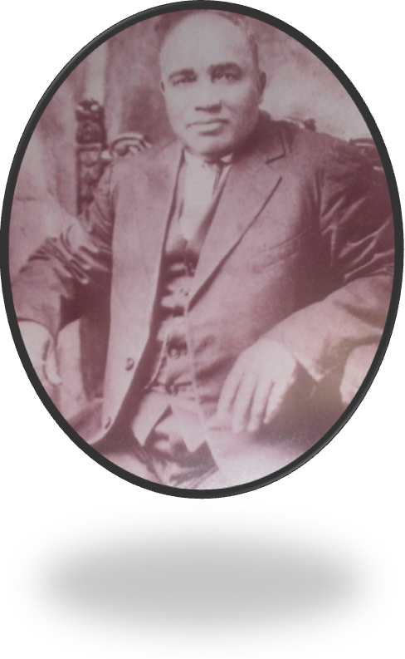
Rev. A. R. Satterfield
Moderator, 1895 – 1898
Rev. Robert Daniels
Moderator, 2009 – 2013
Rev. Dr. William Richardson
Chairman, Executive Board of Directors

2174 Brassfield Road, P.O. Box 808
Creedmoor, North Carolina 27122
(919) 528-3244
ecgmba.org

