EAST CEDAR GROVE MISSIONARY BAPTIST ASSOCIATION
OF NORTH CAROLINA, INC.
Rev. J. Eric Morgan, III, Moderator
“Using all the Parts to Make the Whole” (Eph. 4:11-16)

ECGMBA FOUNDERS DAY WORSHIP SERVICE
PROFILING THE FIRST FEMALE MODERATOR
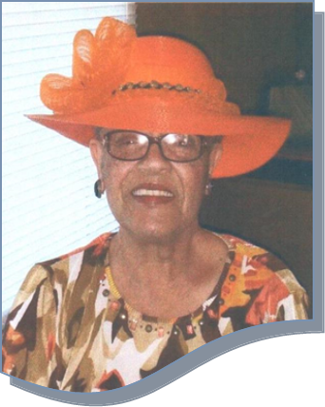

REVEREND MILDRED SNIPES CHAMBERS
2001—2005

I can do all things thorough Christ Jesus who
strengthens me“(Phil. 4:13)

“Together we can make it happen”

First Community Missionary Baptist Church
Reverend William Richardson, Pastor
Saturday, September 19, 2015

Rev. Joyce Daye Clayton, Writer/Compiler
Rev. Elizabeth McCoy, Founders Day Committee Chairperson
Purpose/Dedication

The Apostle Paul in Ephesians 4:7 reminds the Church at Ephesus that “… to each of us grace has been given as Christ apportioned it.” That message is applicable to Rev. Mildred Snipes Chambers, Moderator of ECGMBA from 2001—2005, a devout servant of Our Lord and Savior Jesus Christ. When the time was fitting for her to serve 42 churches, called East Cedar Grove Missionary Baptist Association, she answered the call and said yes. Her labor was not in vein as her legacy includes foundations that are being built upon today. Rev. Chamber’s perseverance and commitment to “vineyard labor” lingers as an inspirational for many. James 4:10 sums it up best— “Humble yourselves in the sight of the Lord, and he shall lift you up.” Hence, this publication is dedicated to a godly woman worthy of recognition as a servant of Almighty God.
(Rev. Joyce D. Clayton, Compiler, September 19, 2015)

ECGMBA MODERATORS 1895 – 2015
Rev. A. R. Satterfield (1895-1898)
Rev. J. M. Taylor (1895 Acting)
Rev. J. T. Peace
Rev. Jerome Cozart
Rev. J. W. Daye
Rev. G. H. Tilley
Rev. Dr. John L. Tilley
Rev. S. T. Thomas
Rev. H. D. Eaton
Rev. Dr. A. S. Croom
Rev. G. W. Thomas
Rev. Dr. W. H. Fuller
Rev. U. R. Booker
Rev. A. L. Thompson
Rev. Dr. Frederick Terry
Rev. Leman M. Gooch
Rev. S. P. Biggers
Rev. Dr. W. T. Bigelow
Rev. H. L. Timberlake
Rev. Dr. William Richardson
Rev. W. R. McNeal
Rev. Dr. Harold Trice
Rev. Dr. James Richmond
Rev. Dr. James Smith
Rev. Mildred Chambers
Rev. Dr. Langston Logan
Rev. Robert Daniels
Rev. J. Eric Morgan, II!
A Tribute to the Reverend Mildred Chambers
The First Female Moderator, ECGMBA

I am honor to pay tribute to a servant of our Association who has set up a standard for all of us to imitate. As I reflect on the services of Reverend Chambers, I am reminded of the story of a female servant in the Bible called “Tabitha”, which is translated as “Dorcas”, meaning, “gazette”. A gazette is an animal that acts like a deer. It leaps into places where others would dare go and it grips attentions that others would ignore. This was how Dorcas was viewed. Acts 9: 36 says, “This woman was full of good works and charitable deeds which she did”. Dorcas was a special woman in the church at Joppa. She was a blessing to all of those who were in need. She set an example for both men and women of her time as to how Christians are to treat each other.

This is how I view Reverend Chambers. Like Dorcas, she has taught us how to serve the Lord with our gifts and abilities. I have noticed how she trained and encouraged the women of our Association to be good stewards of their gifts and abilities. I’ve noticed how she challenged the men to be faithful servants. I’ve also seen upfront her commitment and dedication to the work of our Association. As a young pastor, she challenged me to look within myself for what God expects of me and not what others would say about me. She told me some years ago, “you will one day be a leader of this Association and you need to start preparing yourself for that responsibility”. I wrote this thought because I believed her.

As the first female moderator, Reverend Chambers has led and represented us well. She has led us to participate in the Lott Carey Foreign Mission annual sessions and the General Baptist State Convention sessions. She serviced on the State Convention’s General Board and was invited as a key note preacher at an annual session. She led our women’s auxiliary on many occasions to the Woman’s Baptist Home and Foreign Missionary Convention sessions. One of her greatest services to our Association is her recruiting ability. Many of our former and current leaders were inspired and recruited by Reverend Chambers. This includes the current Moderator.

As I celebrate and pay tribute to this faithful servant of our Lord’s work, let it be said like the hymn writer wrote it. “May the work I’ve done speak for me…The work I’ve done it seems so small, some-times it seems like nothing at all, But when I stand before my God, I want to hear Him say, ‘Well done’, May the work I’ve done speak for me”.

Reverend Chambers, well done! Thanks for the many years of your friendship, encouragement, support and prayer.

Sincerely,

J. Eric Morgan, III, Moderator, ECGMBA
The Reverend Mildred Snipes Chambers
A Brief Biographical Sketch

Personal Data
Born in Person County, North Carolina; Parents, Odessa Beard Snipes and Willie G. Snipes; Children, Calvin (Cher, Daughter-in-law) and Dennis Chambers; Grandchildren, Jaida and Kamaria Chambers
Residence: Roxboro, North Carolina

Education
Person County High School Class of 1959
Degree in Elementary Education, Fayetteville State University, 1967
Graduates Studies at the University of Virginia, Charlottesville, Virginia
Additional Studies at Shaw Divinity Extension Seminary

A Servant: The Ministry of Jesus Christ
Called into Ministry, May 1986
Ordained Minister, August 1986
Licensed to Teach for Seminary Extension of the Southern Baptist Seminary, 1998

Professional Career
34 Years Educator, Pittsylvania County, Virginia; Member of National Education Association

Church Affiliation
Member of Cedar Grove Missionary Baptist Church, Rev. Jessie Timberlake, Pastor
Current servant roles: Associate Minister, Deaconess and a Member of Senior Missionary Ministry and the Pastors Aide Ministry; Previous Servant Roles: Sunday School Teacher, 12 Years Vacation Bible School Teacher, Member of Young Adult Choir and Director, and Bible Study Teacher

A Servant: East Cedar Grove Missionary Baptist Association
Moderator of East Cedar Grove Missionary Baptist Association, 2001-2005
Vice Moderator of ECGMBA, 1994-1997, Rev. Dr. James Richmond, Moderator
Secretary, ECGMBA for 5 years
Assisted with the establishment of ECGMBA Male Chorus
Assisted with the establishment of the United Christian Missionary Baptist Church
Taught Missionary Workshops for Congress of Christian Education
Member of Woman’s Auxiliary of ECGMBA
Corresponding Secretary of Woman’s Auxiliary
Vice President of ECMBA Ministers, Deacon and Deaconess Union
Program Chairperson of ECGMBA Ministers, Deacons and Deaconess Union
Vice Chairperson, ECGMBA Leadership Committee
Chairperson of the Woman’s Baptist Home and Foreign Missionary One Day District Conference
Member of ECGMBA Advisory Council and Member of History Committee of the Advisory Committee

Other Services
Past President of the Person County Chapter of Delta Sigma Theta Sorority, Inc.
Member of Fidelity Chapter #576- Order of Easter Stars

Recognitions
Recipient of the 2004 Trailblazer Award, Cedar Grove Missionary Baptist Association, Herbert Bell Shaw Golden Circle Assembly #337
Interview of Reverend Mildred Chambers, ECGMBA Moderator 2001-2005
by Rev. Joyce Daye Clayton

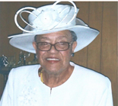

Question 1 Rev. Chambers, describe who you are.
Answer: I am a God fearing woman striving every day to do what the Lord has called me to be. I see myself a woman of service and a witness for the Lord.

Question 2 When and why did you become involved with ECGMBA?
Answer I became involved as a child under the leadership of my parents and Sister Lala Williams, who was very involved in the Association. I initially was following the guidance of my elders, but then continued my involvement because I wanted to serve and have a positive impact on the Association.

Question 3 What roles have you played in the Association?
Answer My services include the following: Moderator of ECGMBA; Vice Moderator of ECGMBA under the leadership of Dr. James Richmond, Sr., Secretary of ECGMBA for 5 years; Vice President of Minister, Deacons and Deaconess Union, Program Chair of Ministers, Deacons and Deaconess Union; Assisted with the establishment of the ECGMBA Male Chorus; Assisted with the establishment of the United Christian Missionary Baptist Church of Creedmoor, NC; Taught Missionary Workshops for the Congress of Christian Education; member of the Woman’s Auxiliary; Served as Corresponding Secretary of Woman’s Auxiliary; served as Vice Chairperson of the ECGMBA Leadership Committee ; Chairperson of the Woman’s Baptist Home and Foreign Missionary One Day District Conference and member of the ECGMBA Advisory and History Committee.

Question 4 Who were your mentors and most influential persons in your growth as a leader in the Association?
Answer My parents, Deacon Willie and Deaconess Odessa Snipes, Sister Lala Williams, Sister Dorothy Okeke and Sister Nannie Lyons.

Question 5 Why did you seek a leadership position in the Association?
Answer The position really sought me out. I was simply trying to serve others and do the will of the Lord.

Question 6 What characterized your leadership style?
Answer I see myself as an engaging leader trying to lead by engaging others to be a part of the growth and service within the Association to the will of God.

Question 7 What were your motivations for seeking the office of moderator?
Answer: I was motivated by a desire to see the continued growth of the Association and to try to get goals that would benefit the churches and church families of our Association.

Question 8 What factors did you consider when deciding to become the first woman nominee for the position?
Answer: I had really not give much thought to the fact that I would be the first female moderator. I was just trying to do the work of the Lord and work with the members of the Association in its advancement.

Question 9 What prepared you for your leadership/what did you bring to the position?
Answer: I think holding various positions over the years in education and in Christian leadership all had a part in preparing me for leadership as a moderator. I felt my strengths included my ability to engage others, being a listener, a strong communicator and of course my commitment to the will of God.

Question 10 Describe your support system.
Answer: My family, my pastor, my church family, Rev. Wilbert Richardson, Rev. William Turner, Rev. W. L. Richardson, Rev. R.D. Timberlake, The Woman’s Auxiliary member, Dr. James W. Smith, Rev. Dr. James A. Richmond, Rev. Rufus Johnson, Sr., all my vice moderators, officer and auxiliary leaders formed my support team.

Question 11 What obstacles did you face?
Answer: The obstacles were related to being accepted and respected for my leadership. It often took me longer to gain the support of those who opposed me. I don’t think individuals opposed me because I was Mildred Chambers but they opposed me because I was woman in what they perceived as a man’s role. I just used this opposition as an opportunity to show those individuals that we all can bring value to god’s house regardless of who we are. God can all of us.

Question 12 What were the Association’s mission, goals and objectives under your leadership?
Answer: The mission statement was “Together We Can Make It Happen” (Ephesians 4:3-6) The goals were: (1)To promote unity among the Association family; (2) to provide information that will inform members and keep them abreast and up to date on Association matters; and (3) to promote the importance of individual participation in decision making.

Question 13 What were the accomplishments and contributions during your term of office?
Answer: (1) I believe that we were able to foster the information shared that we still see alive and well today. With the start of the newsletter we have seen the growth to electronic communications to continue to promote the sharing of information among the Association members; (2) we helped to establish a new church, the United Christian Missionary Baptist Church and (3) a resource list was created and shared with churches so they can locate the talent within our Association.

Question 14 Are you still active in the Association?
Answer: Yes, I remain active in the Association, but due to my health I am not as involved as I once was. I still try and contribute my knowledge as it relates to the history of the Association. I feel that my dedication and commitment to the Association has allowed others to receive my contributions with respect and value.

Question 15 What advice would you give an incoming moderator?
Answer Have vision and a supportive team.

Question 16 What ‘words of wisdom” can you share?
Answer “Put God first in all that you do!”

Ephesians 4:11-16
Spiritual Gifts

“And He Himself gave some to be apostles, some prophets, some evangelists, and some pastors and teachers, for the equipping of the saints for the work of ministry, for the edifying of the body of Christ, till we all come to the unity of the faith and of the knowledge of the Son of God, to a perfect man, to the measure of the stature of the fullness of Christ; that we should no longer be children, tossed to and fro and carried about with every wind of doctrine, by the trickery of men, in the cunning craftiness of deceitful plotting, but, speaking the truth in love, may grow up in all things into Him who is the head—Christ— from whom the whole body, joined and knit together by what every joint supplies, according to the effective working by which every part does its share, causes growth of the body for the edifying of itself in love.

Reflections on Moderator Mildred Chambers
A Tribute
Reverend Dr. William G. Turner
Pastor, Mount Level Missionary Baptist Church, Durham, North Carolina

A wonderful woman of God, the Reverend Mildred Chambers was elected moderator of the East Cedar Grove Baptist Association to be distinguished as the first woman to hold that office. As such, she is a pioneer, a trailblazer, and a shero in faith. She brought with her the skills of a gospel preacher and a seasoned educator. She executed her office with tremendous courage and compassion, taking bold stands and even facing adversity. She showed what one woman can do when the grace of God is resting upon her life.

I had the privilege of working with her as chairman of the executive board during her tenure. During her time in office she preached at the General Baptist State Convention and encouraged other women to be bold for God. She supported her pastor, and in return received his unwavering encouragement and support. Truly, she has made great achievement in the cause of the gospel. She has shown generations to follow what the Spirit of the Lord can do through a yielded vessel.

I salute you my sister, and bid others to do the same.

With deep admiration, I am

W.G. Turner

Impact of a Female Moderator on the ECGMBA and Beyond
Dr. James A. Richmond, Sr. Pastor, Ph.D., D.D., Shady Hill Missionary Baptist Church, Roxboro, NC

Reverend Mildred S. Chamber made a remarkable difference with dignity and grace as the first female Moderator of the ECGMBA as well as of any Association in the GBSC of NC. In spite of doubts, full support, and limitation of not being a pastor, she led with experience, insight, and inspiration from a plethora of longstanding positions held in the Association. Although I have known and admired her work for years, her invaluable knowledge and contribution became clearer when she served as Vice Moderator during my tenure as Moderator. It was during that time that I truly realized her attributes as a potential candidate for the office of Moderator. She had ideas to promote the mission of the Association, tactic with an aptitude to engage in discussions and debates with success, effective oral and written communication skills, and the ability to gain respect for leadership by age-structure and gender. She embraced and empowered the Auxiliaries of the Association as well as the Moderator of other Associations in the state. In fact, she faced an incredible challenge of delivering a sermon at the Annual Session of the GBSC of NC. Although the task was arduous, it brought recognition to the ECGMBA that being a female and Moderator are feasible. I think that the two most significant impacts of her tenure were demonstrating that commitment and dedication in an organization can lead to a higher position, and that working through bias due to gender and limitations of not being a pastor can counteract becoming a reasonably successful Moderator of an Association. Her successes are comparable to former male Moderators whose recommendations and visions failed fruition for sundry reasons.

Reflection on Moderator Mildred Chambers
Rev. Dr. Langston Logan Comments on Rev. Mildred Chambers as Moderator
Pastor, Lawson Chapel Missionary Baptist Church

It is my honor & great privilege to say a few words about Rev. Chambers. She has served long & faithful at the Cedar Grove Baptist church in Roxboro as the Associate Minister under Pastor Jesse Timberlake. I had the distinct privilege to serve under her leadership when she was Moderator of our great Association as Chair of the Executive Board. I worked very closely with her in that position. I found Rev. Chambers to be alert, open & willing to listen to all who came to her.

As Moderator she was diligent in her duties & always prompt. She expressed great concern for the pastors & churches in our Association as well as the youth. While serving with her I experienced a woman who was a good leader & teacher full of compassion with the love of God in her heart and a desire to do the will of God in our Association. I remember being at the state convention in Fayetteville, North Carolina when President Dr. Fuller introduced her to speak as the First Female Moderator in the state of North Carolina. I was so very proud of her & our great Association. That was a moment in time that I will never forget.

As she became Past Moderator she didn't become slack in her attendance but continued to support our Association in any way she could. I am most appreciative to her for her support & wisdom that she has shared with me over the years. I know that I am a much better person, preacher and pastor because of my hands on ministry experience with Rev. Chambers. To God be the glory for all the great works He has wrought through her.

Comments on Rev. Mildred Chambers
Rev. William Richardson, M. Div., L.L.D., Pastor, First Community Missionary Baptist Church
Chairman, Executive Board of the East Cedar Grove Association, Past Moderator

I am pleased to comment on the wonderful tenure of Rev. Chambers, who served as the first female moderator of the historic East Cedar Grove Association. Under moderator Chambers’ leadership her interest for a more modern facility for the Association became a rallying point for members. During her tenure, she demonstrated impressive organizational and administrative ability to put forth sound working plans. Her ideas were both physical and spiritual. Physically, Rev. Chambers put forth and helped to organize long range plans that would enhance the association’s ability to minister more effectively to sister churches and the community. Spiritually, her calm demeanor and equitable treatment of all organization and individuals served as stimuli to help unite each one of us into a wonderful working part of the body. After having this great opportunity to have and experience her leadership, we can count it a marvelous blessing to share in such creativity. Rev. Chambers’ commitment, ideas, and governance, stands as monuments to our history and symbols to this Christian fellowship. We are much richer, spirituality and knowledgeable because of former moderator, Rev. Mildred Chambers.

Reflections on Moderator Mildred Chambers
Sister Glennie Carver, Lattisville Grove Missionary Baptist Church
Past President, Woman’s Auxiliary of ECGMBA

Rev. Mildred Chambers began her service as Moderator of East Cedar Grove Missionary Baptist Association in July, 2001 and immediately began to visit association churches. She had a building proposal in her plan and had a group of people in place to work. We talked a lot about her proposal. She wanted us to work together.

I didn’t want her to be moderator, not because she could not do the job. I thought it was too big of a job. The men were not going to treat her fair nor recognize her authority. Reverend William Turner and Reverend James Smith worked with her. Many others worked with her also, but some didn’t. There was a church when she was moderator that needed help financially. She came and asked the Association for help. Rev. Chambers helped the church. The church was a little slow paying the money back. It was thrown in her face so much that Rev. Chambers took the money out of her pocket and paid the loan off. I think that was great and showed she was a woman of God.

We went to many conventions together. Rev. Chambers was invited to preach at the General Baptist Convention. We were excited about her going. A choir was prepared to sing and all that wanted to attend went to Fredrick, NC. Some of the services were running behind, although it was not Rev. Chamber’s fault. The president of the General Baptist was rude to Rev. Chambers. When she got up to preach he kicked the podium and told her to cut it short. I wrote him a letter telling him about what he did. I did not mail it because I found no address. I did not like his actions because of what he did.

We went to the Cedar Grove Association where she preached and she was great. We went many places. God blessed us as we did not get lost nor have any accidents. I thank God for the journey.

Remarks on Reverend Mildred Chambers
Rev. Dr. James Smith, Sen. Pastor, Mount Calvary Missionary Baptist Church, Bahama, NC
Past Moderator

Rev. Chambers was involved and active in the East Cedar Grove Association when I began attending in 1991. I remember her as leader in the Women's Auxiliary where she did an excellent job. She served in the capacity of Vice Moderator of the Association when I was serving as Moderator. Working with her was a joy. She was pleasant and very cooperative. When my tenure as Moderator of the Association ended, the Association elected her as Moderator. She made history by becoming the first female Moderator of East Cedar Grove Association. She was a successful Moderator and continued to build on the foundation of previous Moderators. She made history again by being what I believe was the first female to preach at the Annual Session of an election of the General Baptist State Convention of NC, Inc.

Reflections on Moderator Mildred Chambers
Sister Magdalene Ragland, Cedar Grove Missionary Baptist Church, Roxboro, NC
Past President, Woman’s Auxiliary of ECGMBA

It is truly and honor for me to highlight the impact and changes that occurred when Reverend Mildred Snipes Chambers was elected to serve as the first black woman moderator of the East Cedar Grove Missionary Baptist Association. First, it validated Rev. Chamber’s mantra “I can do all things through Christ who strengthens me.” Rev Chambers knew at an early age that she had to work to prepare herself academically but being prepared spiritually was the key to her success. She realized that God is the strength beneath her wings and that He sustains her each and every day.

Secondly, it was a wakeup call for all of us to let us know that God can and will use man, woman, boy, girl, wherever and whenever to get the job done. Reverend Chambers demonstrated the ability to follow as well as lead. She was willing to serve in any capacity. Through her daily Christian walk with God, she knew that he was grooming her to stand boldly, be steadfast, and be patient, humble and unmovable to be able to embrace the tasks and challenges she would have to endure while serving as the moderator.

Thirdly, Reverend Chamber’s ability to accept the hiccups and challenges while serving the first black woman moderator of the ECGMBA empowered not only women, but men, youth and young adults to stay in the race. Reverend Chambers knows that it does not matter where you start in the race. What matters is that you stay in the race until it is finished, then we can say as Paul said, “I have fought a good fought a good fight, I have finished my course, and I have kept the faith. Reverend Chamber strives daily to stay in the race, to live a life that encourages and motivates us to keep our eyes, mind and heart focused on God.

While serving as the moderato of the Association Reverend Chambers demonstrated her abilities as an effective communicator, facilitator, educator, character builder, activator, visionary and change agent. We applaud you for your leadership, dedication and commitment to East Cedar Grove Missionary Baptist Association. We know that “With God all things are possible.”

Remarks on Rev. Mildred Chambers
Rev. Rufus Johnson, Pastor, Union Grove Missionary Baptist Church, Hurdle Mills, NC

When I think about the significance and impact of our first female moderator, Rev. Mildred Chambers, she was always loving, kind and willing to listen to others as moderator. Also, she will be known for giving others an opportunity to serve in the ECGMBA. Moderator Chambers is one of the key building blocks that makes the ECGMBA what it is today.

~~~~~~~~~~~

“And he gave some, apostles; and some, prophets; and some, evangelists; and some, pastors and teachers; For the perfecting of the saints, for the work of the ministry, for the edifying of the body of Christ: Till we all come in the unity of the faith, and of the knowledge of the Son of God, unto a perfect man, unto the measure of the stature of the fulness of Christ…” (Eph. 4:11-13)

Reflections of Moderator Mildred Chambers
Elizabeth S. Marrow, Oak Grove Missionary Baptist Church
Former Woman’s Auxiliary President of the ECGMBA
First Vice President of The Woman’s Baptist Home & Foreign Missionary Convention of NC

I believe that Rev, Chambers opened many doors for women in the religious arena because of her position as first female moderator in our association, and in the state. She presented herself with honesty and integrity. She was confident of her actions as moderator, and she was ambitious in getting the job (whatever it was) done.

Recalling her years as our leader, I remember her vision to enlarge or to build a multipurpose building that would fit our needs, and help bring in income. She not only carried this vision, but she also had plans to help make it become a reality. She worked hard with her colleagues, other ministers, in trying to at least set her vision in motion. We all know that this did not happen, but I was asked to give the impact that she as the first female moderator had on the Association and state. As we are still trying to improve our physical surroundings, and are still meeting from church to church, Reverend Chamber’s vision is still very much alive for our goal is to one day connect the many parts to make the whole, grow in grace, and build this great Association both spiritually and physically so that it will recapture the status it had in our many communities and counties when our forefathers and foremothers came together to worship, teach, preach, and praise God for His mighty works.

Reverend Mildred Chambers will be in our historical records as one of our leaders who gave up some of her tomorrow so that East Cedar Grove Missionary Baptist Association would have a greater today. I applaud her love for, and her dedication to ECGMBA. To my good friend “Mildred” You have committed yourself to God, you trust also in Him and one day your vision will come to pass, and we will know that it was the vision of the Lord for ECGMBA for others continued to carry the torch.

Forever Present

He is forever present
When times get rough
And situations get tough,
He makes a way out of no way.
On duty, morning, noon,
and all throughout the day,
When pain racks the body
And fetal it becomes,
The Lord will lift you up and,
He will fill your cup.

Joyce Daye Clayton
7/14/07

Reflections on Moderator Mildred Chambers
Sarah Johnson, Lee’s Chapel Missionary Baptist Church
President of Woman’s Auxiliary of ECGMBA

Rev Mildred Chambers- a woman of God with integrity and strength is a fearless teacher and leader that took a risk! To me she was a friend and sister in Christ. She and I work together in a lot of projects but the most exciting one was when she became the first Woman Moderator of the East Cedar Grove Missionary Baptist Association and the only one in our General Baptist State Convention. That was a great day for the women of God that had worked hard as kingdom builders to see one of us in that position. I was over flowed with humility and gratitude.

Moderator, Rev. Chambers started her administration working and putting things in place for us to have a better meeting place at Smith Thomas. One of her visions was to build a new building with that in mind she implemented a building committee that I had the pleasure to serve on. Said committee visited about 2-3 sites in different counties that had built beautiful fellowship hall and multipurpose buildings. We were so excited after our trip and begin to make plans.

Reflections on Rev. Mildred Chambers
Deacon Johnny Pettiford, First Ledge Rock Missionary Baptist Church

It was a very special moment when Rev. Chambers became moderator of the East Cedar Grove Association. She was the first woman that I can recall that served in this position. Rev. Chambers took her job as a moderator very seriously. She was anxious to see that all things were done according to what she had learned from former moderators and what she perceived as her role.

She was a good listener. She encouraged members to discuss with her ideas that could benefit the Association in any way. The most outstanding project that she worked on that I can remember involved the problem of delinquent churches in meeting representative obligations. Moderator Chambers did not send out letters to remind the churches, but made personal visitations to discuss what might be the problem. She was considerate of “problems” that were confronting some churches and volunteered to work with the group. Rev. Chamber’s was not welcomed in all visitations, but that did not discourage her in carrying out her duties.

I honestly believe that she was sincere in all of her undertakings as she served out her term. We never please all in leadership positions but we must understand that we are workers for Jesus first and He should get the glory out of our work!

Ephesians 4:1-3, NKJV
A Servant of God

“Therefore, the prisoner of the Lord, beseech you to walk worthy of the calling with which you were called, with all lowliness and gentleness, with longsuffering, bearing with one another in love, endeavoring to keep the unity of the Spirit in the bond of peace.”

Reflections
To The Reverend Mildred Chambers
Rev. Robert L. Daniels, Pastor, St. John’s Missionary Baptist Church, Durham, NC

Today I wish to join others in the East Cedar Grove Missionary Baptist Association (ECGMBA) in honoring the former Moderator, the Reverend Mildred Chambers. It is a privilege to give thanks for her and her service to the ECGMBA.

The Reverend Mildred Chambers stepped into the role of the Moderator of the ECGMBA, as well as the first female to hold this esteemed office. Although females have been an integral part in shaping and supporting the Association, many of them have suffered under the yoke of the traditions of men. In accepting the challenging leadership role as Moderator, Reverend Chambers demonstrated the courage to preach, teach and lead the ECGMBA. She was not reluctant and did not shy away from her high calling.

As one reflects on her leadership role, Reverend Chambers was a trail blazer. She faced opposition and at times was engaged in an uphill journey to lead the Association to the place and purpose it was called to occupy. Reverend Chambers assisted others in the ECGMBA who were in need of a helping hand. Throughout her tenure she trusted God and remained a faithful, honest steward over God’s people.
Reverend Chambers’ strength and courage were demonstrated in her actions and intent for the Association.

Her work in the ECGMBA is exemplary of her integrity and commitment. As she continues to walk by faith, I salute her and give praises to God for her legacy of love and service to the ECGMBA.

Humbly submitted,
Robert L. Daniels

In honor of Past Moderator Rev. Mildred Chambers
For Tireless Work in the East Cedar Grove Missionary Baptist Association
Rev. Dr. Harold Trice, Sr., Pastor, Union Chapel Missionary Baptist Church & Past Moderator

Greetings,

I remember Rev. Chambers working under a number of Moderators before the body elected her as the first female Moderator in the history of the association. During her tenure she has faced many challenges that only a woman of her character could have endured. I honor her for her integrity, ingenuity and impeccable patience.

Glory to God for the great things He has done through Rev. Mildred Chambers.

Pastor Harold F. Trice, Sr.

East Cedar Grove Missionary Baptist Association of North Carolina, Inc.

Excerpts from ECGMBA History

On August 10, the year 1895 a resolution was passed in the Cedar Grove Association as follows: Whereas, we as members and churches composing the Cedar Grove Association have grown to such magnitude that it has become burdensome upon any one community or church to support us in our present condition. We have become convinced that we would secure much better results by dividing our forces, because of the personal inconveniences necessitated by our pastors and messengers in having to struggle over mountains and across valleys, through gorges and chasms; Therefore be it resolved: 1) That we be and are hereby divided into two separate associations, with the Lynchburg and Durham Railroad as the line; 2) That the churches west of said line retain the name Cedar Gove Association; 3) That the property known as the Cedar Gove Academy be retained by the Cedar Grove Association, as long as kept for school purposes, and if sold the Eastern Association shall have equal part of the proceeds in accordance to the valuation of the property at the present time; 4) That nothing herein contained shall prevent churches on either side of said line from becoming member so the Association on the opposite side of said line. These resolutions were respectfully submitted by the Rev. J.R. Cozart. After thirty minutes of debate and discussion they were accepted. Thus the East Cedar Grove Association sprang into being August 10, 1895.

On November 1st and 2nd the constitutional convention for the Association convened at the Lawson Church, Person County, North Carolina. The meeting was called to order by The Rev. J.R. Cozart. The Rev. J. M. Taylor was chosen as temporary moderator. Devotional exercise was conducted by reading a portion of the Scripture ad singing hymn No 713, “I I’m Not Ashamed to Own My Lord.” Prayer was by the Rev. S. Wade. At the conclusion of the devotional exercises The Rev. J. R. Taylor [made timely] and well directed remarks. The Rev. L.P. Wortham was then chosen temporary secretary and Hon. H. G. Tilley enrolling clerk. On motion the enrolling clerk called the following churches and delegates. Jones Chapel, Lawson Chapel, Mr. Jeffers; H. Walters, Cedar grove; R. Day, R.V Pool; Shady Hill, Dr. W. Mangum, Jack Tapp, Siloam; Chesley Bass, Henry Cousin, Cleggs Chapel; St James, W. H. Lyon, William Webb; Red Mountain, W. H. Parker; Mt Calvary, Henry Johnson; Ledger Rock, Pine Grove, John Winston, E. Green; Mt Vernon, H..G. Tilley, L. H. Hones; Mt Level; New Hope, L. P. Wortham, R. N. Jenkins, Oak Grove, Levis Gill, W. H. Allen, Glenn’s Grove, Vernon Hill, Jack Thomas, Henry Thorp, and Olive Grove, Charles Mayes. On motion of committee five on permanent organization was appointed, big: D. N. Cousin, John Winston, L. H. Jones, W. H. Parker and D. W. Mangum.

Source: The Rev. William Fuller, Secretary. (The History is from the Diamond Anniversary of East Cedar Grove Missionary Baptist Association Program Booklet, July 14, 16, 1970)

“But he said to me, "My grace is sufficient for you, for my power is made perfect in weakness." Therefore I will boast all the more gladly about my weaknesses, so that Christ's power may rest on me.”
(2 Cor. 12:9)

Selected Highlights of the Administration of Rev. Mildred Chambers, ECGMBA Moderator, 2001—2005
“To Serve the Present Age” (Eph. 4:11-12); “Together We can Make It Happen” (Eph. 4:13-6)

A Message from the Moderator 2003
“God has unshackled us through His Son Jesus. We no longer have a walk around with chains shackled. “Press on.” In John we find where God said I will not leave you comfortless and that’s the Holy Spirit. The opportunity is ours to gain blessings. We must be transformed from the worldly things. We love beautiful things. Jesus, “I’ll press on for you tomorrow. Suppose our forefathers made the same statement. Where would we be today? Hush somebody is calling my name. Swing low. Wade in the water. Press on to the mountains and lowest valley. Press on when mistreated (Excepts from 109th Annual Session, ECGMBA, July 9, 2003)

The Building Committee
Report of the Building Committee, July 9, 2003, Objectives: What are we seeding to do? Objectives: The Association, both during our sessions and on the survey forms completed by churches, says we need to develop, renovate and initiate additional buildings. The following are to be done: identify and establish a workable plan; design plan and determine costs; financing for the plan; implement plan that is [to] build and/or renovate; and to keep the Association informed of the committee’s work, get and seek approval of projects, proposals, renovations, building and timetables. Financing: How shall we procure the needed funds to complete our objectives? Sell land, borrow, and use land as collateral using Mechanics and Farmers, Mutual Savings and Loan as the lending institution and others.

Property
“Would like to survey the Elm Street property, approximately 18.59 acres...” (Annual Session, 2003)

Operating Year Established
The Association shall operate on the calendar year effective January 1, 2006.

Church Admitted to the Association
“The Executive Board received a letter from United Missionary Christian Church of Youngsville, NC, requesting consideration for membership in the East Cedar Grove Association, Pastor Rev. James Worley. We replied with a letter that set for the following stipulations: 1) that the name be amended so that Missionary Baptist is included; 2) that bylaws be consistent with those of Missionary Baptist churches, including Articles of Faith; 3) that the pastor have or receive regular credentials as an ordained Baptist minister; and 5) that there be a document of record signed by the pastor and church clerk to show that said affiliation is the desire of the membership…..We therefore, recommend the admission of United Christian Missionary Baptist Church into the East Cedar Grove Missionary Baptist Association, pending satisfactory stipulations set forth above. (Submitted by Dr. William C. Turner, Jr. Chair Executive Board of East Cedar Grove Missionary Baptist Association, July 10, 2002) 108th Annual Conference, ECGMBA,), Proceedings

Recreation and Fellowship
“The purpose of the 2003 Recreation/Fellowship Committee is to “attempt to bring back unity, participation and fellowship among the churches in the Association….
Church Visitations
An objective kept by the Moderator Chambers)

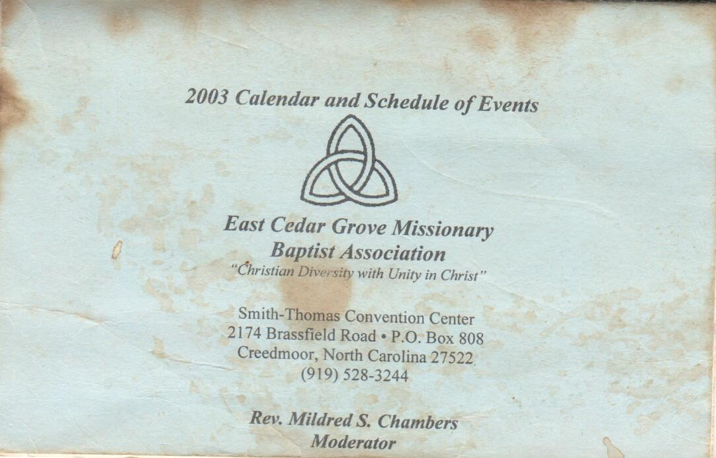
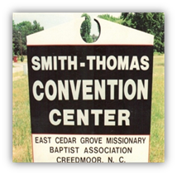
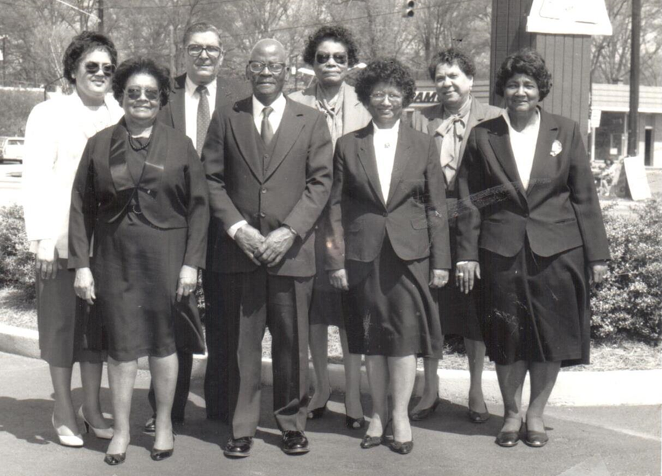
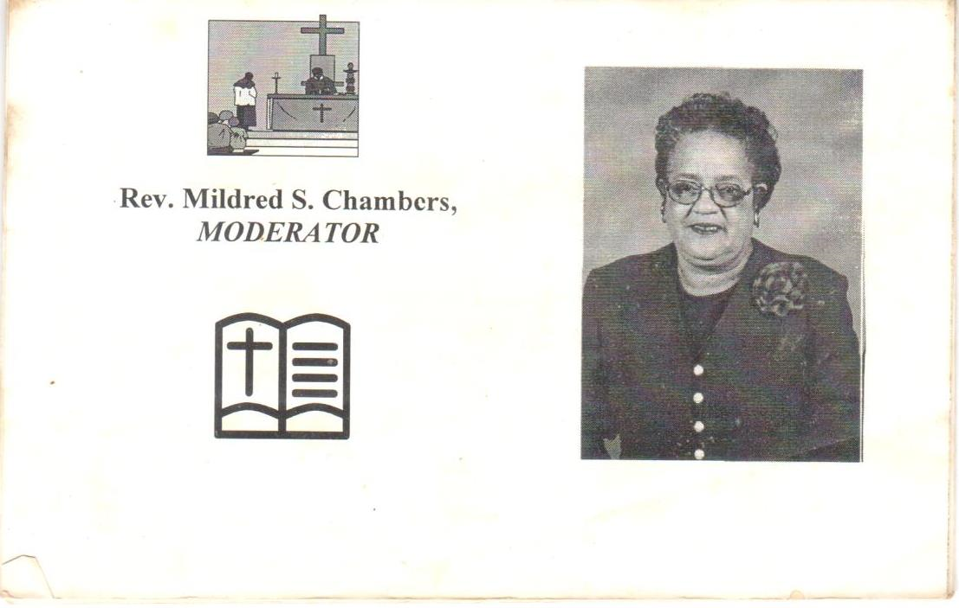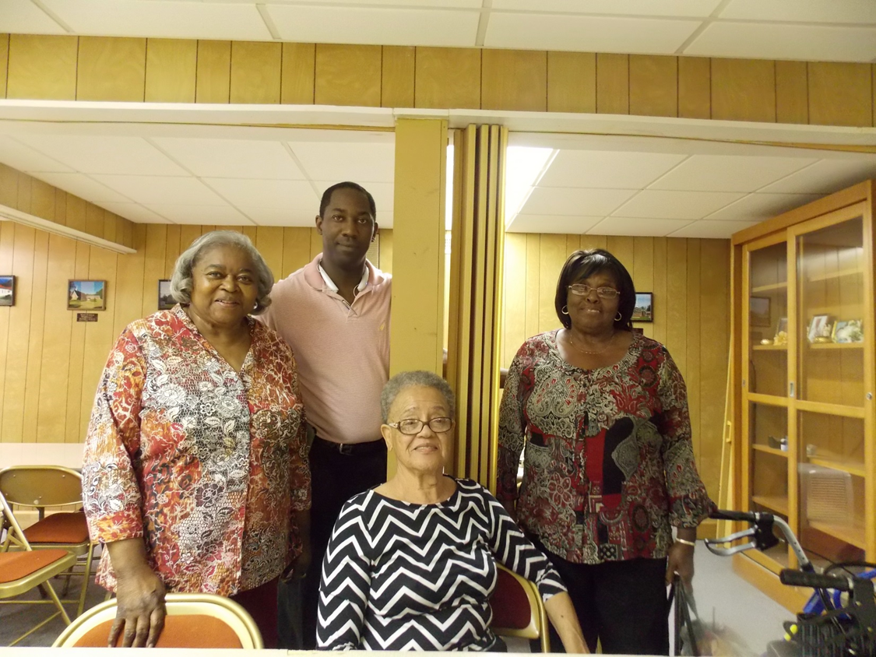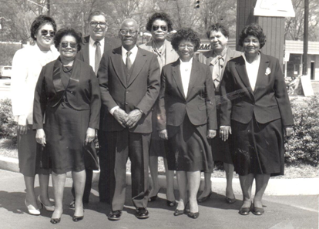
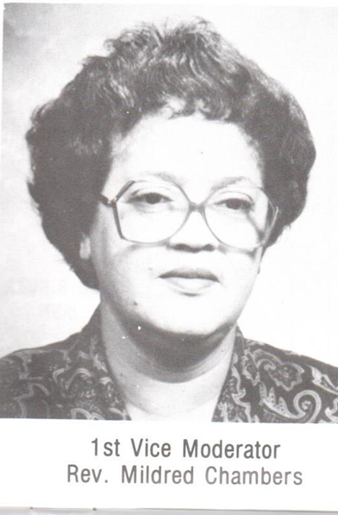
EAST CEDAR GROVE MISSIONARY BAPTIST ASSOCIATION OF NC, INC.
THE LEADERSHIP TEAM 2013—2017
Rev. J. Eric Morgan, III Moderator
Rev. James Isaac, III, First Vice Moderator
Rev. Ronald Booker, Second Vice Moderator
Dec. Johnny Pettiford, Recording Secretary
Sis. Lois Gooch, Corresponding Secretary
Sis. Linda Thomas, Treasurer
Sis. Sharon A. Vincent, Financial Secretary
Rev. Dr. William Richardson, Executive Board Chairman
Rev. Dr. Harold Trice, Vice-Chair Ex. Board
Min. Shelton Harris, Chair, Trustee Board
Rev. Robert Daniels, Chair, Bldg. Committee
Rev. George Crews, III, President, Ministers, Deacons and Deaconess Union
Dec. Ronnie Robinson, Chair, Usher’s League
Sis. Sarah Johnson, Pres. Woman’s Auxiliary
Rev. Tony Boss, Pres. Congress of Christian Education
Bro. William Pointer, Chair, Laymen’s League
Rev. Joyce McDowell Reid, Director Christian Education
Rev. Joyce D. Clayton, Chair, Advisory Council

THE LEADERSHIP TEAM 2001—2005

Rev. Mildred Chambers, Moderator
Rev. W. L. Richardson, Vice Moderator
Rev. Jessie I. Alston, 1st Vice Moderator
Dr. William C. Turner, Chair, Executive Board
Bro. Hurbert L. Gooch, Jr.., Treasurer
Rev. Harold Trice, Chair, Ordaining Council
Rev. William Richardson, Catechizer
Rev. Larry McElroy, Sr. President, Ministers, Deacons and Deaconess Union (MDDU)
Sis. Mary Bass, President, Woman’s Auxiliary
Sis. Magdalene Ragland, 1st Vice President
Bro. Johnny Pettiford, President, Congress of Christian Education
Min. Diane Cash, Music Department, Women Chair Director
Rev. Ralph Mangum, Music Department, Male Choir Director
Bor. Larry Robinson, President, Usher’s Department
Bro. William Johnson, President, Laymen’s League
Sis. NaRuth Holeman, Program Committee Chair

Smith-Thomas Convention Center
2174 Brassfield Road, P.O. Box 808
Creedmoor, NC 27522
eastcedargrove-mba.org

