NATIONAL BAPTIST LAYMEN’S MOVEMENT
Auxliliary of the
NATIONAL BAPTIST CONVENTION, USA, INC.
Bill Campbell
General Secretary
900 Peach Ln
Desoto, TX 75115
(972) 224-8644 Voice
(972) 224-1222 Fax
(214) 682-6548 Cell
dc4091@sbcglobal.net

Willie Burke, President

41 Merker Dr, Edison, NJ 08837
(732) 662-4380 (Voice) (732) 713-6768 (Mobile) wrburke2015@gmail.com (E-mail)

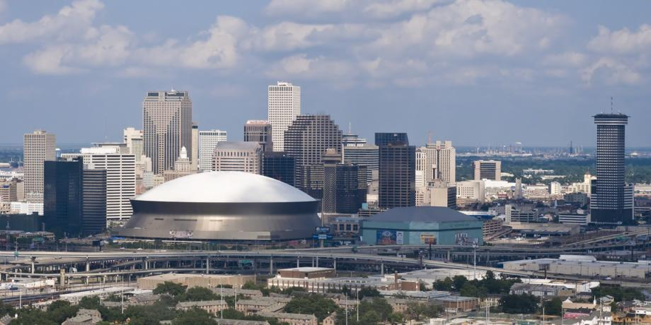

An Evening with the Royal Family and John L. Webb Fellowship and Awards Banquet New Orleans, Louisiana

Greetings to each of you in the name of Jesus.

As each of you are aware, the September 2019 Session of our National Baptist Laymen’s Movement is quickly approaching.

We are extending an invitation to each of you to attend An Evening with our Royal Family on Thursday, September 5, 2019 at 6:00pm. Participation in the Royal Court has a minimum of $750.00. All contestants with the Royal Court are asked to assemble at 5:00pm on Thursday and location will be announced. We are asking all states to give financially to this affair. Please don’t have a zero by your state or convention.

The John L. Webb Fellowship and Awards Banquet will start on Thursday September 5, 2019 at 7:45pm with location to be announced.
Our guest preacher for the evening will be Rev. C.S. Gordon, Jr. , Pastor of the New Zion Baptist Church New Orleans, Louisiana.

The price of the tickets is $50.00 per person and can be purchased at the on site registration. We have tables of 8 that can be purchased early by contacting Brother Glen Chelf or William Graves, Jr. in the amount of $400.00 per table. We are asking our regional vice presidents and officers to please commit to a table early for your state or region. Attached with this invitation is a table layout diagram to choose from. Please commit to a table early for your group.

For more information please contact William A. Graves, Jr at (540)520-9233 or Brother James Deen at (912) 381-7859 or Glen Chelf (505) 249-0394

Working for the Kingdom,

William A. Graves, Jr.
Chairman Social Ministry

James Deen
Co-Chairman Social Ministry

Mike Washington
Vice President At-Large
Michigan

I.V. Reeves
Far West Vice President
Washington

Leslie Kendrick
West Vice President
Oklahoma

L.C. Mitchell
Southwest Vice President
Mississippi

William Graves
Southeast Vice President
Virginia

John Glover
Northeast Vice President
Pennsylvania

Thad Jones
Midwest Vice President
Missouri

Jerry Williams
Treasurer
5801 Arabian Run
Indianapolis, IN 46228

Thomas Lee
Assistant Treasurer
California

Jerry Williams
Assistant General Secretary
Indiana

Albert Brown
Recording Secretary
Wisconsin

