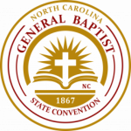 **THE WOMAN’S BAPTIST HOME & FOREIGN MISSIONARY CONVENTION  
 AUXILIARY OF THE GENERAL BAPTIST STATE CONVENTION OF NC, INC.  
Mrs. Lena Johnson, President**

Convention Updates

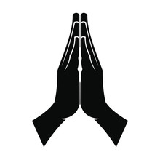**JOIN NEHEMIAH PRAYER WARRIORS FOR AN  
 *“HOUR OF PRAYER”***

May 14, 2022  
7:00 AM  
Call in Number: 1-267-807-9495  
 Access Code: 117396923#

Minister Debra Ransom, Chair  
____________________________________________

The Woman’s Baptist Home & Foreign Missionary Convention Auxiliary (WCA)  
is now accepting applications for Youth and Young Adult Scholarships.  
 A $1,000 non-renewable scholarship will be awarded to two Youth and  
 a $1,000 non-renewable scholarship will be awarded to a Young Adult.

The Application can be downloaded at: wbhfmconline.org  
  
**The Application Deadline for 2022 has been extended to Friday, June 10th**

Dr. Shirley Bullock, Chair

________________________________________

**Virtual Ministers’ Wives and Ministers’ Widows Retreat  
May 14, 2022  
10:00 AM**

Featured Speaker: Minister Fannie Willis

Register online at: wbhfmconline.org  
Registration Fee: $20  
  
Minister Anna Chance, Chair  
____________________________

Churches, City/County Unions, Auxiliaries,   
District Conferences, and Parents

WE INVITE YOUR YOUTH TO JOIN US TO   
 REBUILD DEPARTMENT  
Ages - Birth to 20  
**Next Meeting Date: Saturday, May 14 at 6 pm   
Please send your email address to:   
maxie.kinglewis15@gmail.com   
to receive Zoom link.**

Rev. Dr. Marilyn King Lewis, Youth Supervisor **____________________________________________________**

**Young Adult Retreat**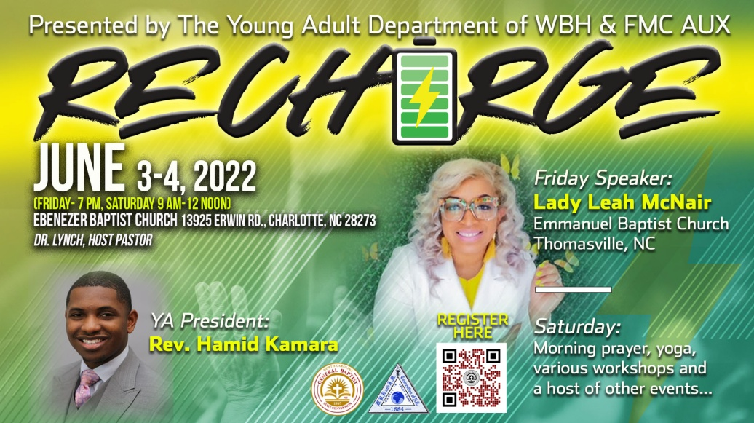

**Register via the QR Code on the flyer or the following link:  
www.gbsconline.org/young-adult-retreat-registration**

________________________________

JULY 24-27, 2022  
Host Church – Galilee Baptist Church  
Winston-Salem, NC  
Rev. Dr. Nathan E. Scovens, Pastor

MORE INFORMATION COMING SOON   
  
Remember: This is an Election Year – “Every Vote Counts”

________________________________________________