National Baptist Convention USA, Inc.
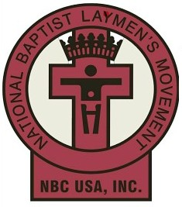

23rd Annual Walter Cade Jr.
Southeast Regional Workshop
Chesapeake Virginia
Friday, October 11, 2019 - Sunday, October 13, 2019

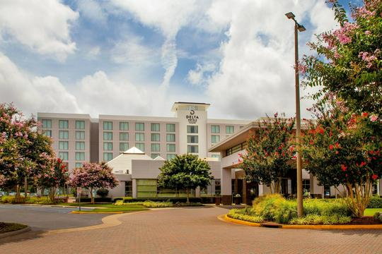
Delta Hotels by Marriott
725 Woodlake Drive,
Chesapeake, VA 23320
Telephone: (757)-523-1500

For More Information Contact

Deacon Benjamin Myrick III
VBSC Laymen President
Cell: (804)-400-6392
Email: onedrummer@hotmail.com

Brother Howard Ingram
Committee Chairman
Cell: (757)-951-3230
Email: hrtingram@aol.com

HOUSING AND REGISTRATION

$185.00 per person – Double Occupancy
$250.00 per person – Single Occupancy

Housing & Registration Fee Includes
Workshop Registration
2 Nights at the Delta Marriott
Banquet
4 Meals

WALTER CADE JR. 23rd ANNUAL SOUTHEAST REGIONAL WORKSHOP
Delta Hotels By Marriott
725 Woodlake Drive,Chesapeake, VA 23320
Friday October 11, 2019 – Sunday, October 13, 2019

Virginia Baptist State Laymen
Deacon Benjamin Myrick III Brother Howard Ingram
VBSC Laymen President Host Committee Chairman
Cell: (804)-400-6392 Cell: (757)-951-3230
Email: onedrummer@hotmail.com Email: hrtingram@aol.com

HOUSING AND REGISTRATION FORM
All packages include two nights stay in the hotel, 4 meals, Saturday night Banquet and entry into all sessions.
Tickets will be required for all meals by everyone.
The deadline for the submission of Housing and Registration Form is September 11, 2019.

HOUSING AND REGISTRATION FEE
- Single Occupancy: $250.00 per person _____
- Double Occupancy (1 Bed) $185.00 per person _____
- Double Occupancy (2 Beds) $185.00 per person _____

Persons not staying in hotel but planning to attend Workshop: $125.00 per person _____
(Entitles attendance to all sessions and all 5 meals, including Banquet)

Total Amount: _______________
Please make checks payable to: VA Baptist State Laymen

PLEASE CIRCLE YOUR STATE: FL – GA – NC – SC – VA
YOUR CONTACT INFORMATION

Name: _____________________________________ Email Address: _____________________________________

Address: ____________________________________ City: ________________ State: _________ Zip: __________

Telephone: ( ) _______________________________ Cell: ( ) ____________________________________

Additional Room Occupants (Please print complete name)

- ___________________________________________ 2. ________________________________________
DEADLINE FOR HOUSING AND REGISTRATION FORM SUBMISSION: SEPTEMBER 11, 2019
Please Return Completed Form To:
Brother Howard Ingram
3 Middleton Court
Hampton, VA 23661
Cell: (757)-951-3230 Email: hrtingram@aol.com
WALTER CADE JR. 23rd ANNUAL SOUTHEAST REGIONAL WORKSHOP
Delta Hotels By Marriott
725 Woodlake Drive,Chesapeake, VA 23320
Friday October 11, 2019 – Sunday, October 13, 2019

Virginia Baptist State Laymen
Deacon Benjamin Myrick III Brother Howard Ingram
VBSC Laymen President Host Committee Chairman
Cell: (804)-400-6392 Cell: (757)-951-3230
Email: onedrummer@hotmail.com Email: hrtingram@aol.com

March 1, 2019

Greetings Southeast Region Laymen,

We are blessed to welcome you, the delegates of the National Baptist Southeastern Region, to the great State of Virginia for the Walter Cade Jr. 23rd Annual Southeast Regional Workshop. We are humbled to host this workshop and bring you greeting from the Virginia Baptist State Convention and our President, Rev Dr. Charles Whitfield.
“Behold, how good and pleasant it is when brothers dwell in unity. Psalm 133:1.

We will gather in the beautiful city of Chesapeake Virginia for this 23rd Annual Southeast Regional Workshop. Our meeting site will be the Delta Hotel by Marriott 725 Woodlake Drive,Chesapeake, VA 23320 during Friday October 11, 2019 – Sunday, October 13, 2019.

Attached to this letter are two important and necessary documents:

- Housing and Registration Form
- Housing and Registration is $185.00 per person – double occupancy
- Housing and Registration is $250.00 per person – single occupancy
- Souvenir Journal Advertisement Application – Ad pricing information included

We ask that you share these documents and distribute them to the Laymen of your respective states.
Please note: There are deadlines which must be adhered to for both, the Housing and Registration Form as well as the Souvenir Journal Advertisement Application.

Registration Deadline: Deadline for Registration submission is September 11, 2019.
Souvenir Journal: Deadline for Ad submission and payment is September 1, 2019.

Please return completed Housing and Registration form and monies to the following address.
Brother Howard Ingram
3 Middleton Court
Hampton, VA 23661
Should you have any questions in reference to the information enclosed or our upcoming Workshop, please contact (757)-951-3230.Thank you for your prayers, support and your participation. We will see you in Chesapeake, VA!

Humbly Submitted

Benjamin Myrick III, VBSC Laymen President
Howard Ingram, Host Committee Chairman
WALTER CADE JR. 23rd ANNUAL SOUTHEAST REGIONAL WORKSHOP
Delta Hotels By Marriott
725 Woodlake Drive,Chesapeake, VA 23320
Friday October 11, 2019 – Sunday, October 13, 2019

Virginia Baptist State Laymen
Deacon Benjamin Myrick III Brother Howard Ingram
VBSC Laymen President Host Committee Chairman
Cell: (804)-400-6392 Cell: (757)-951-3230
Email: onedrummer@hotmail.com Email: hrtingram@aol.com

SOUVENIR JOURNAL ADVERTISEMENT APPLICATION

Greetings,

Our Souvenir Journal Committee is working diligently to make this year’s Journal a memorable, comprehensive representation of the Southeastern Region. Please share this document with the Laymen/Brotherhood of your state.

ADS SUBMISSION: To submit an ad, please send the following to the email address below: 1) the text for the ad; 2) the image for the ad. Pictures must be submitted in JPEG or PNG format. Hand written ads must be mailed to the address listed below and will be formatted by the Journal Production Team.

SOUVENIR JOURNAL ADS SUBMISSION AND PAYMENT DEADLINE
SEPTEMBER 1, 2019

Make Checks Payable To:
Virginia Baptist State Laymen

Mail Checks and Handwritten Ads To:
Brother Howard Ingram
3 Middleton Court
Hampton, VA 23661

Email Ads To:
hrtingram@aol.com
Full Page | $100.00
Half Page | $ 50.00
Quarter Page | $ 35.00
Business Card | $ 25.00
Patron (Name Only) Recognition List | $ 10.00
Inside Front Cover – Full Page | $200.00
Inside Back Cover – Full Page | $150.00
Back Cover – Full Page | $200.00

Name
Name
Business card

¼ Page

Half Page

Full Page
ADS SIZES PRICES QUANTITY TOTAL
For more Information, Contact Howard Ingram, 757-951-3230.

