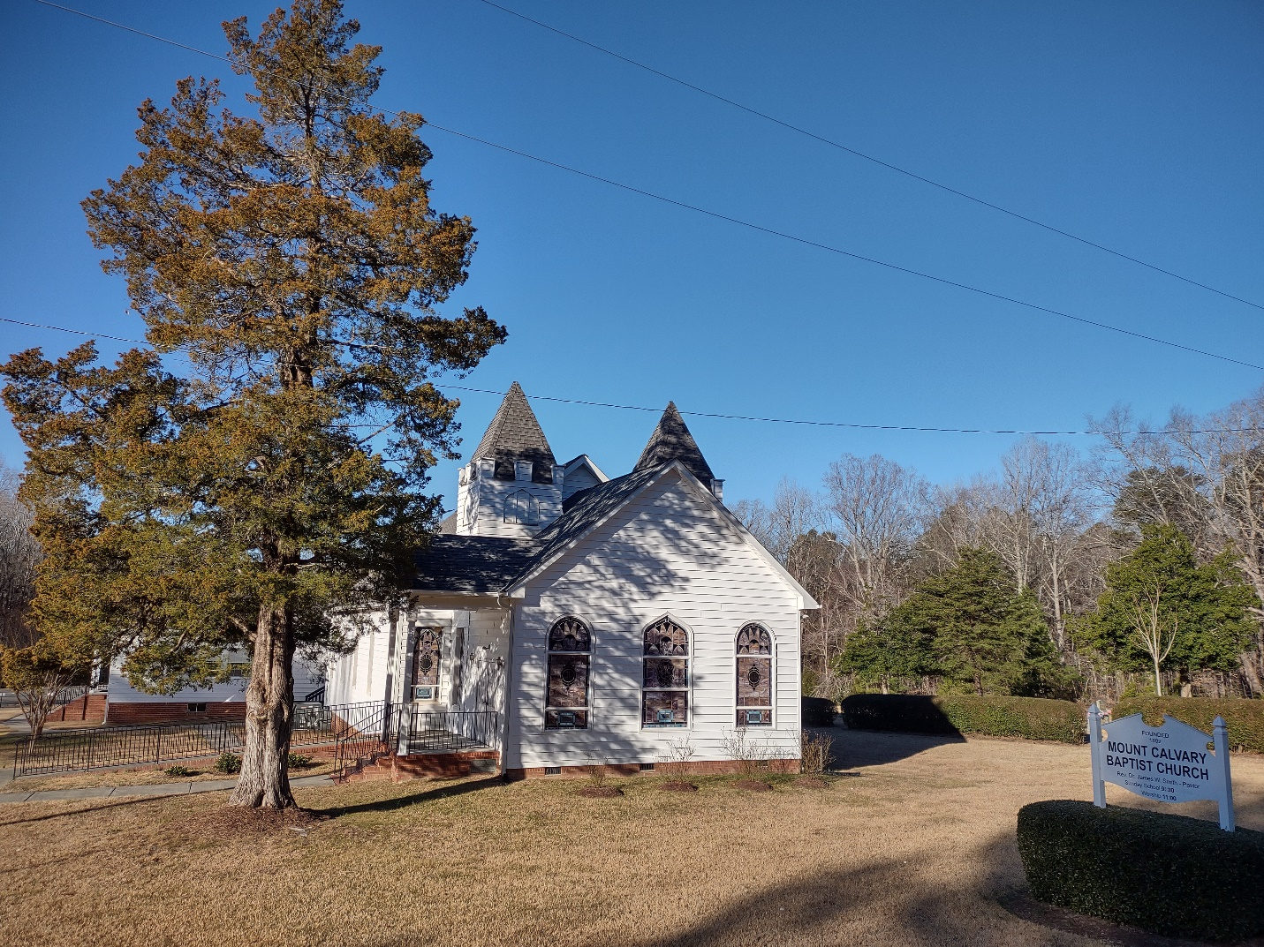

MT. CALVARY MISSIONARY BAPTIST CHURCH

8021 Stagville Road, Bahama, NC 27503
Website: www.mtcalvary-bahama.org

POSITION VACANCY: PASTOR

Closing Date: May 31, 2022

DESCRIPTION

Mt. Calvary Missionary Baptist Church is a rural church located at the corner of Stagville and John Jones Road in Bahama, NC. Our church is a Bible based, Christ centered, ministry mind, family-oriented church that has been in existence for over 125 years. Our congregation includes people of all ages. We are committed to honoring Christ in all things that we do. Worship services are held each Sunday and Bible Study each Wednesday evening.

EDUCATION REQUIREMENT

Must have received a seminary degree from an accredited school.

REQUIRED EXPERIENCE

- Three to five years of experience
- Ordained
- Missionary Baptist Denomination
- Strong knowledge of Baptist Doctrine, Policy and Procedures

JOB RESPONSIBILITIES

- To preach, teach and to equip the congregation to fulfill its vision and mission
- The ability to effectively communicate with all ages and genders
- Teaching Sunday School and Bible Study with clarity

APPLICATION PROCESS

Interested persons should submit a letter of interest, resume and letters of recommendations online at:

Online at https://www.mtcalvary-bahama.org/pastoral_search
This takes you directly to the page where you can upload your information. Follow the instructions.

You can also mail to:

Mt. Calvary Missionary Baptist Church
Attention: Pulpit Search Committee
P. O. Box 171
Bahama, NC 27503

