NATIONAL BAPTIST LAYMEN’S MOVEMENT
Auxliliary of the
NATIONAL BAPTIST CONVENTION, USA, INC.
Bill Campbell
General Secretary
900 Peach Ln
Desoto, TX 75115
(972) 224-8644 Voice
(972) 224-1222 Fax
(214) 682-6548 Cell
dc4091@sbcglobal.net

Willie Burke, President

41 Merker Dr, Edison, NJ 08837
(732) 662-4380 (Voice) (732) 713-6768 (Mobile) wrburke2015@gmail.com (E-mail)

Mike Washington
Vice President At-Large
Michigan

I.V. Reeves
Far West Vice President
Washington

Leslie Kendrick
West Vice President
Oklahoma

L.C. Mitchell
Southwest Vice President
Mississippi

William Graves
Southeast Vice President
Virginia

John Glover
Northeast Vice President
Pennsylvania

Thad Jones
Midwest Vice President
Missouri

Antonio Christian
Treasurer
P.O Box 536
Swartz, LA 94577

Thomas Lee
Assistant Treasurer
California

Jerry Williams
Assistant General Secretary
Indiana

Albert Brown
Recording Secretary
Wisconsin

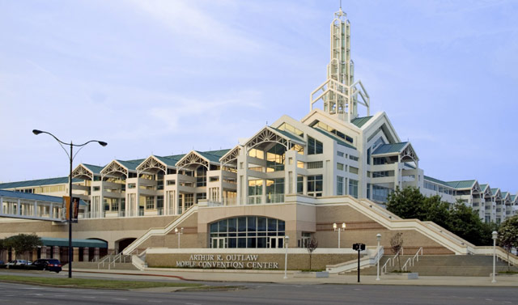

SPECIAL PROJECTS BREAKFAST

Greeting State Presidents, Fellow Laymen and Women Supporters,

The Special Projects Breakfast is held every January during our Mid- Winter Board Meeting. This fund raising effort will be held on Thursday, January 11, 2018 at 7:00am, at St. Luke Missionary Baptist Church 715 Texas Street Mobile, Alabama. Rev. Charles Faulks, Pastor of the Pilgrim Rest Baptist Church of Tyler, Texas is our guest preacher for this grand occasion.

During this special projects breakfast we will be announcing the amounts contributed by each state convention.

Each state convention is asked to contribute a minimum of $2,500.00 in this effort. There is a model for state conventions to meet this goal: Ask 100 persons to give a consecrated gift of $25.00 each.

We are asking that there be no zero’s by your state convention’s name.

The funds raised in this effort goes toward the Laymen’s Projects that are conducted domestically and internationally.

If you will not be attending but want to make your states contributions please mail to Brother Antonio Christian P.O. Box 536 Swartz, LA. 71281. Please make checks payable
National Baptist Laymen earmarked Special Projects.

For the Kingdom,

William A. Graves Jr. Vice President Social Ministry

James Deen Assistant Vice President Social Ministry

Sincerely,
Willie R Burke
Willie R Burke
National Laymen President

.

